**ASSIGNMENT 1:**

**Problem Definition:** Create an account in AWS and configure a budget

**Account Creation:**

1. Go to ***AWS Management Console*** and click on “***Sign Up****”*.

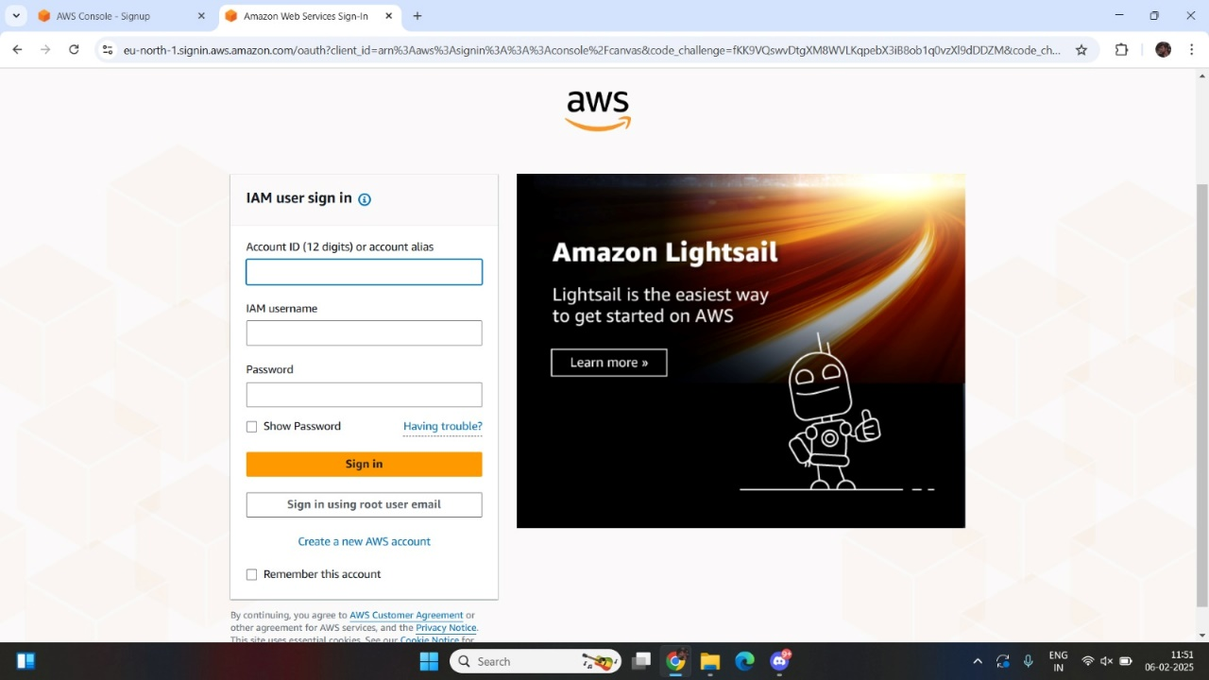

2. Enter *root user email address* and *AWS account name.*

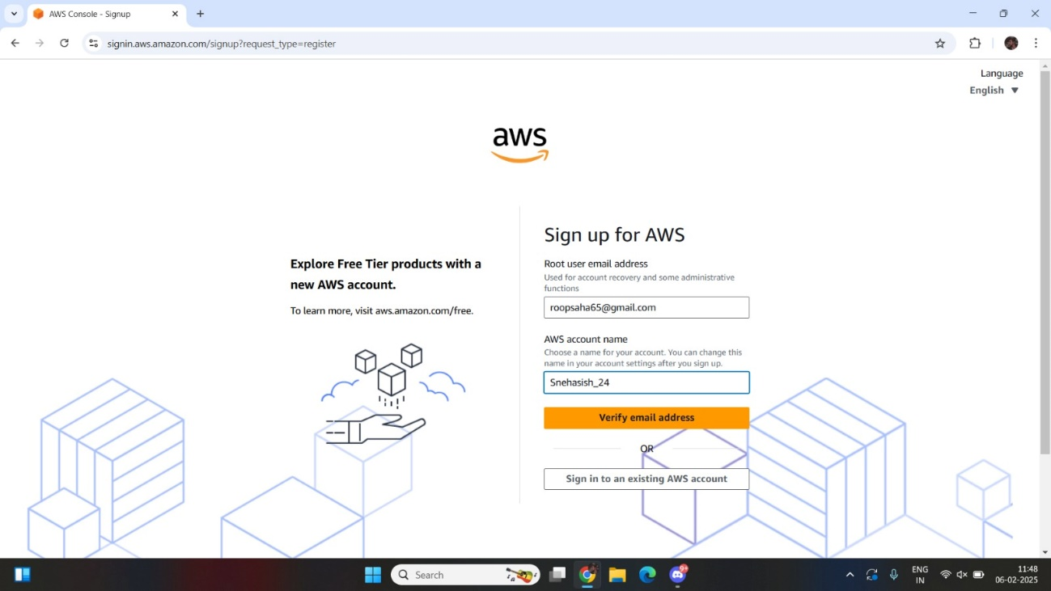

3. Verify your email address.

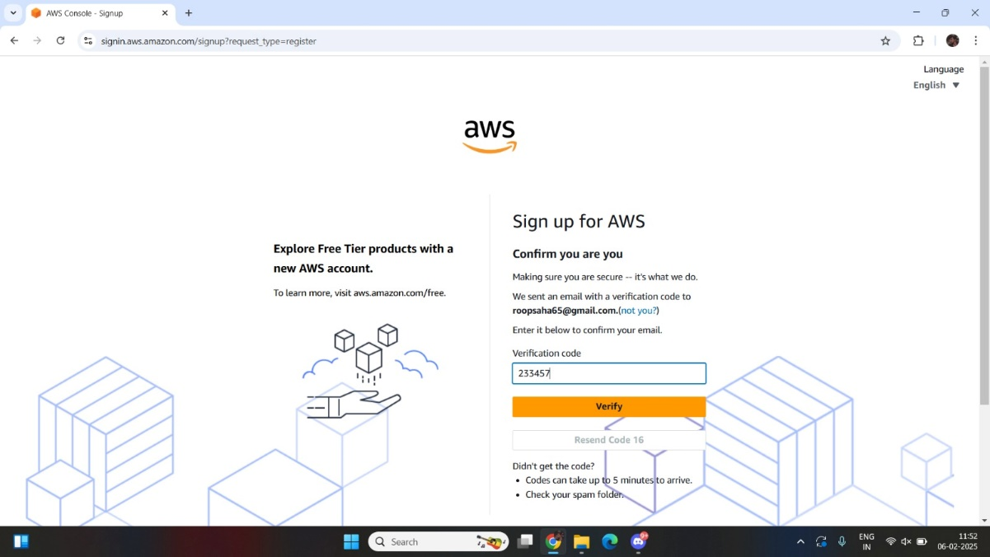

4. Set your password, then click on “***Continue (step 1 of 5)****”.*

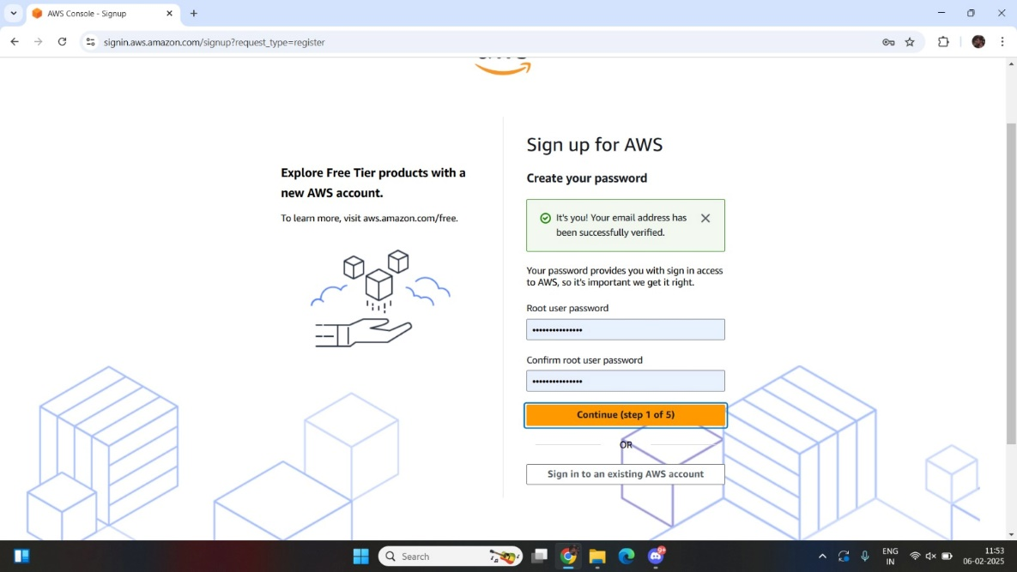

5. Fill the required details, tick off the check box and then click on

***“Continue (step 2 of 5)”****.*

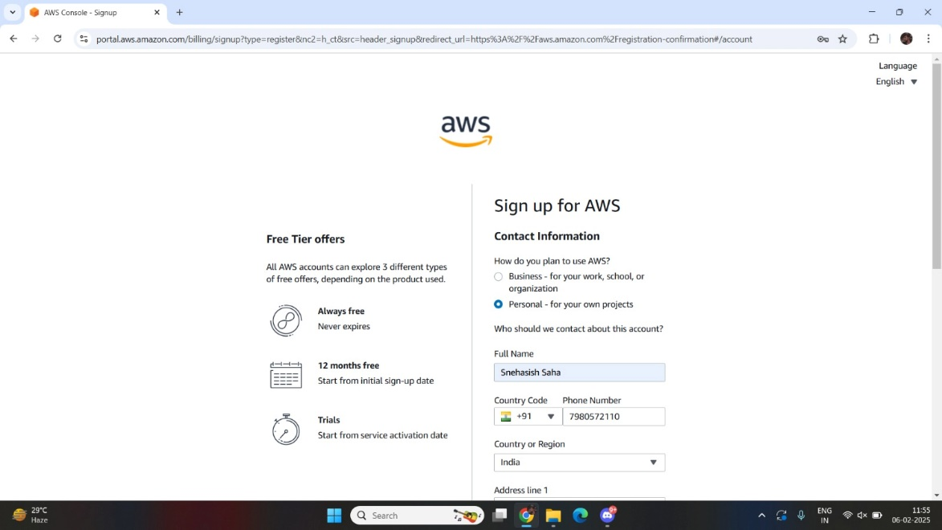

6. Enter billing information and complete payment, then click on

***“Continue (step 3 of 5)”****.*

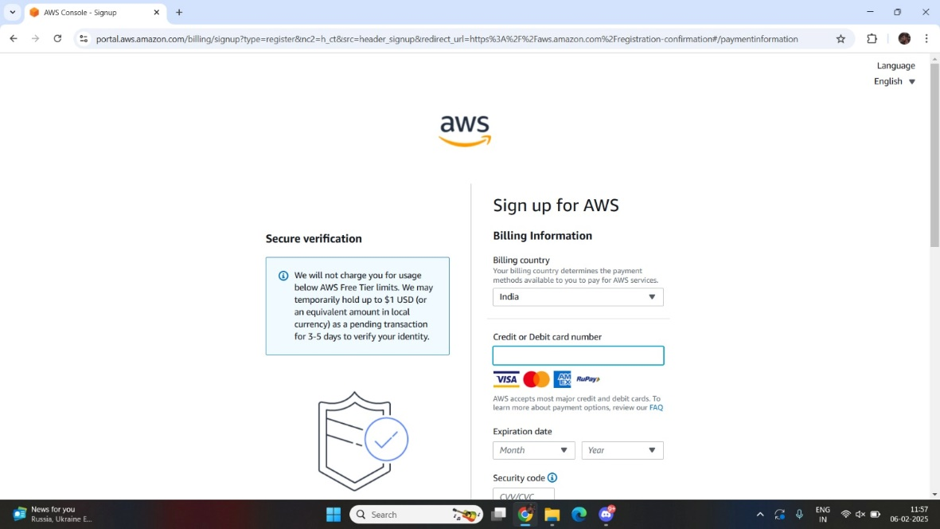

7. Verify your phone number then click ***“Continue (step 4 of 5)”****.*

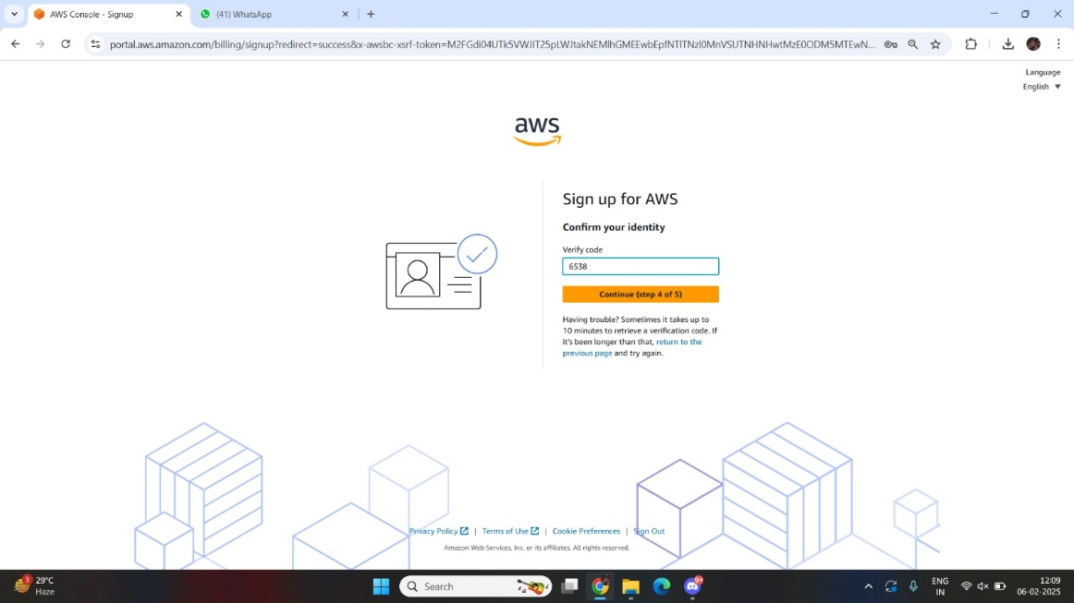

8. Select a *Support Plan* then click on **“Complete sign up”**.

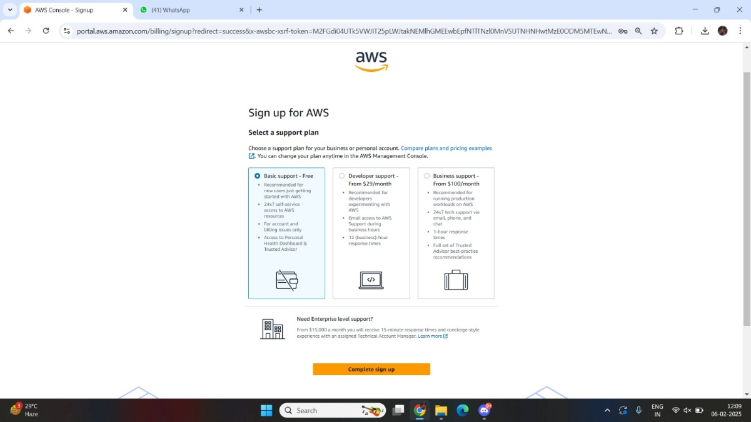

9. Congratulation page will be shown if account is created

successfully.

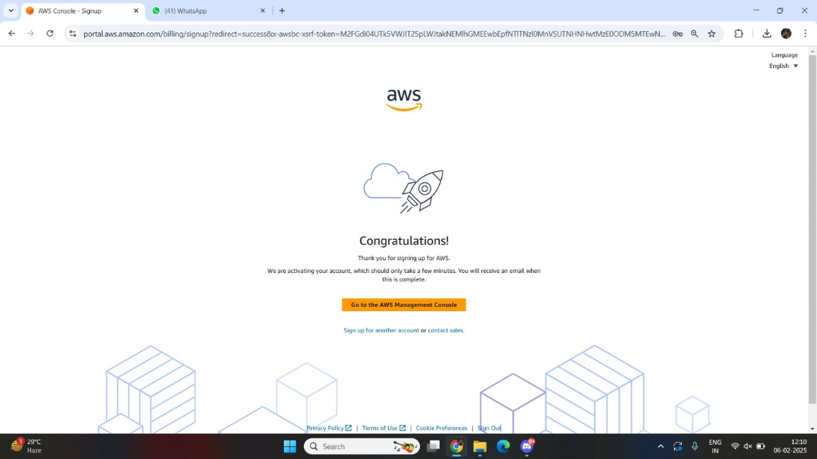

**Budget Configuration:**

1. Login to ***AWS Management Console*,** click on your username at the

top right corner and click on ***“Billing and Cost Management*”**.

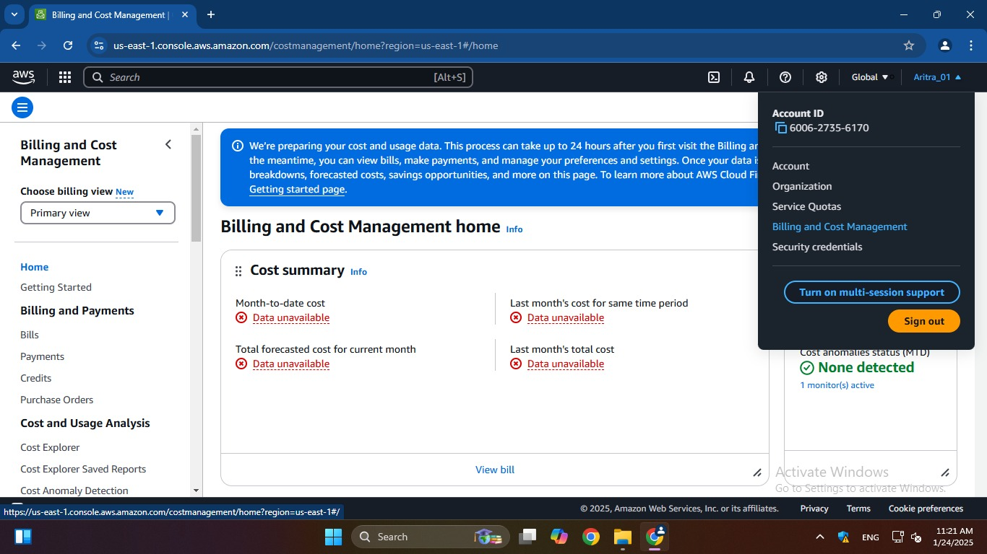

2. Under ***“Budgets and Planning”,*** click on ***“Budgets”*** and then click on

***“Click on budget”.***

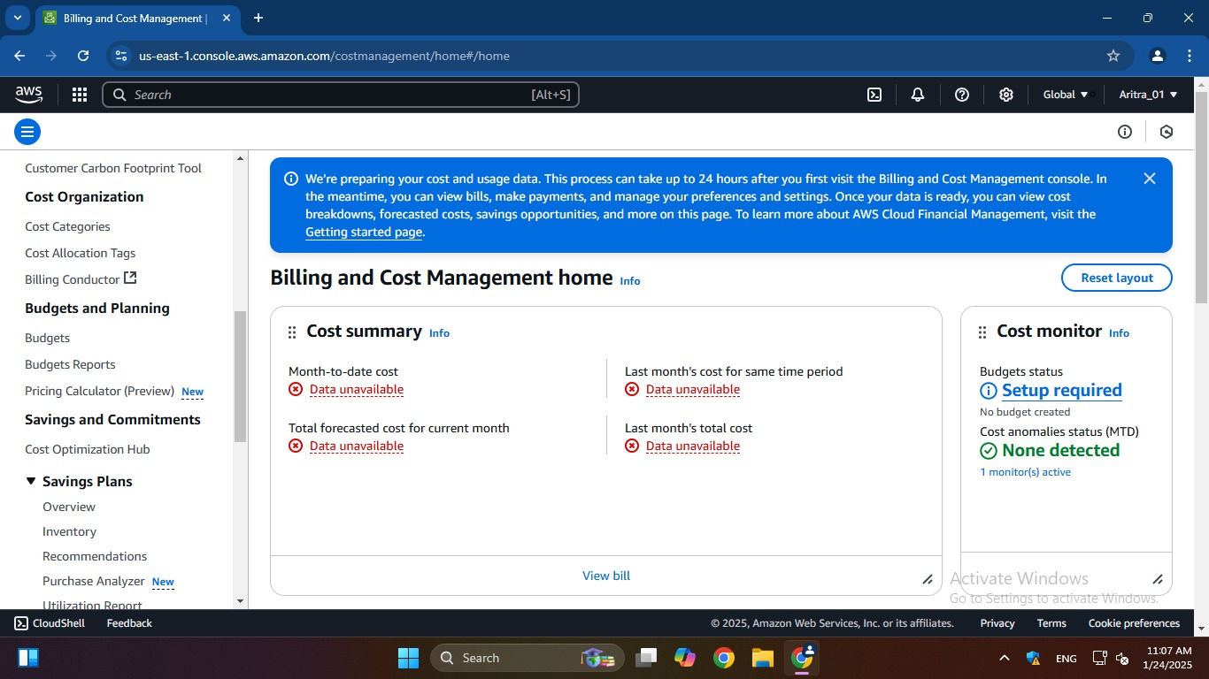

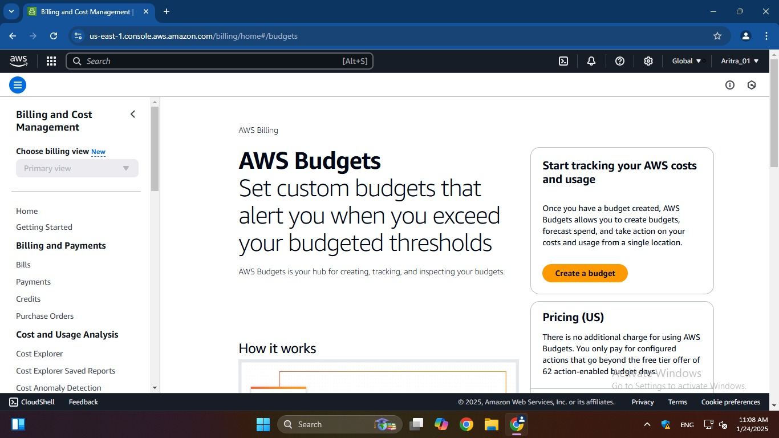

3. Configure budget setup by selecting ***“Customize (advanced)”*** then

click on ***“Next”*.**

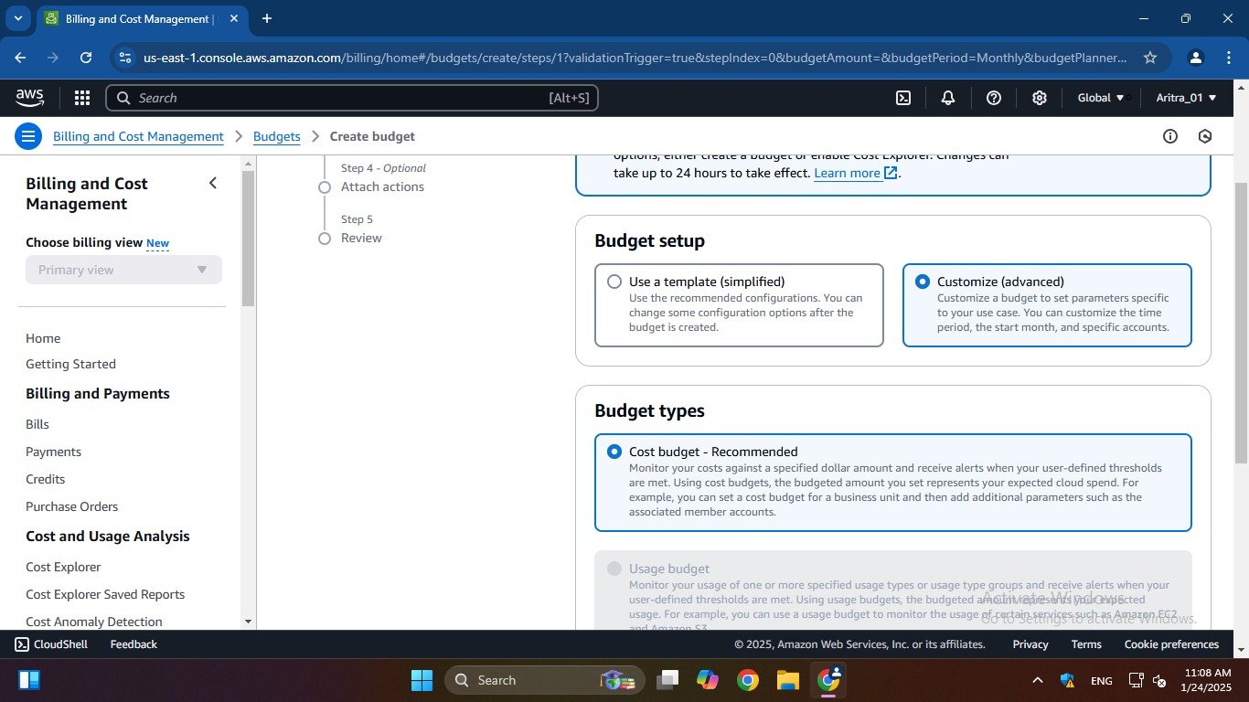

4. Add budget details.

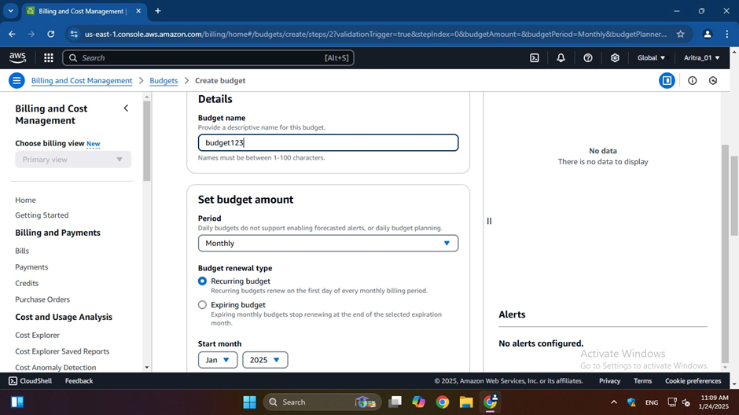

5. After selecting ***“Add threshold”***, fill-in the necessary details and

then click on ***“Next”.***

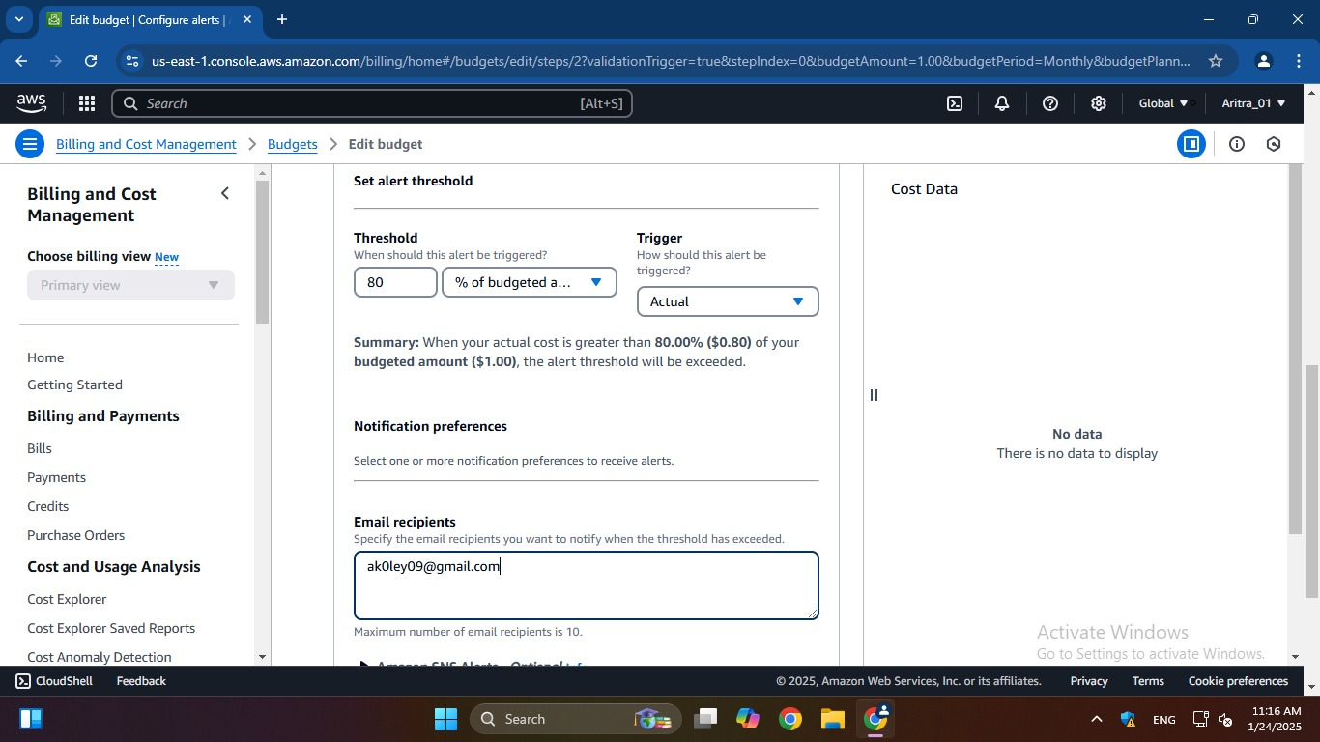

6. Review the budget details and click on ***“Save”*** to finalize the

budget.

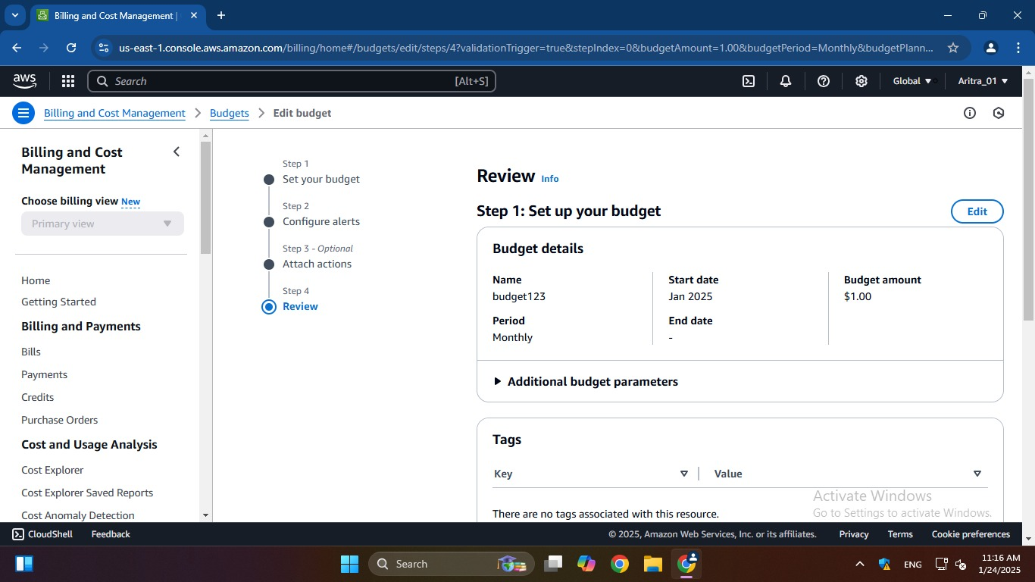

7. Budget is successfully created.

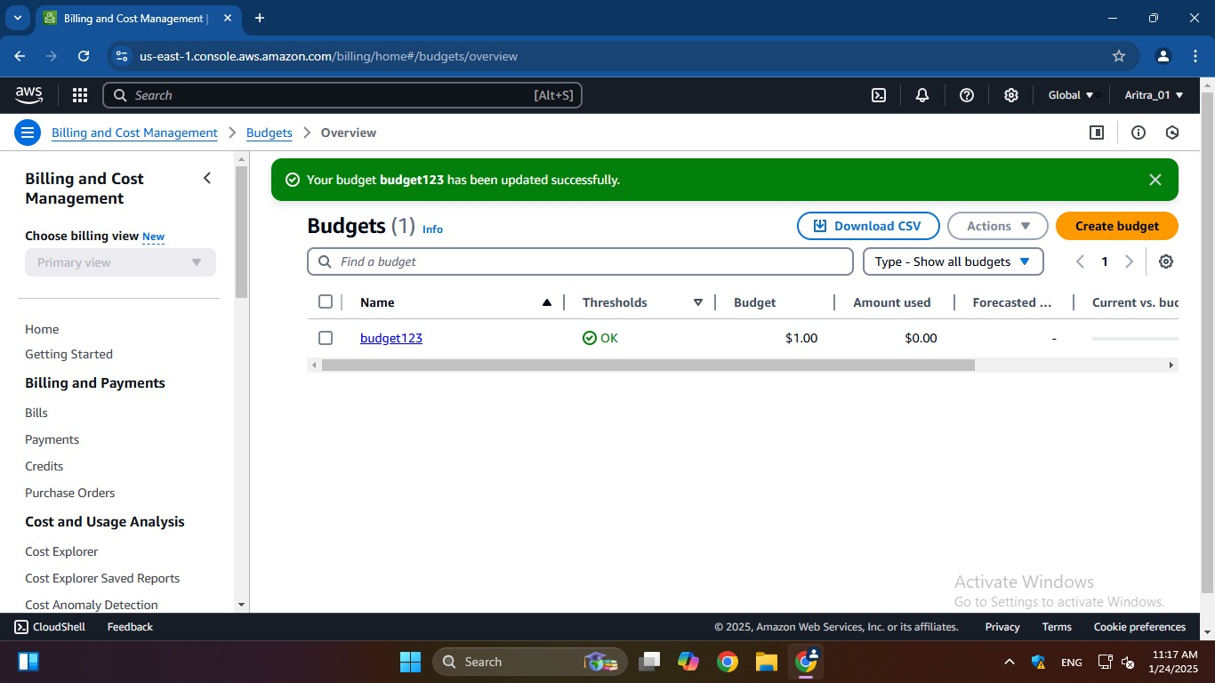

**ASSIGNMENT 2:**

**Problem Definition:** Create MFA (Multi-Factor Authentication) for authentication.

**Instructions:**

1. Log into AWS account and go to ***“Security credentials”.***

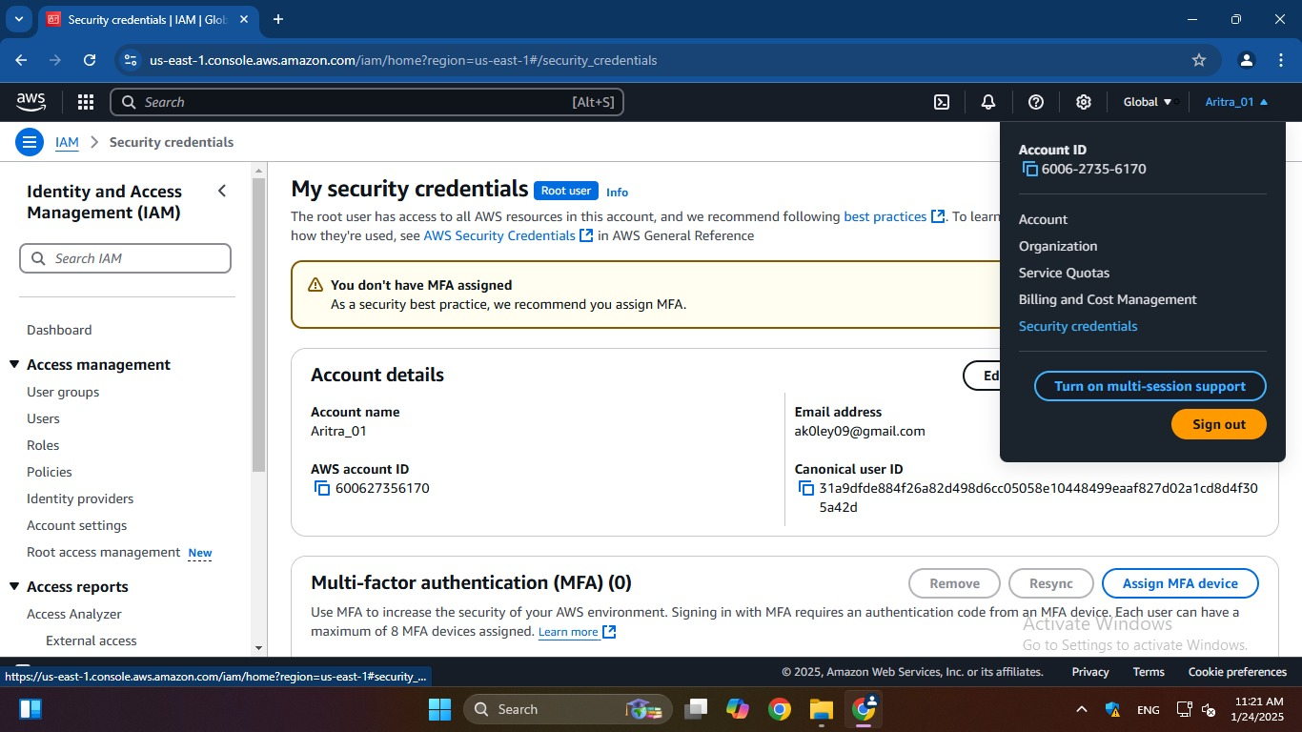

2. Add MFA device by clicking on ***“Assign MFA device”***.

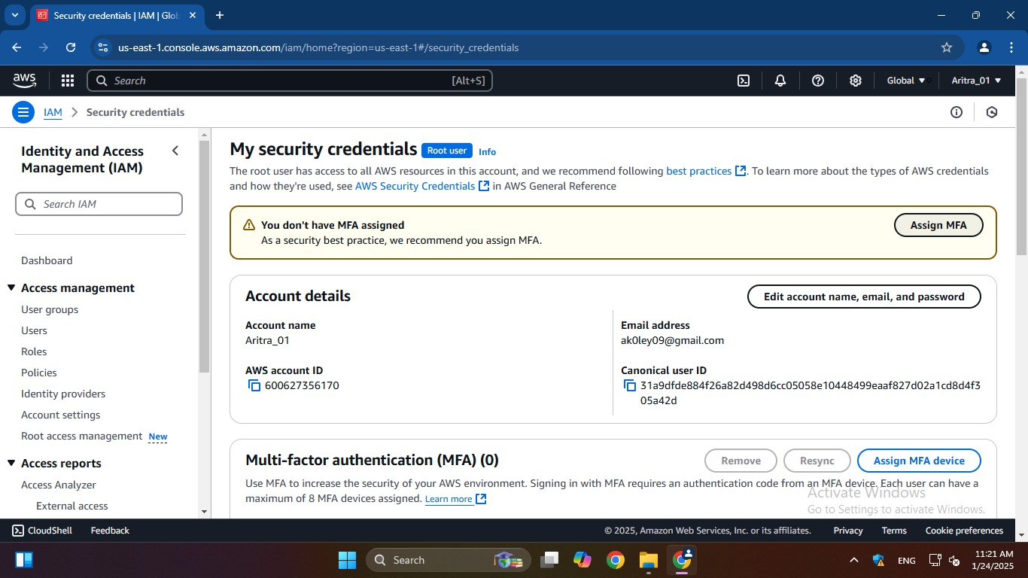

3. Enter a desired device name, MFA device and then click on ***“Next”***.

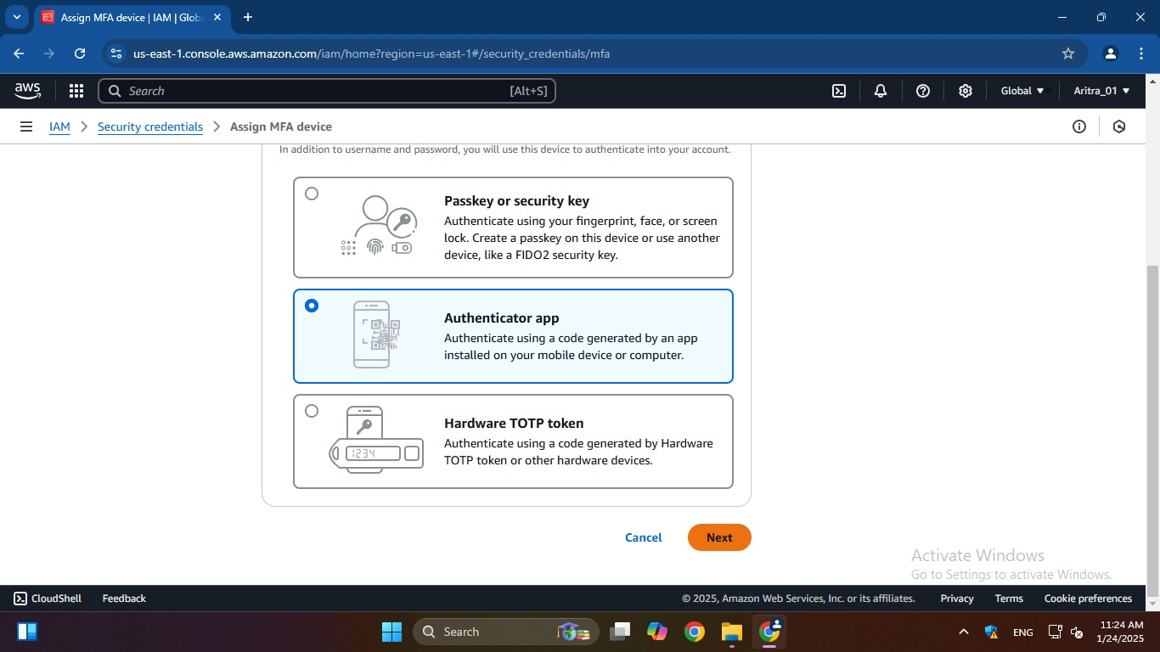

4. Enter code using authenticator app and click on ***“Add MFA”*** to

complete the process.

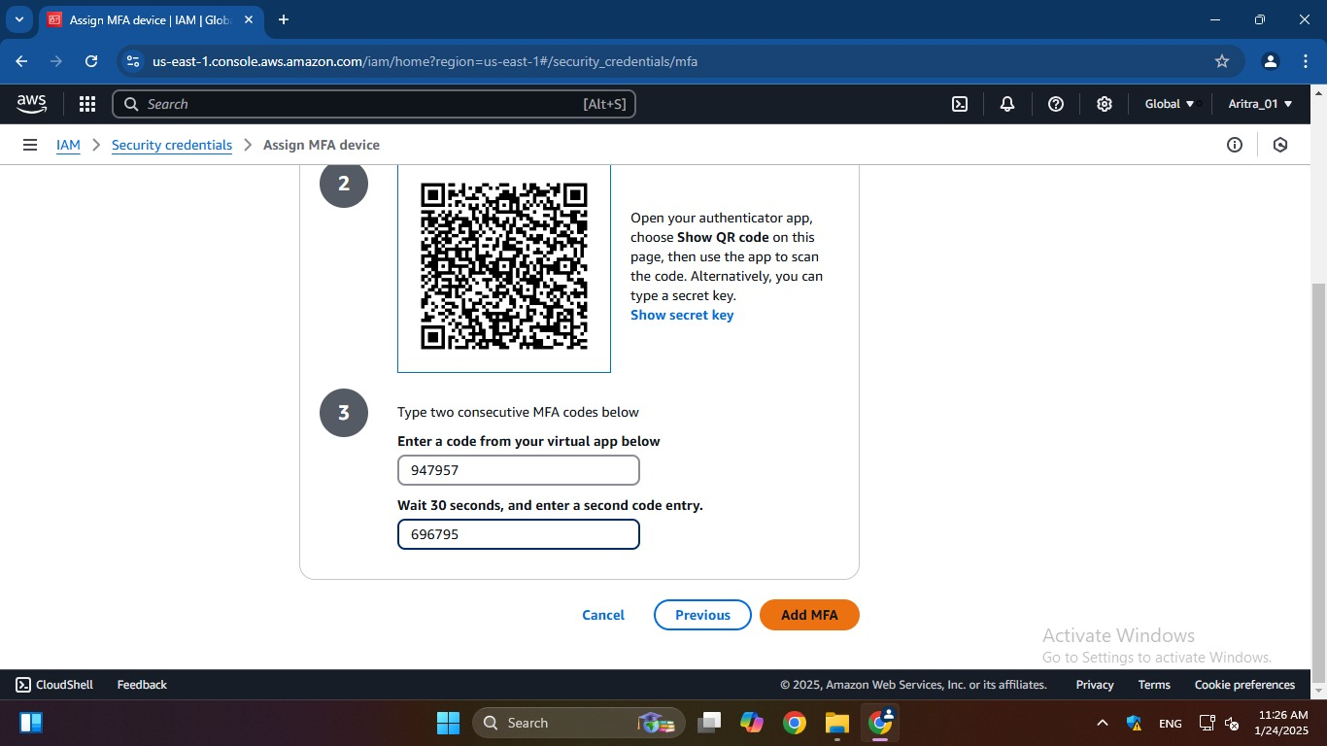

5. MFA device assigned successfully.

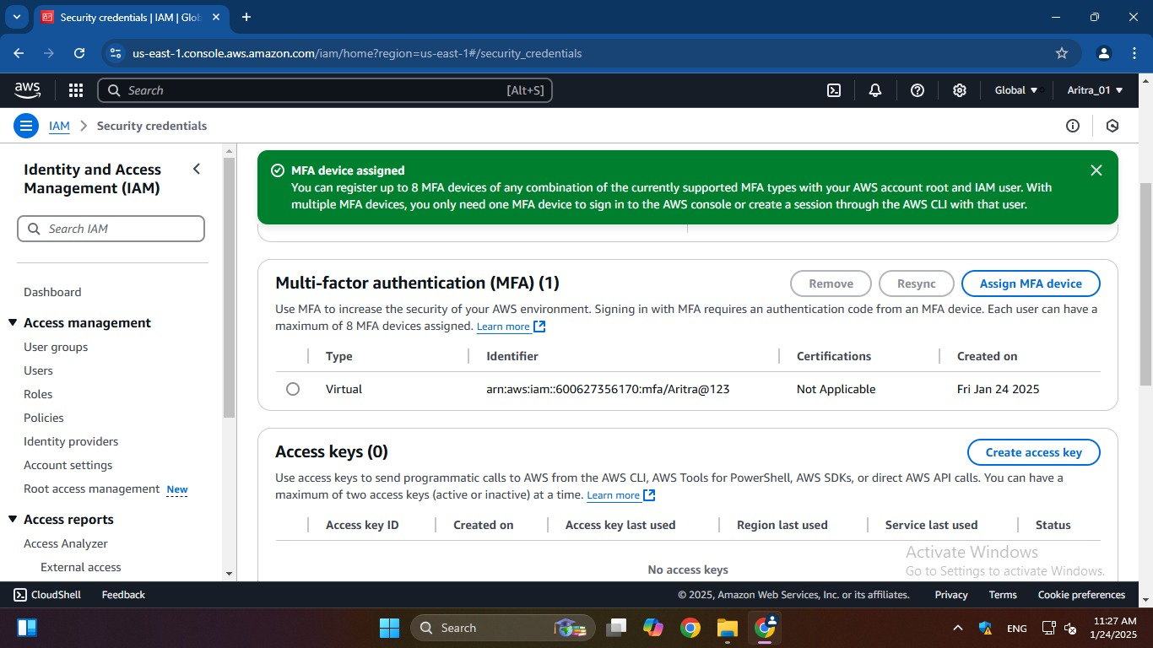

**ASSIGNMENT 3:**

**Problem Definition:** Create IAM user and give full access to S3.

**Instructions:**

1. From AWS console, search for ***“IAM”*** and click on it.

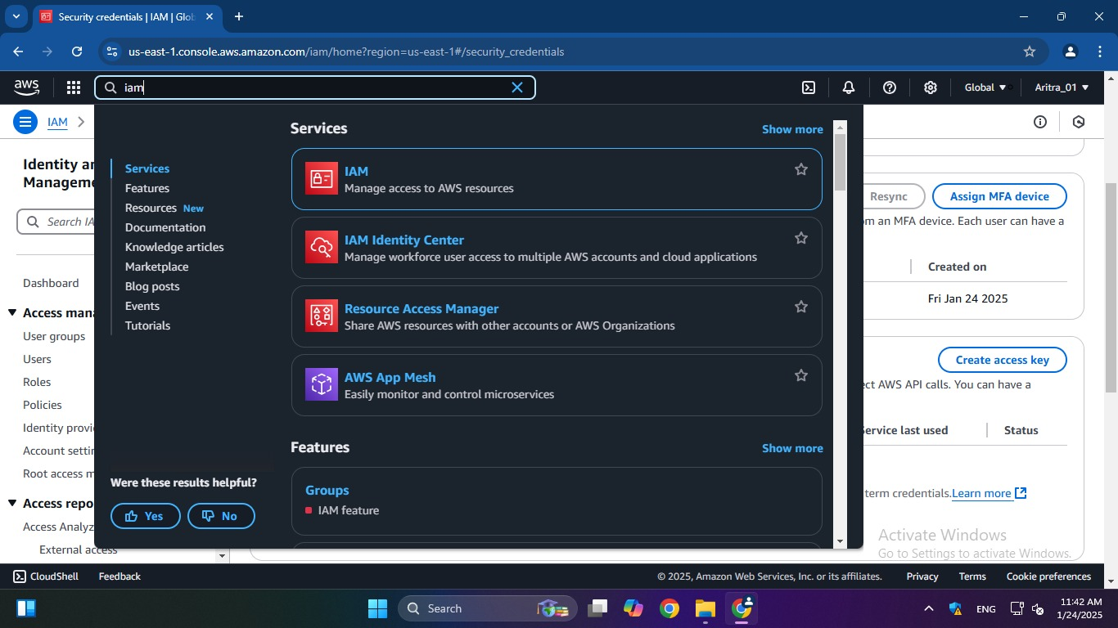

2. Under “***IAM resources”*** click on ***“Users”***.

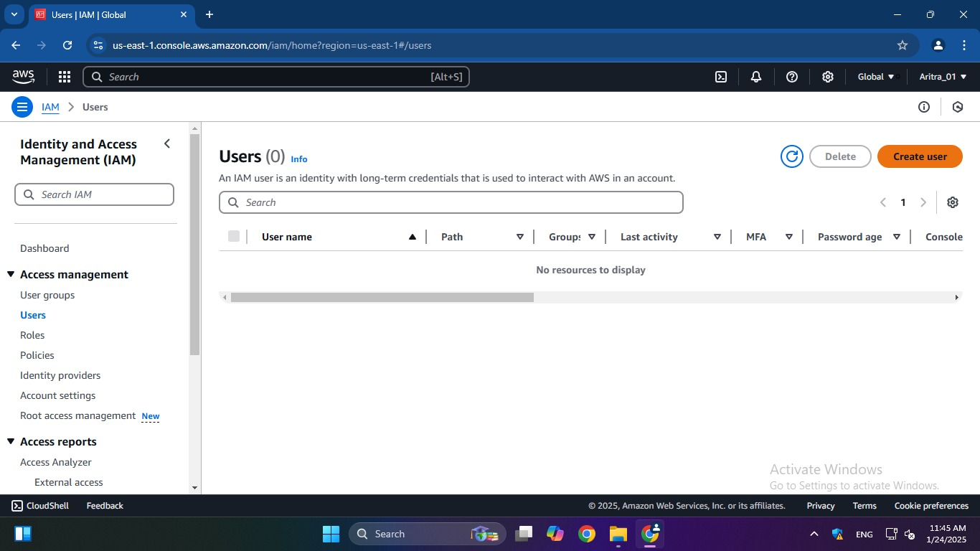

3. Click on ***“Create User”***. Provide User details (name, password, etc.)

and click on ***“Next”*** to proceed.

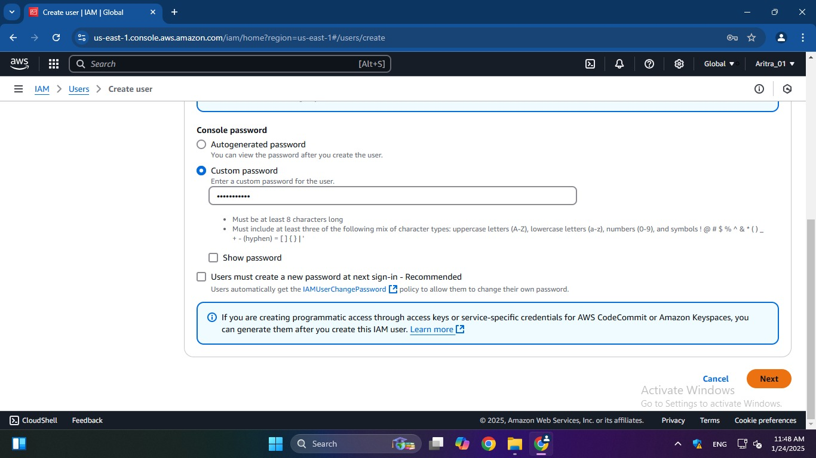

4. Under ***“Permissions options”***, click on ***“Add user to group”*** and go to

***“Create group”***.

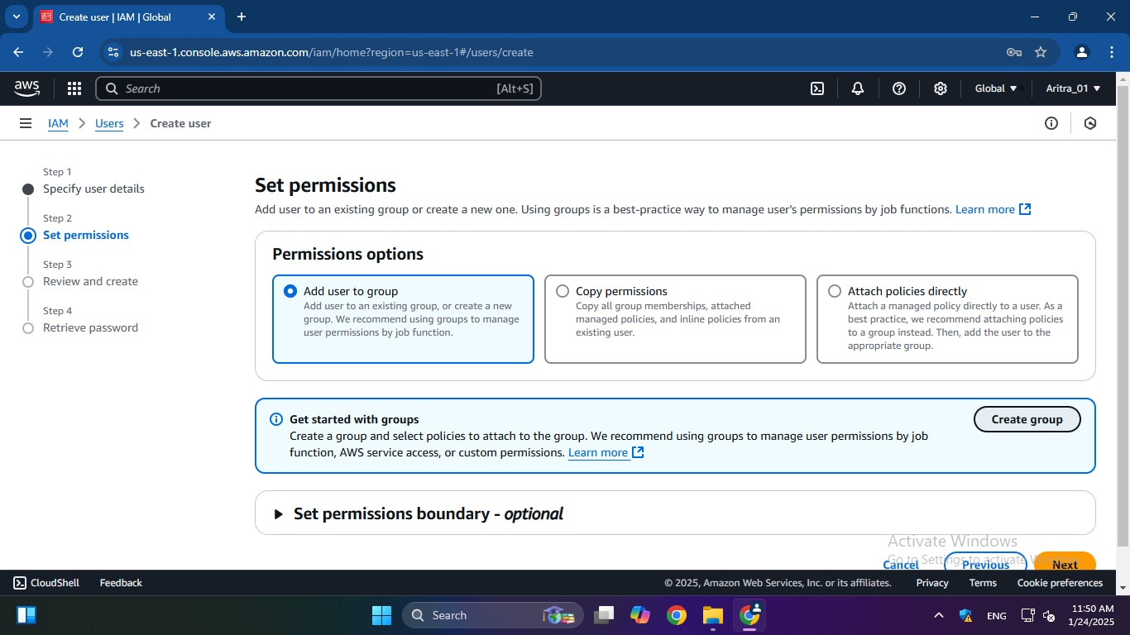

5. To create user group, first provide ***“User group name”***, then from

“***Permission policies”*** search for ***“S3”*** and select full access of the

particular permission we want to give to that group. Then click on

***“Create User Group”***.

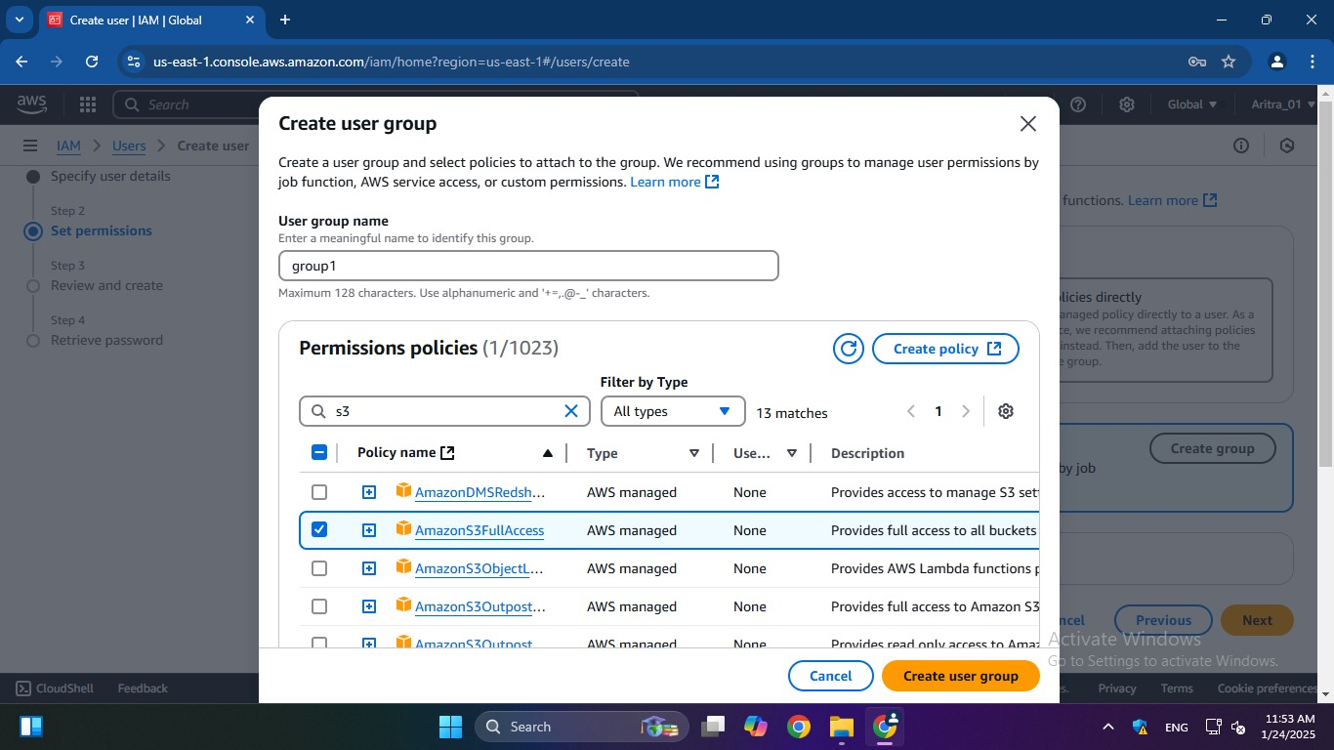

6. The group is successfully created. Tick the checkbox of the created

group in ***“User groups***”, so that our IAM user is connected to this

group and gets the required permission. Then click on ***“Next”***.

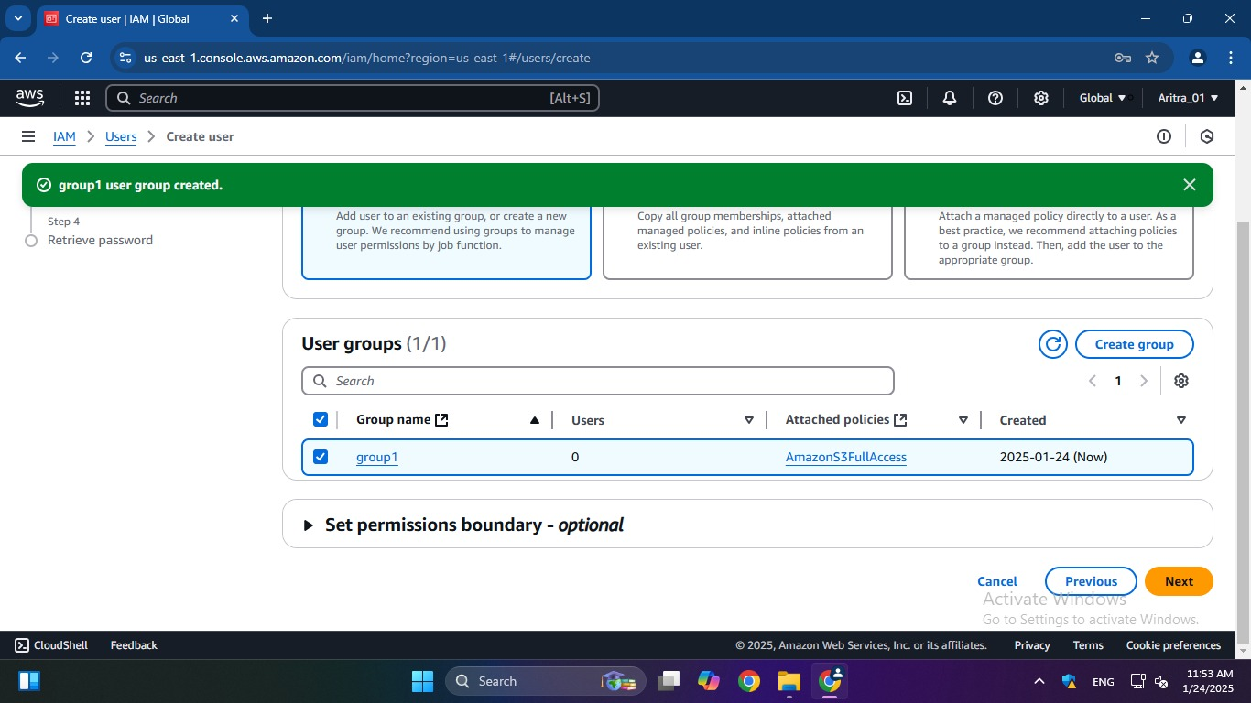

7.Under ***“Review and create”***, click on ***“Create user”*** to create our IAM

user.

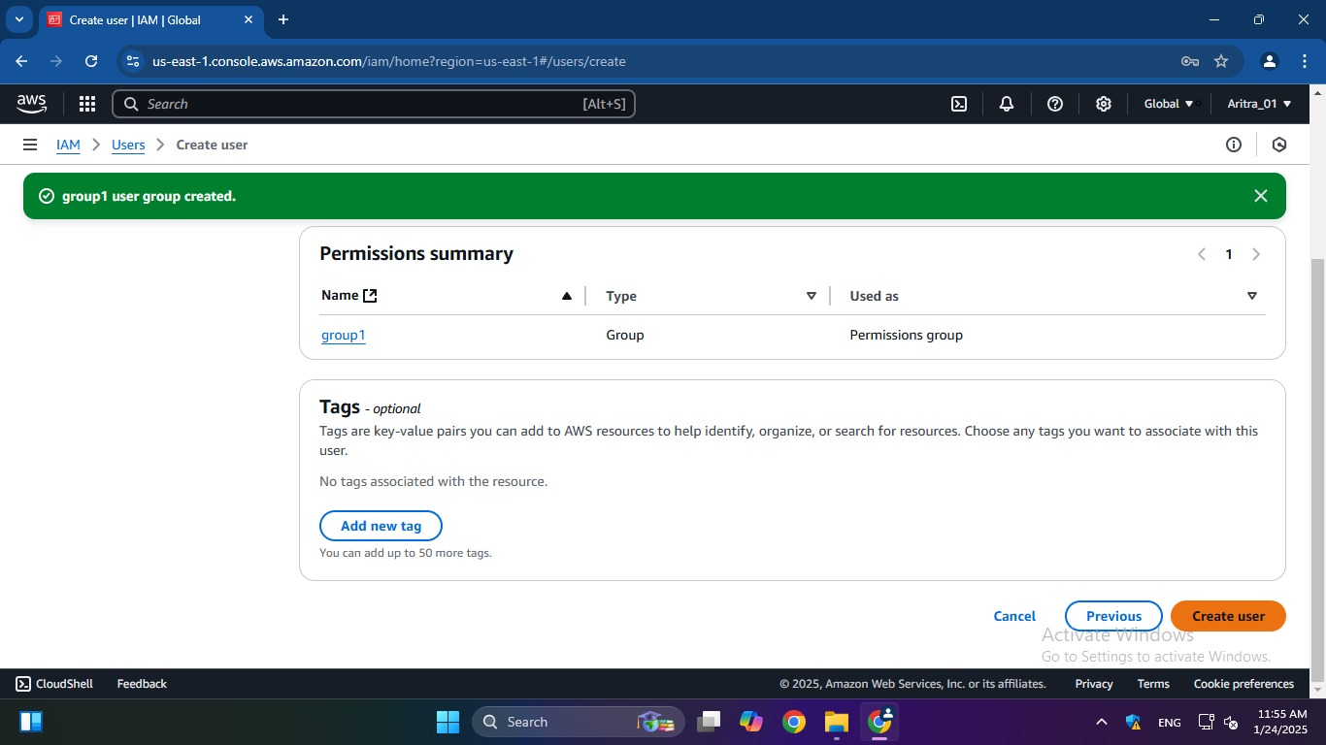

8. IAM user is created successfully.

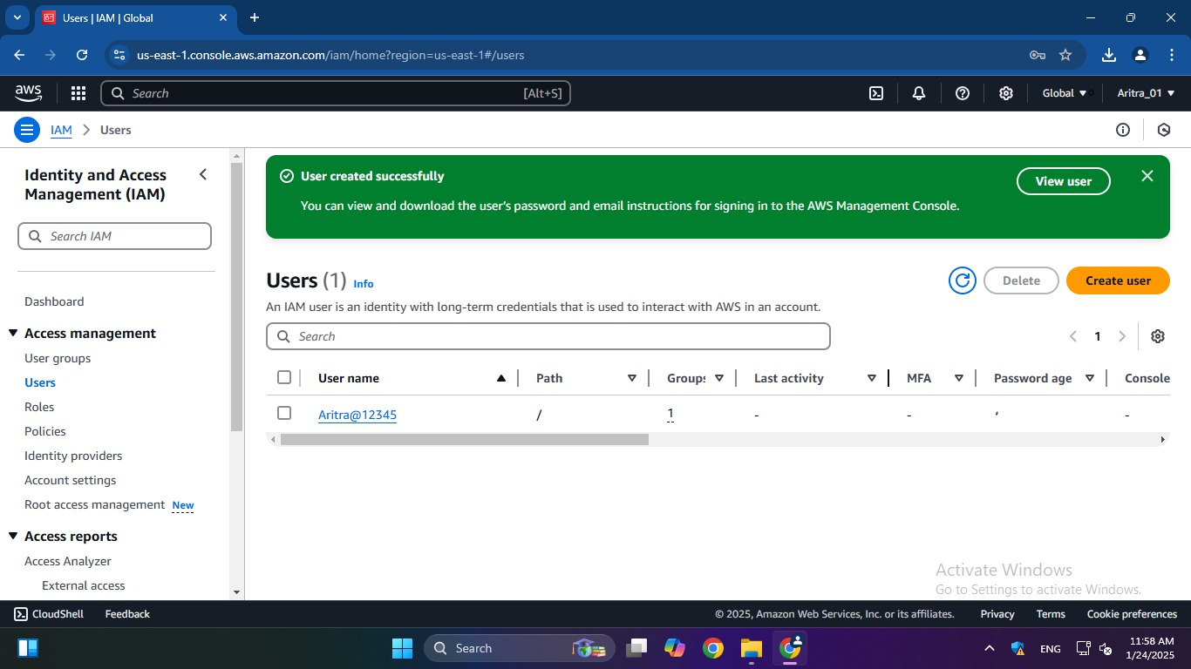

**ASSIGNMENT 4:**

**Problem Definition:** Create a private bucket in AWS. Upload a file and check by reassigned URL whether you can access the file or not

**Instructions:**

1. Access the ***AWS console***, search for ***S3***, and select the top option

from the search results.

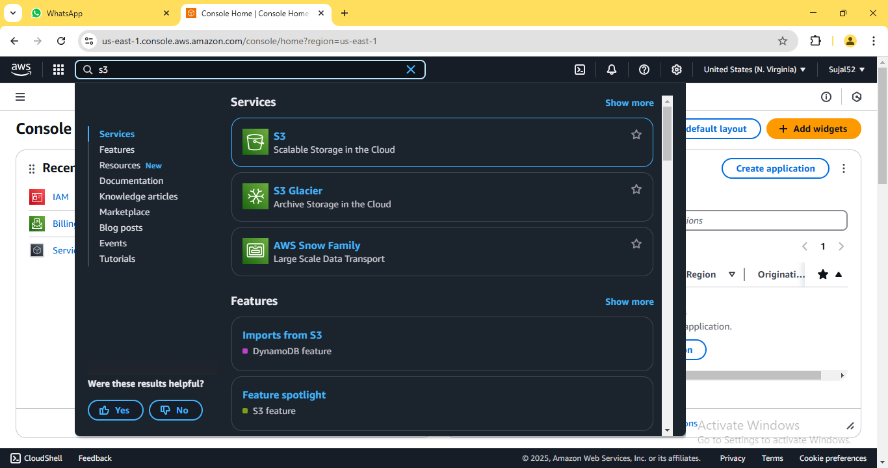

2. Click on ***“Create bucket”***.

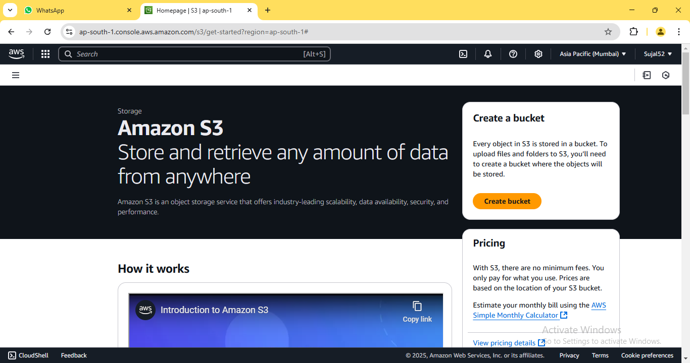

3. Enter bucket name. Leave the other options set to default as we are

creating a private bucket. Then click on ***“Create bucket”***.

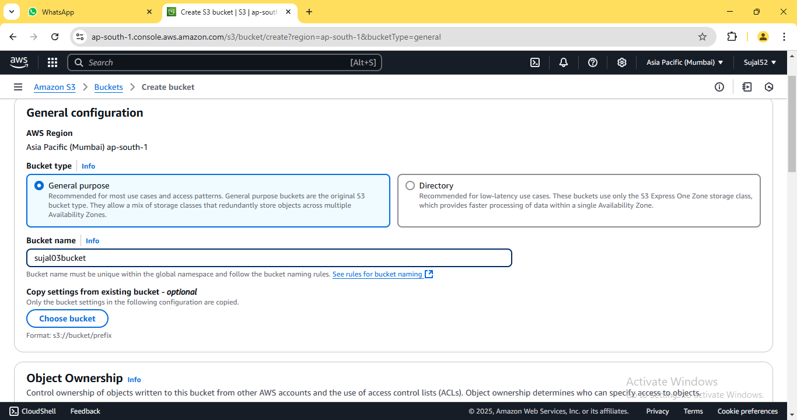

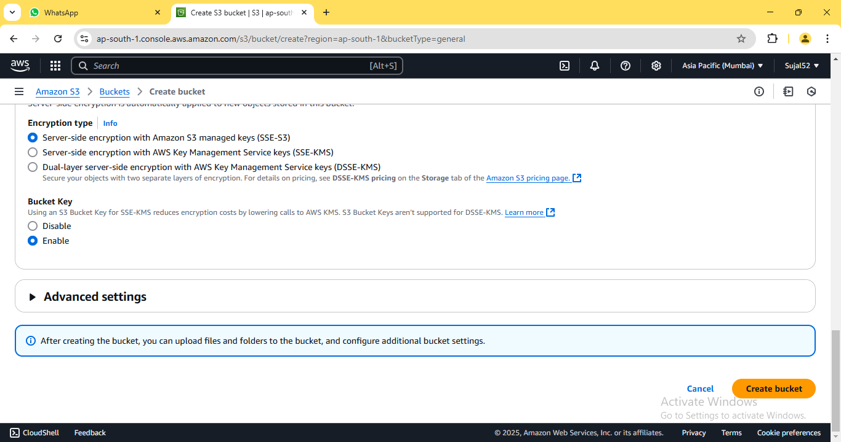

4. A green coloured pop-up dialogue box shall confirm the creation of

our bucket. It shall also be displayed on the bucket list.

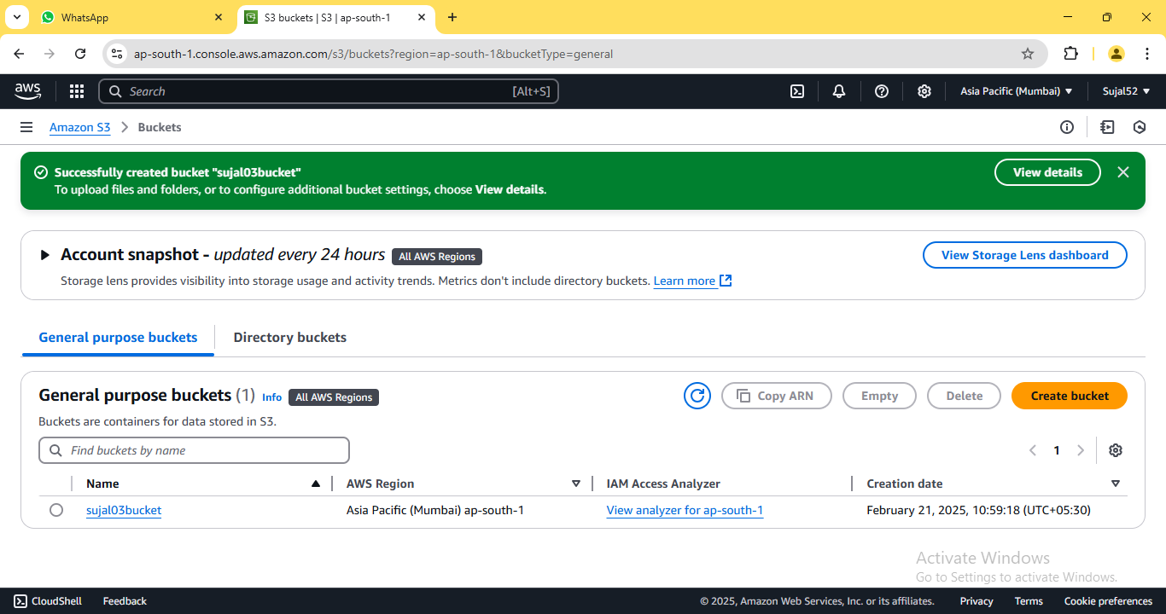

5. Click on the name of our newly created bucket. On the bucket

detail page, click on ***“Upload”***.

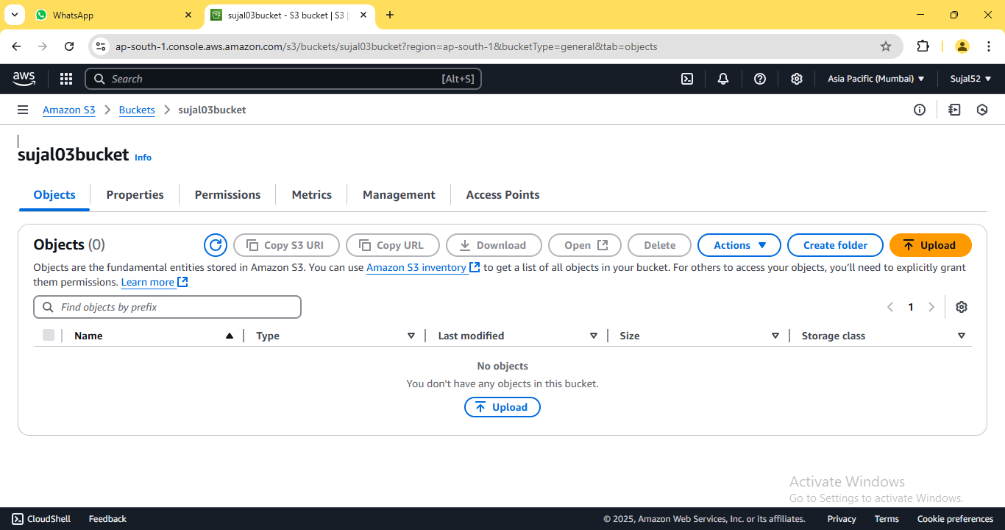

6. Click on ***“Add files”*** then select the file we want to upload to our

bucket. Select our file from the list and click on ***“Upload”*** button.

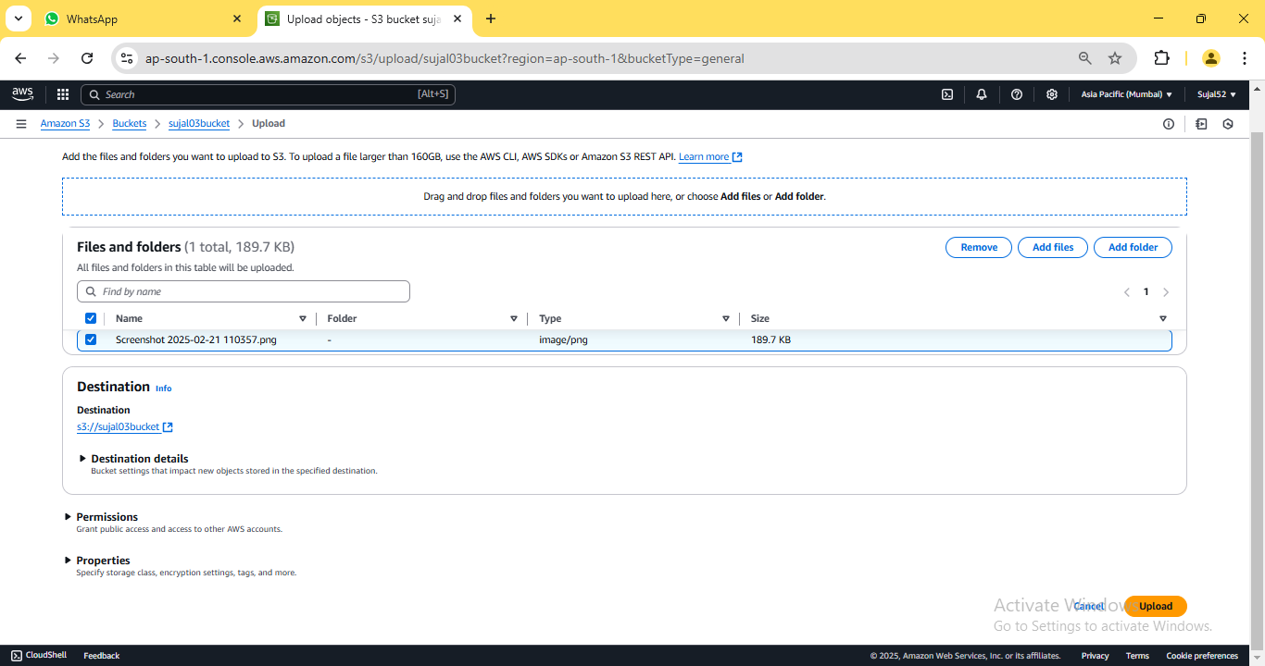

7. The notification confirms that the file has been successfully

uploaded. Click on ***“Close”*** to return to our bucket details page.

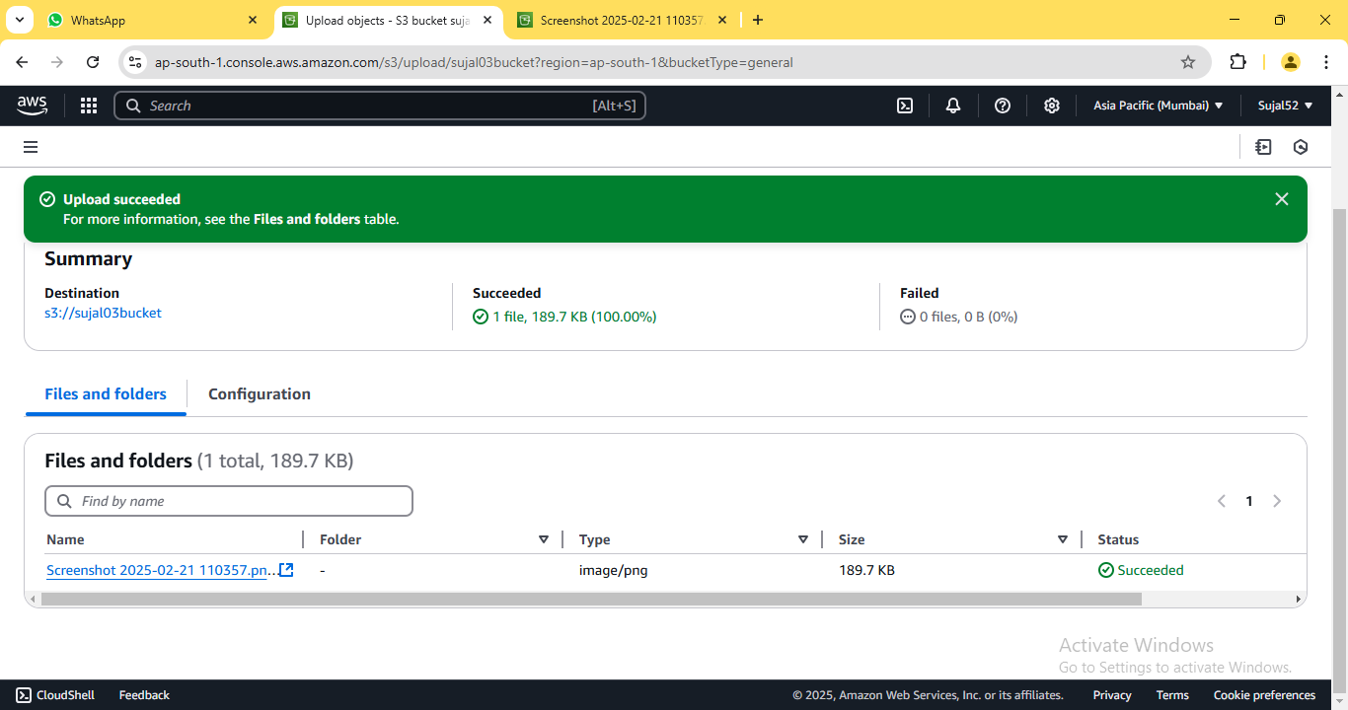

8. Click on our previously uploaded file from the list. Copy the ***“Object***

***URL”*** from the file details page that appears.

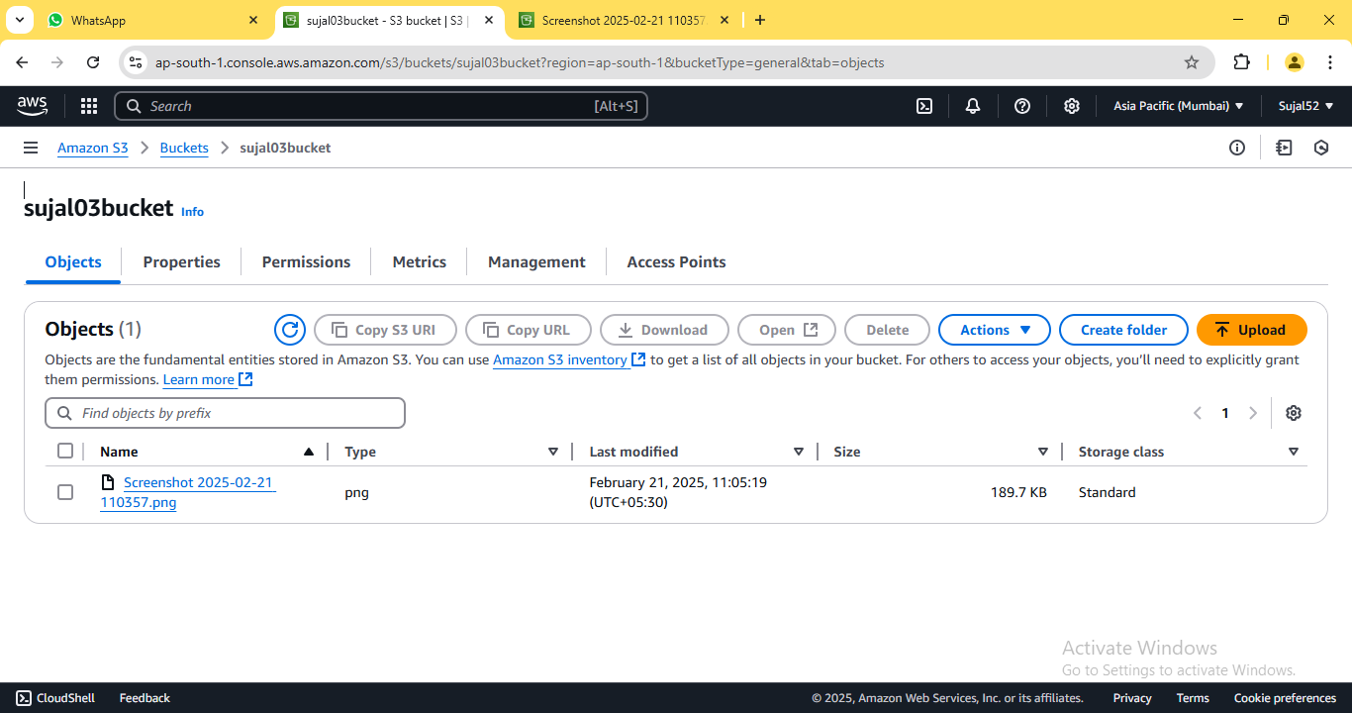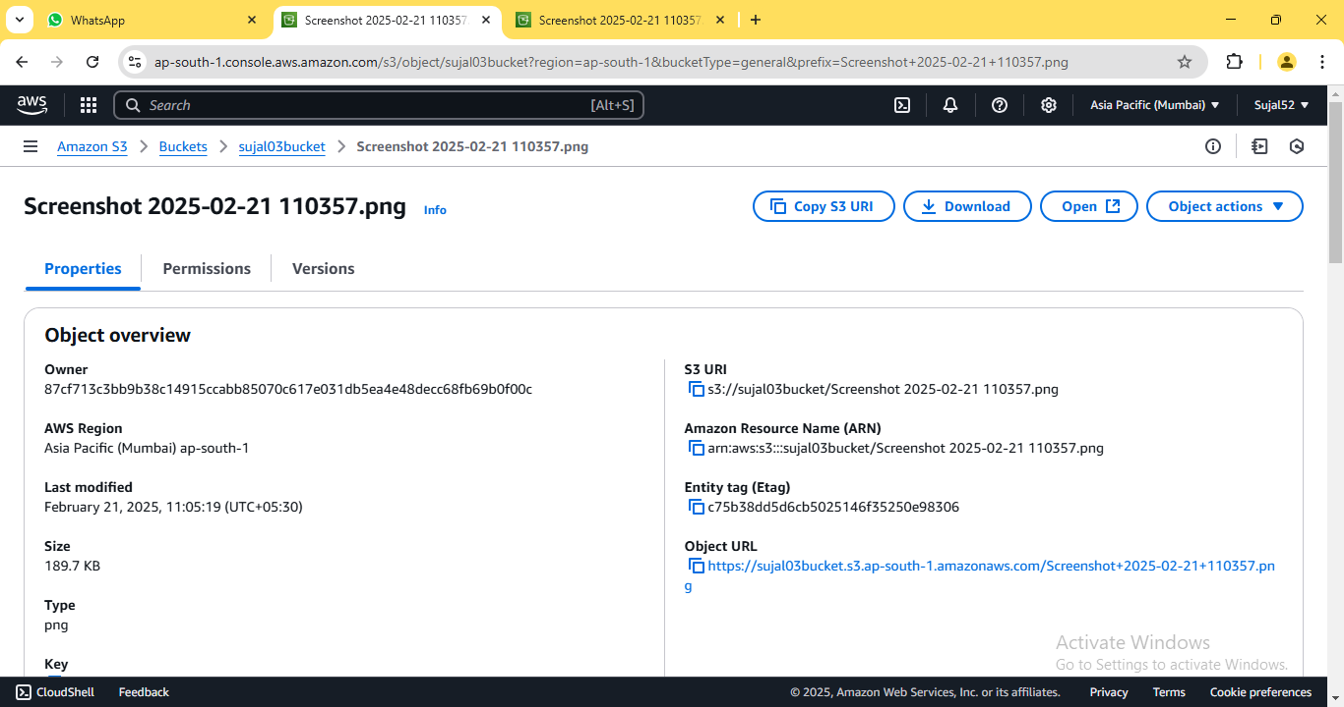

9. Open the copied URL in a new browser window. An error appears

indicating that access to the contents is restricted since this is a

private bucket.

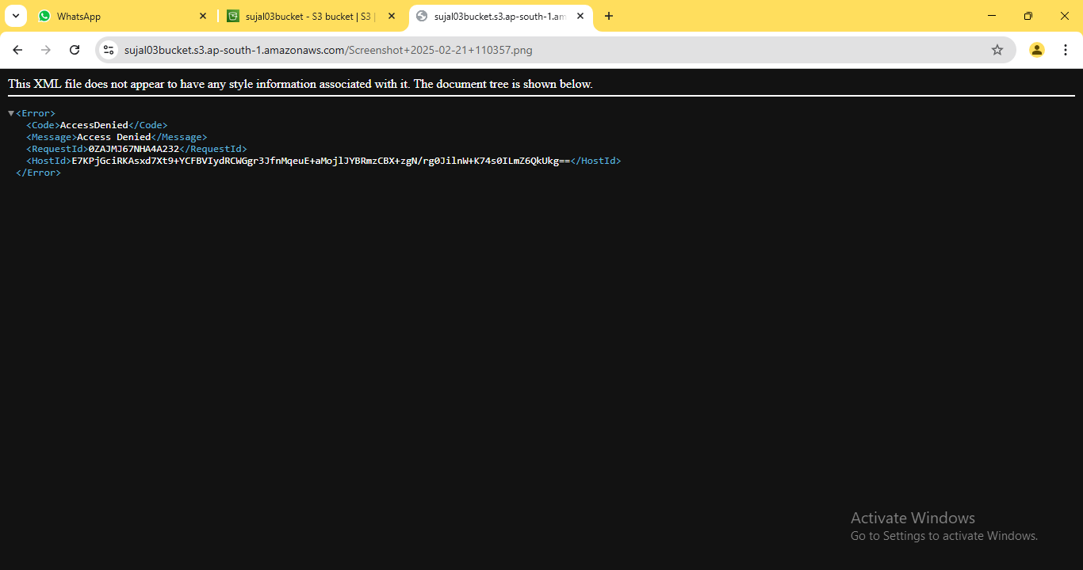

10. Go back to bucket details page, select our file from the list, click

on ***“Actions”*** and select ***“Share with a presigned URL”*** from the

dropdown.

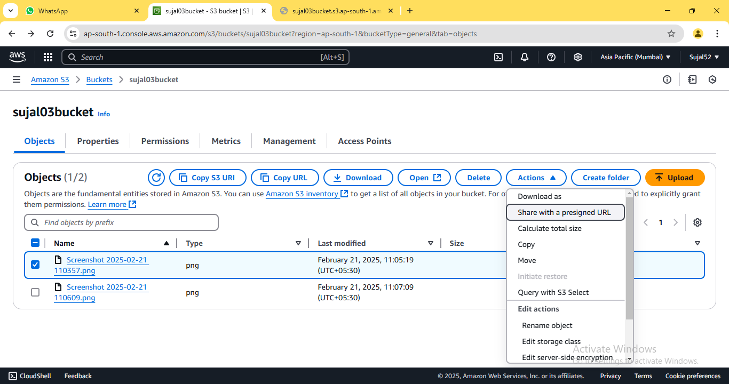

11. Select the desired duration until you want the presigned URL to

expire then click on ***“Create presigned URL”***.

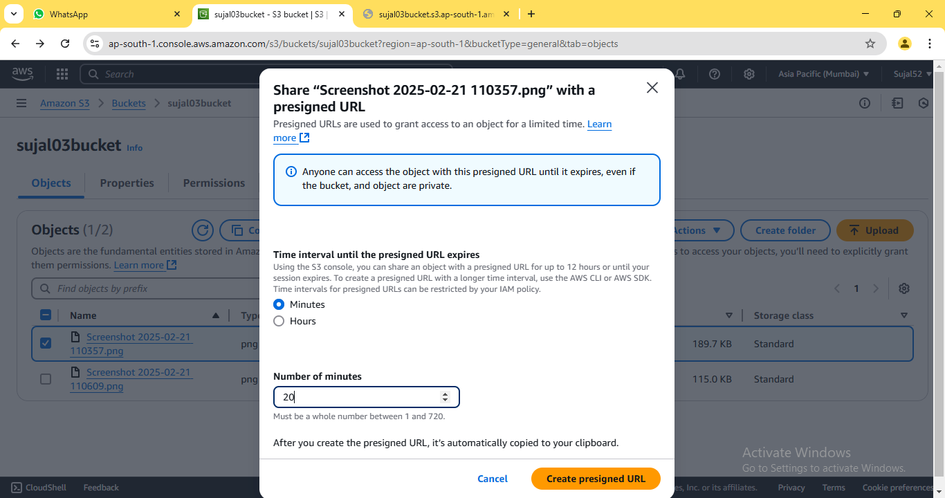

12. Copy the pre-assigned URL and paste it on a new window. Now,

you can view the uploaded file.

**ASSIGNMENT 5:**

**Problem Definition:** Create a public Bucket in AWS. Upload a file and give the necessary permission to check whether file the URL is working.

**Instructions:**

1. Access the ***AWS console***, search for ***S3***, and select the top option

from the search results.



2. Click on ***“Create bucket”***.



3. Enter bucket name. Select ***“ACLs enabled”*** since we are creating a

public bucket.

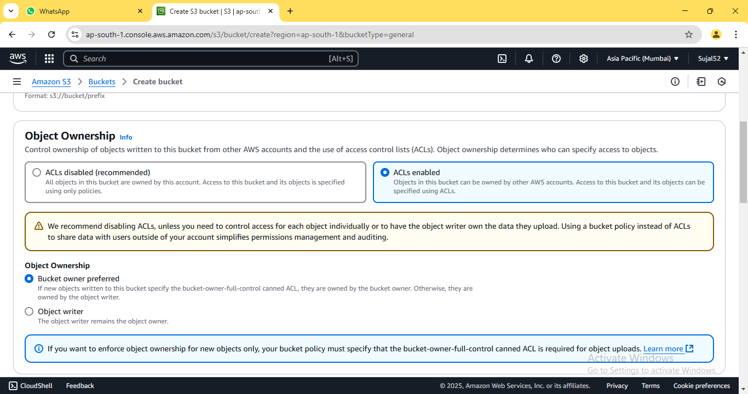

4. Now, uncheck the box for ***“Block all public access”***. At the bottom

of the window, check the box confirming that the current setting

changes may result in a public bucket.

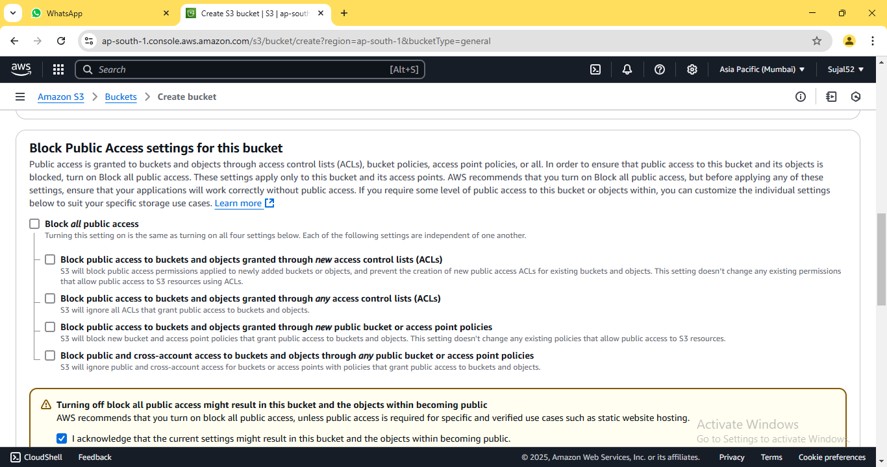

5. Scroll down without any further modifications and proceed to click

on ***“Create Bucket”***.

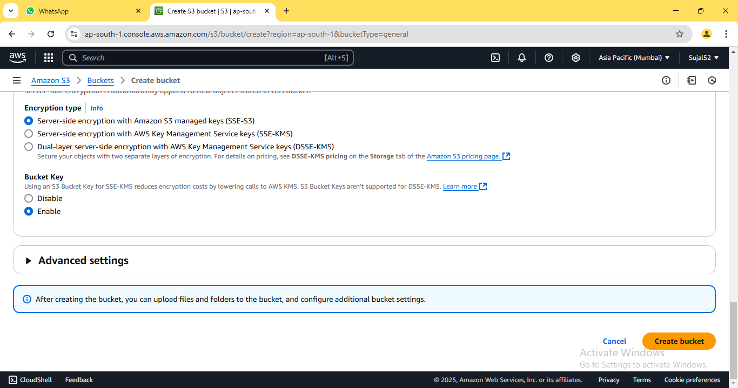

6. A green coloured pop-up dialogue box shall confirm the creation of

our bucket. It shall also be displayed on the bucket list.



7. Click on the name of our newly created bucket. On the bucket

detail page, click on ***“Upload”***.



8. Click on ***“Add files”*** then select the file we want to upload to our

bucket. Select our file from the list and click on ***“Upload”*** button.



9. The notification confirms that the file has been successfully

uploaded. Click on ***“Close”*** to return to our bucket details page.



10. Click on our previously uploaded file from the list. Copy the ***“Object***

***URL”*** from the file details page that opens.



11. Open the copied URL in a new browser window. An error appears

indicating that access to the contents is restricted since this is a

private bucket.



12. Go back to file details page and click on ***“Permissions”*** tab. Then

click on ***“Edit”*** button.

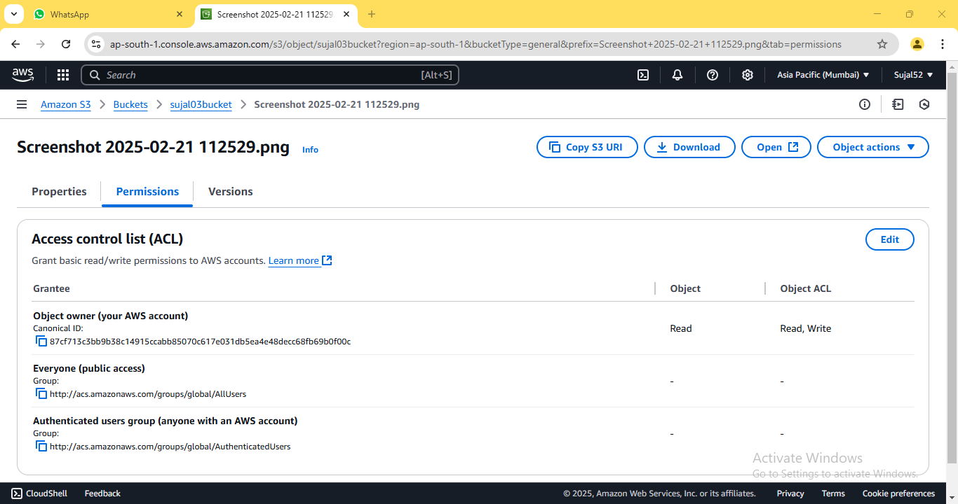

13. Edit the permissions as follow then click on ***“Save changes”***.

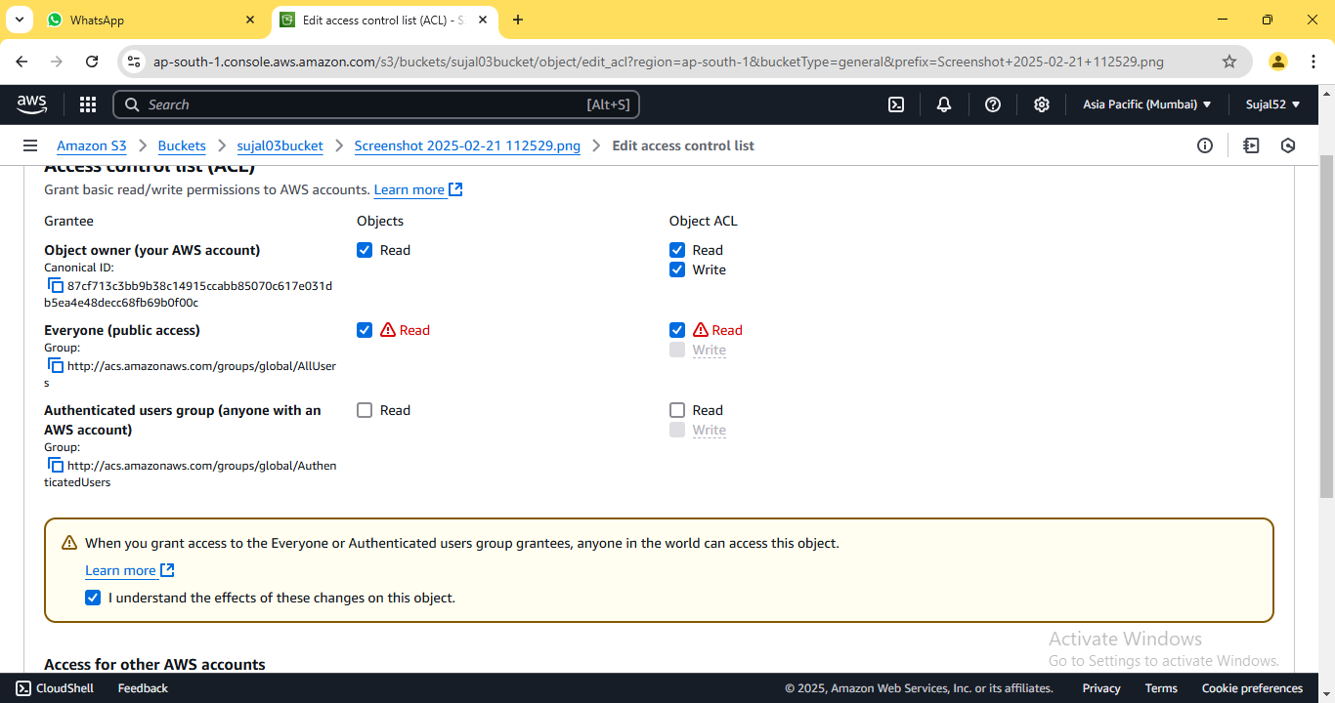

14. Copy the URL as mentioned previously and open it on new

window.

**ASSIGNMENT 6:**

**Problem Definition:** Upload a static website on S3.

**Instructions:**

1. Access the ***AWS console***, search for ***S3***, and select the top option

from the search results.



2. Click on ***“Create bucket”***.



3. Enter bucket name. Select ***“ACLs enabled”*** since we are creating a

public bucket. Uncheck the box for ***“Block all public access”.***

Leave other options as default and click on ***“Create bucket”.***



 

4. A green coloured pop-up dialogue box shall confirm the creation of

our bucket. It shall also be displayed on the bucket list.



5. Click on the name of our newly created bucket. On the bucket

detail page, click on ***“Upload”***.



6. Click on ***“Add files”***. Select our html files from the list. Expand

***“Permissions”*** tab, select ***“Grant public read access”*** and check

the confirmation popup. Finally, click on ***“Upload”*** button.

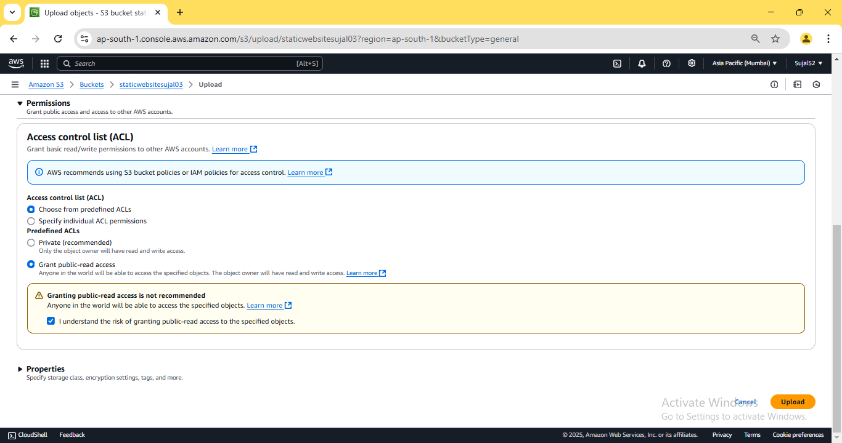

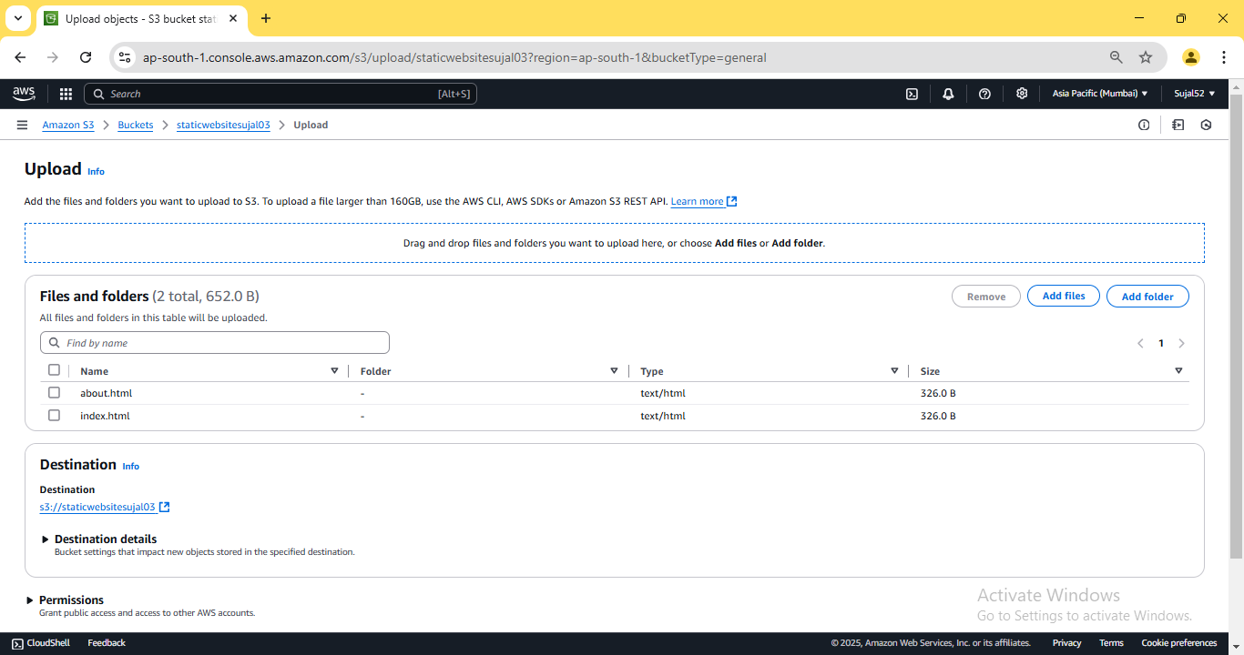

7. The notification confirms that the file has been successfully

uploaded. Click on ***“Close”*** to return to our bucket details page.

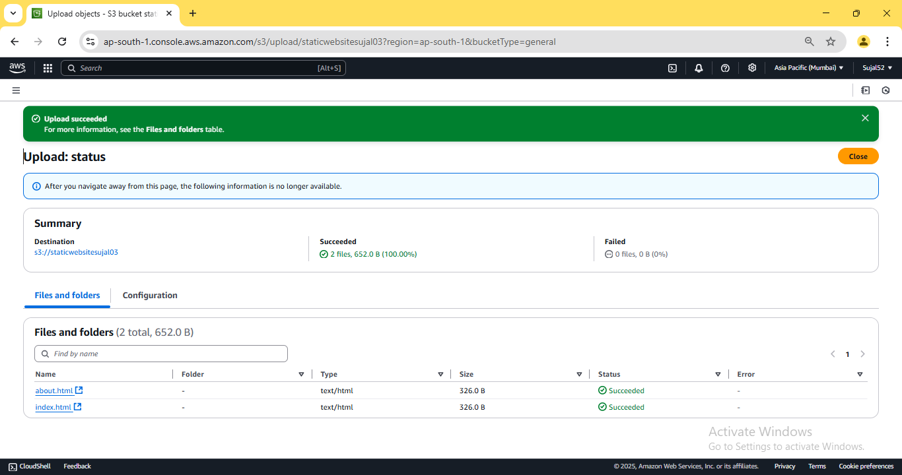

8. From the bucket details page, click on ***“Properties”*** tab, scroll down

and click on ***“Edit”*** next to ***“Static website hosting”***.

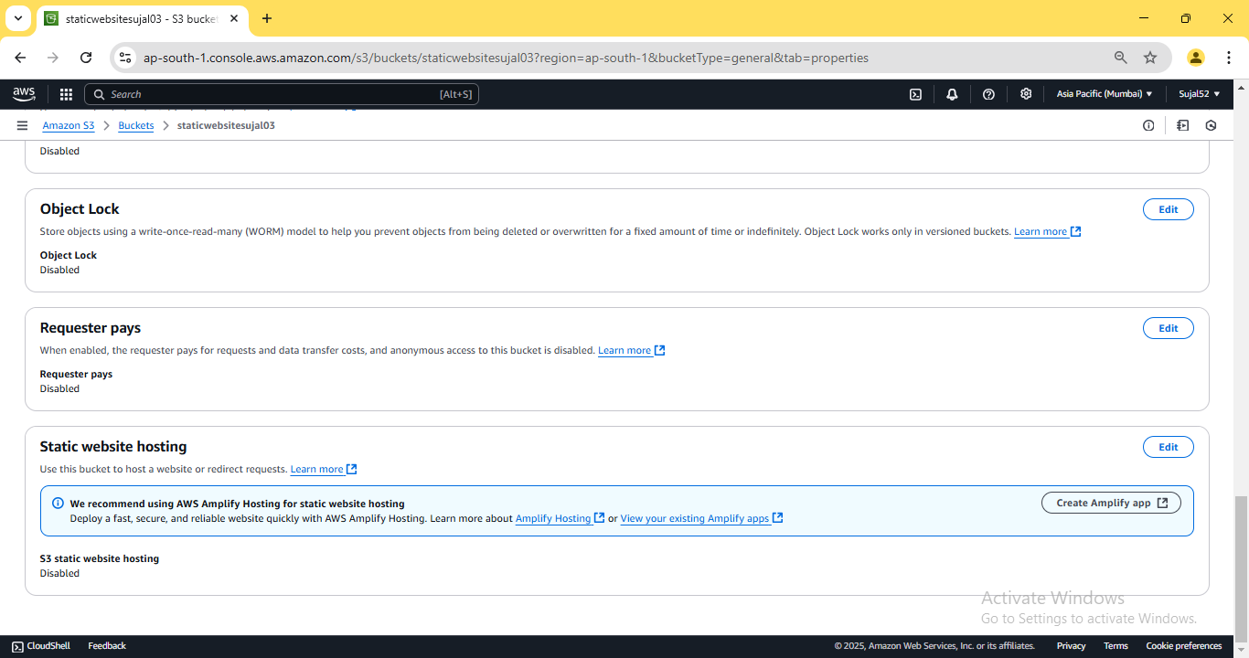

9. Under ***“Static website hosting”***, click on ***“Enable”***, then fill in the

name of index document and click on “***Save changes”***.

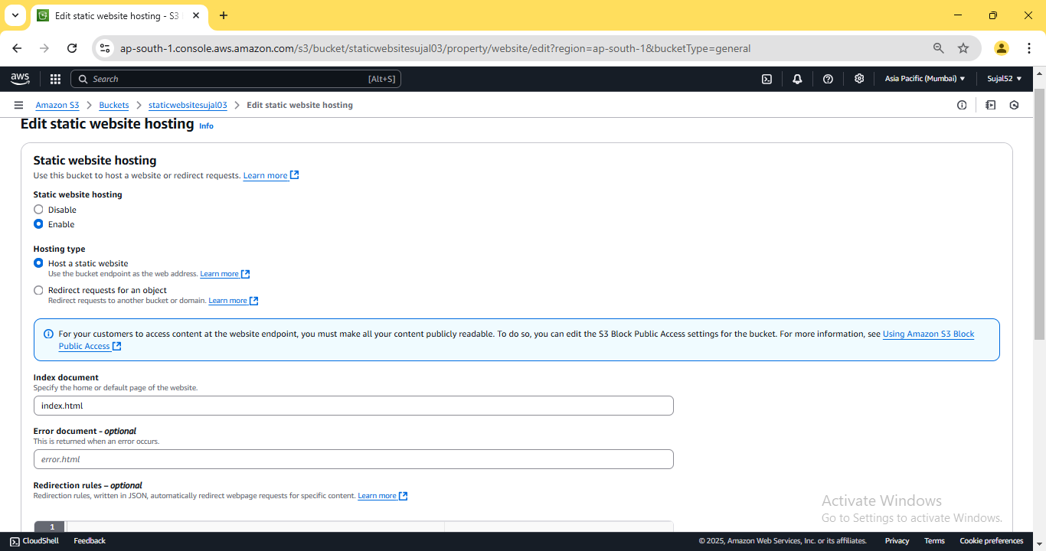

10. Once again, scroll down to ***“Static website hosting”*** and copy the

URL under ***“Bucket website endpoint”***.

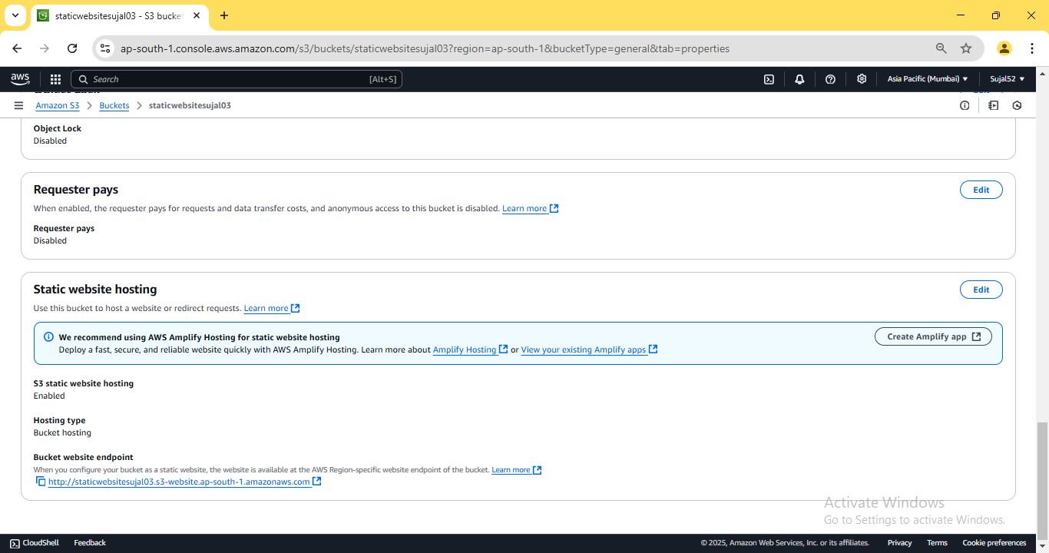

11. Open the copied URL in a new browser window. Our website

should be accessible now.

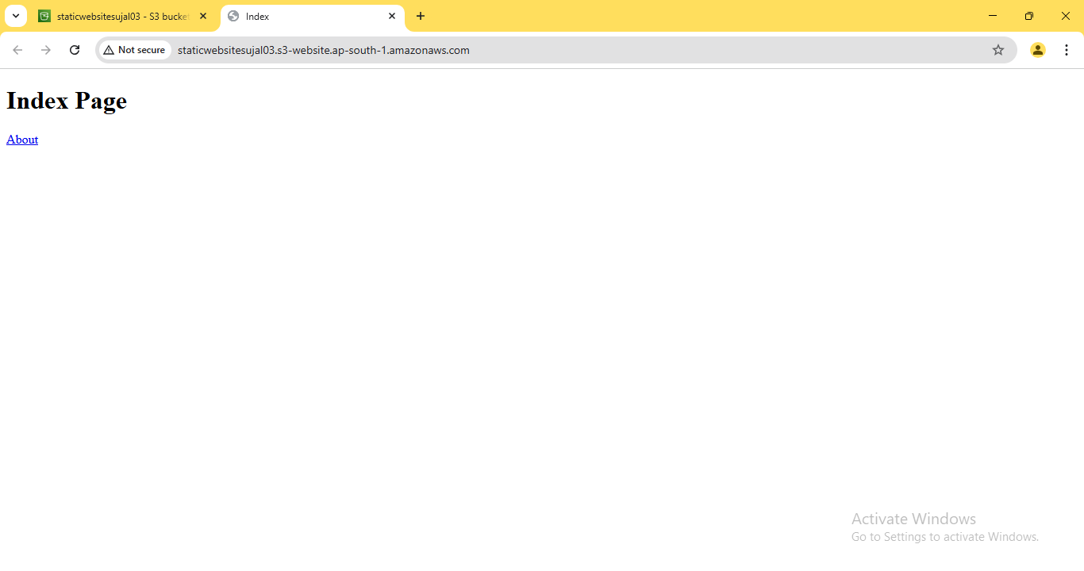

**ASSIGNMENT 7:**

**Problem Definition:** Hosting a website on EC2.

**Instructions:**

1. Access the ***AWS console***, search for ***EC2***, and select the top option

from the search results.

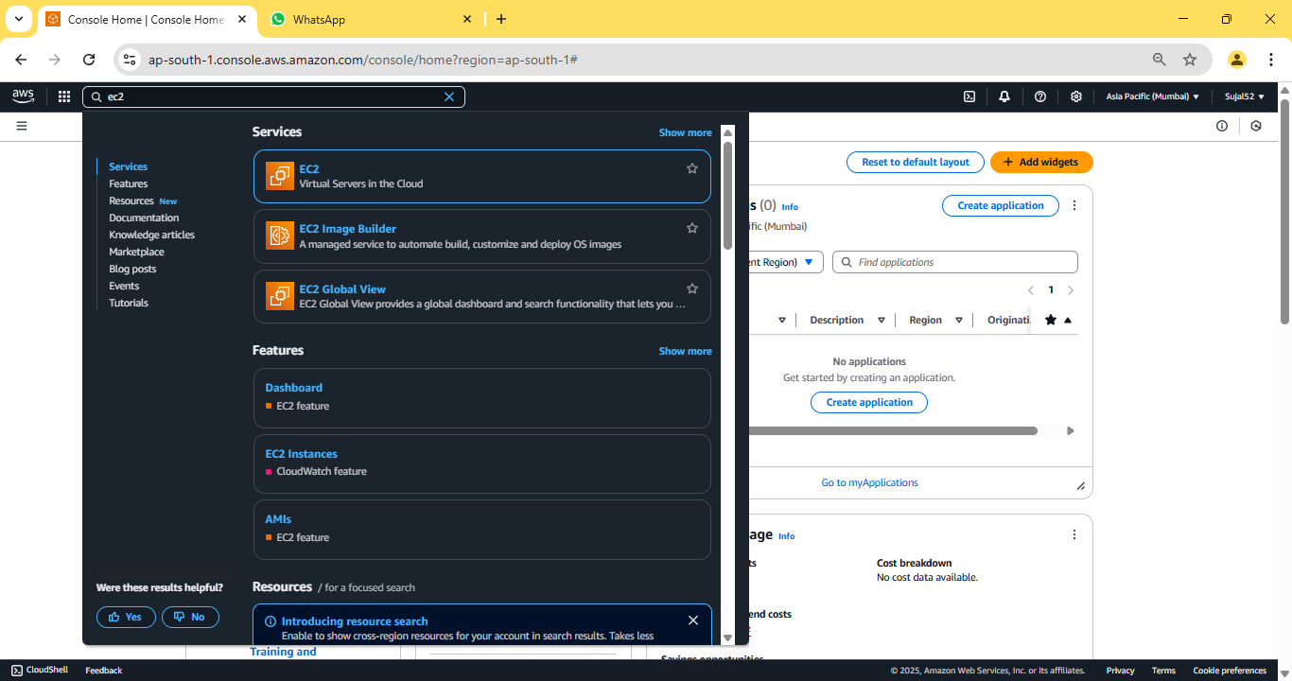

2. Click on ***“Launch instance”***.

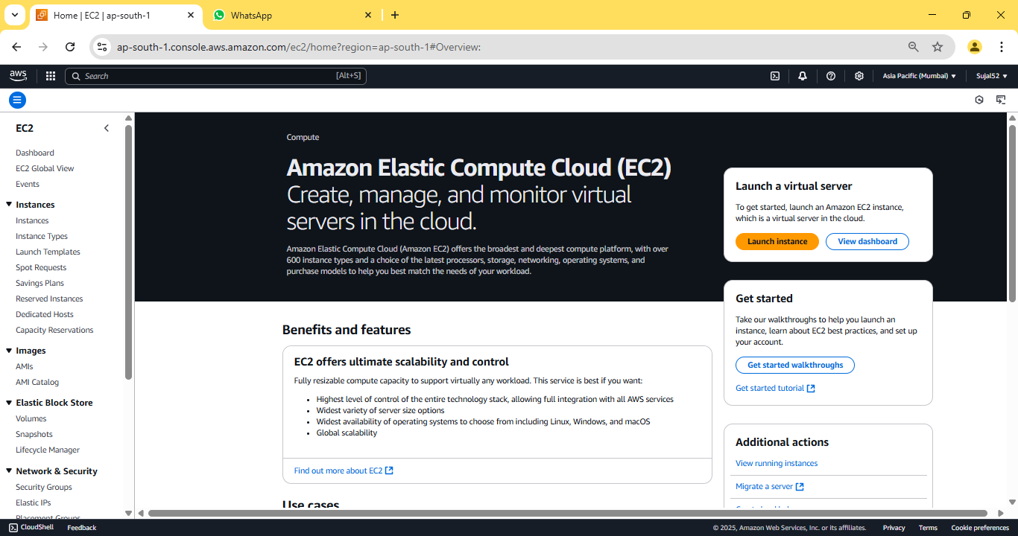

3. Enter instance name and select ***Ubuntu*** under ***“Application and OS***

***Images”.*** Under ***“Key Pair (login)”*** click on ***“Create new key pair”***,

enter key pair name then click on ***“Create key pair”*** button, a *.pem

file will be downloaded. Then click on ***“Launch instance”*** button

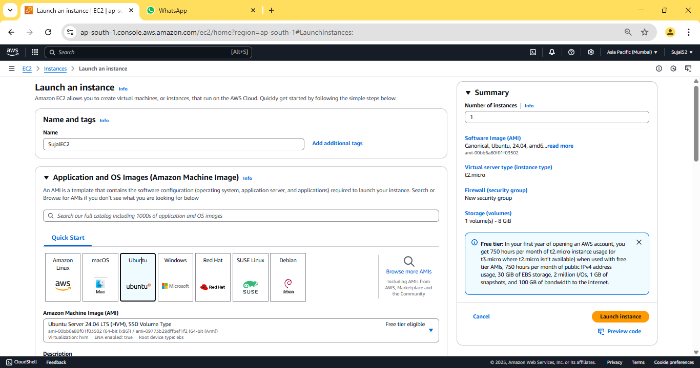

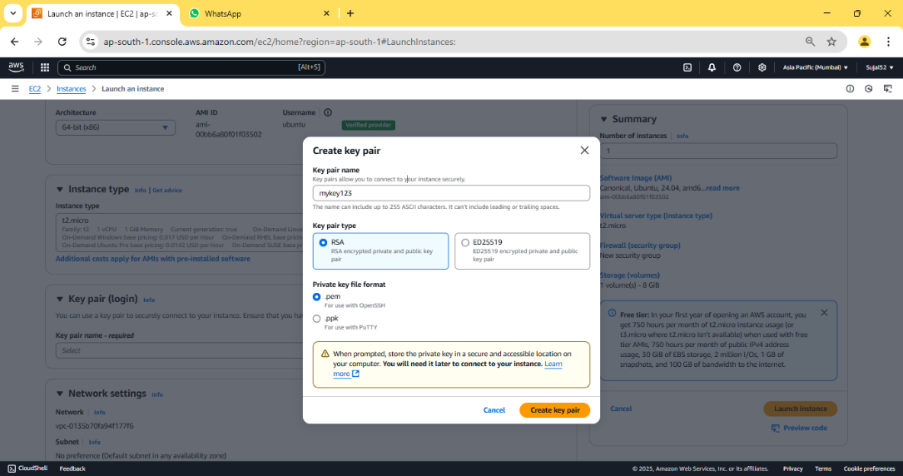

4. Our instance is created successfully.

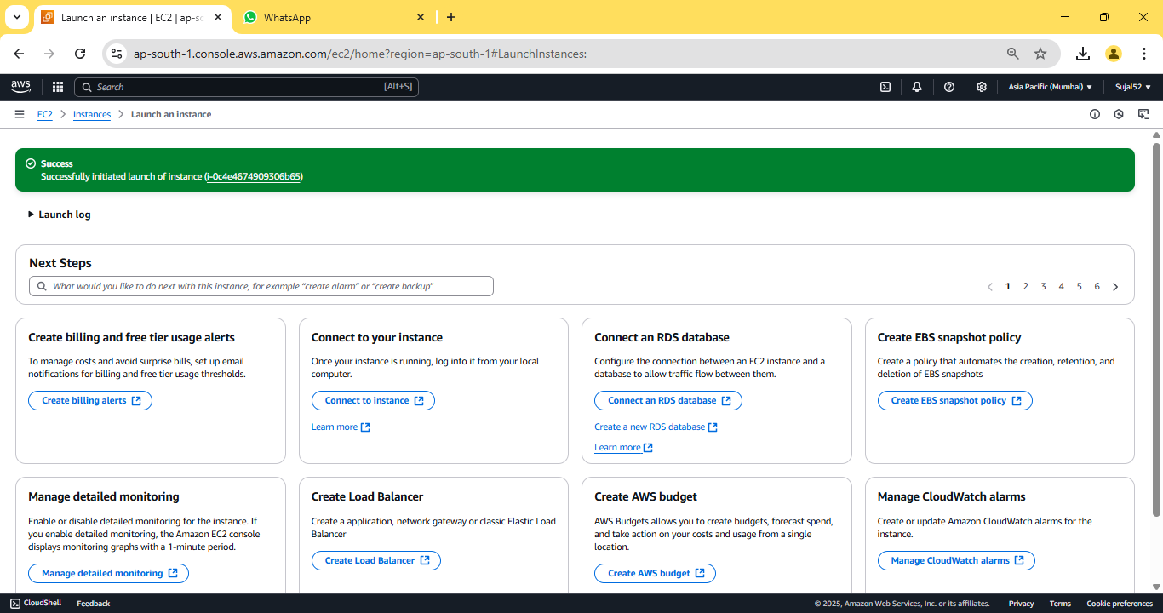

5. Go to ***“Instance”*** from the sidebar, then click on ***Instance ID*** of our

newly created instance.

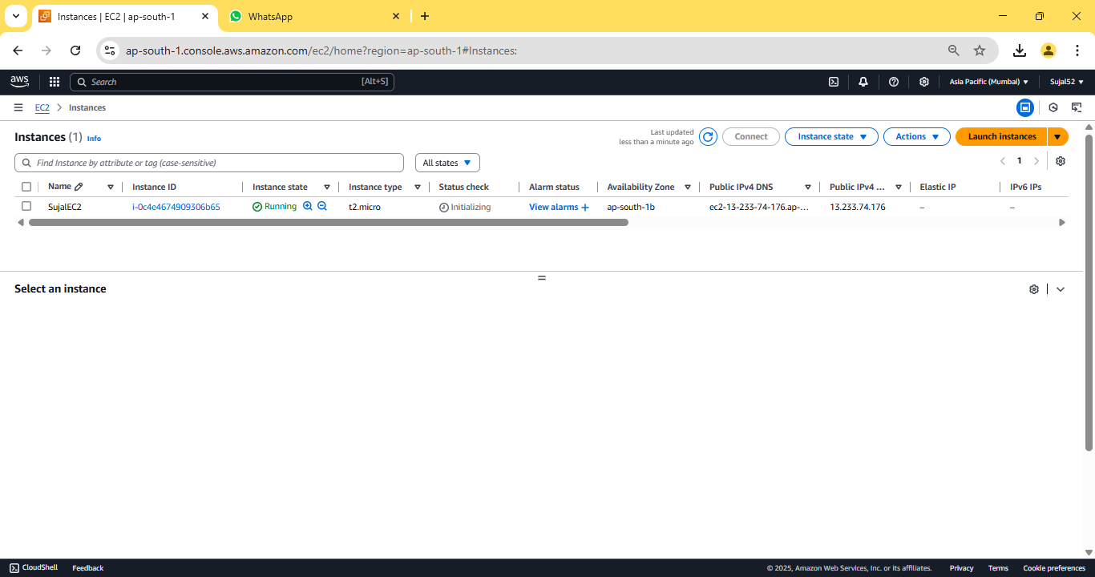

6. Copy ***“Public IPV4 address”***.

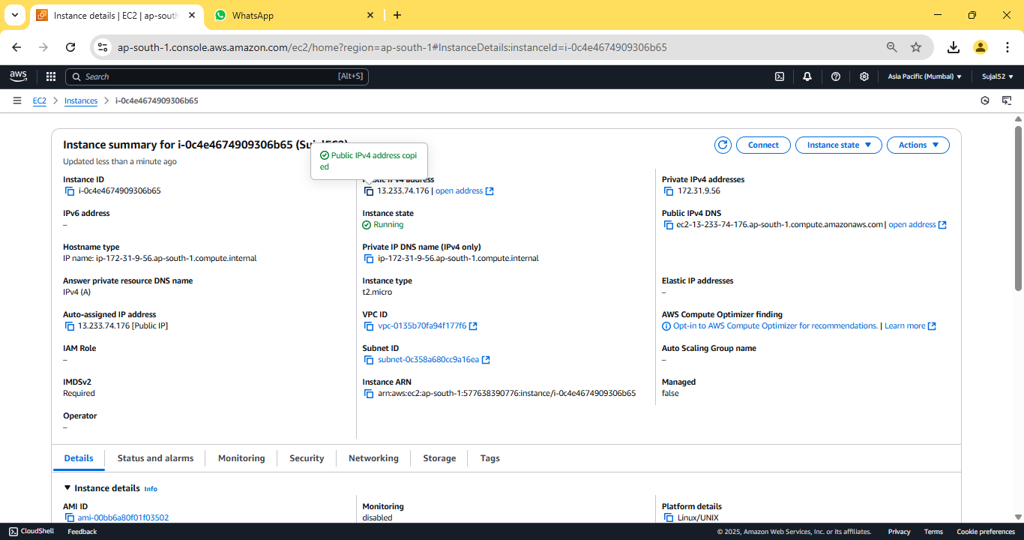

7. Open ***Bitvise SSH Client,*** paste the previously copied address in host

field.

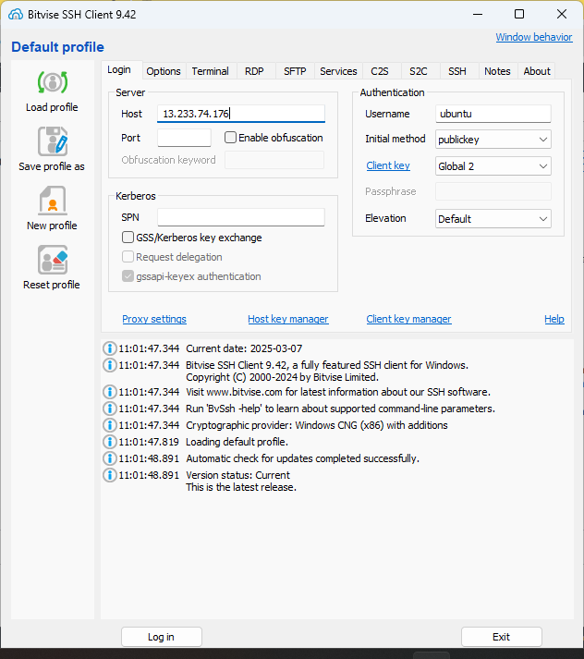

8. Click ***“Client key manager”,*** click on ***“Import”*** and select our

previously downloaded key pair file. Click on ***“Import”*** button. Our

key pair should be imported successfully.

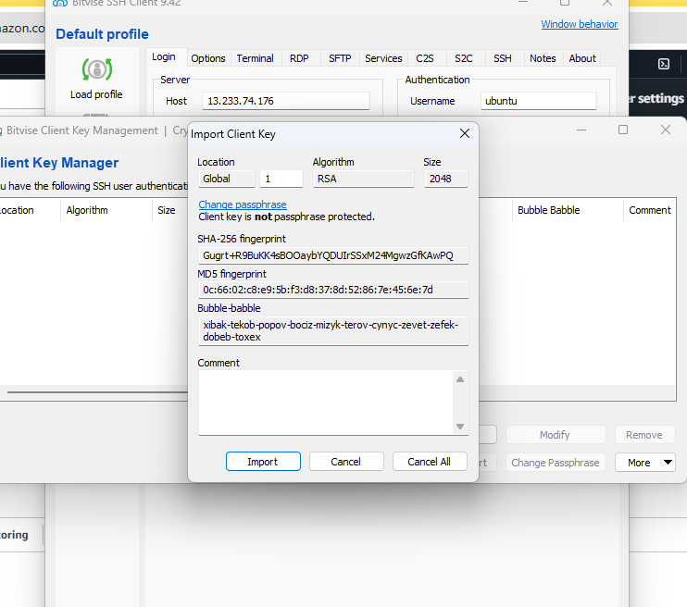

9. In ***“Bitvise SSH Client”***, under ***“Authentication”*** give the username

as ***“ubuntu”***, select ***“Global 1”*** under ***“Client Key”*** then

click on ***“Log in”*** & ***“Accept and save”***.

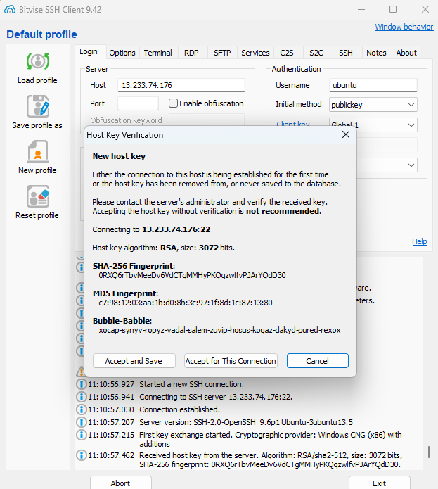

10. Click on ***“New terminal console”*** from the sidebar. In the terminal

enter the following commands:

sudo apt-get update && sudo apt-get upgrade

sudo apt-get install nginx

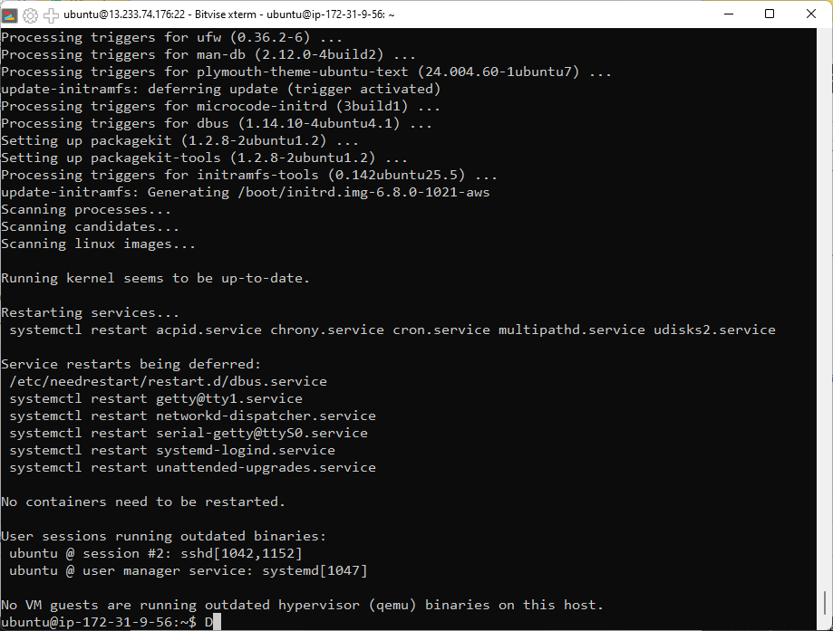

11. We need to move our html files into var/www/html directory to

host it, but first we need to give write permission to do so. To

change file permission enter the following command:

cd var/www/

sudo chmod 777 html

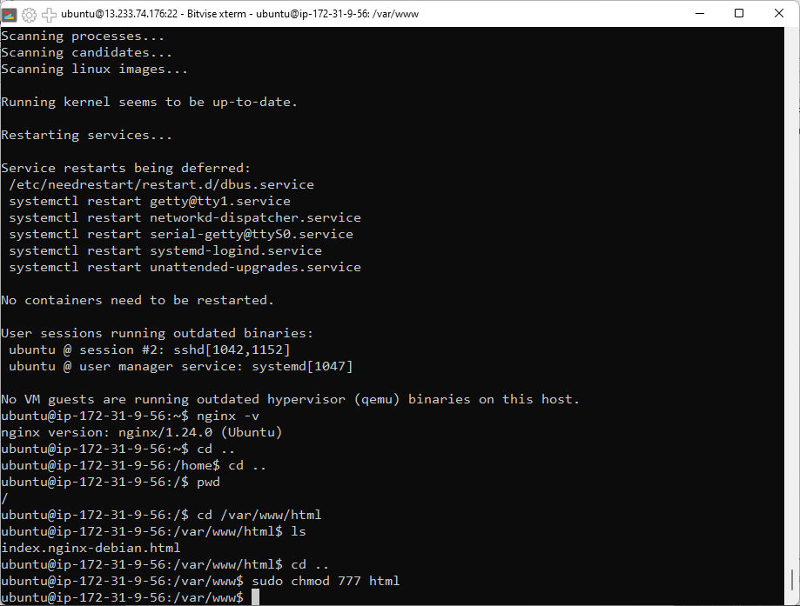

12. Go to SFTP window from the sidebar, under ***Local file*** open the

folder containing html files and under ***Remote file*** open

/var/www/html. Drag and drop the HTML files from local to remote.

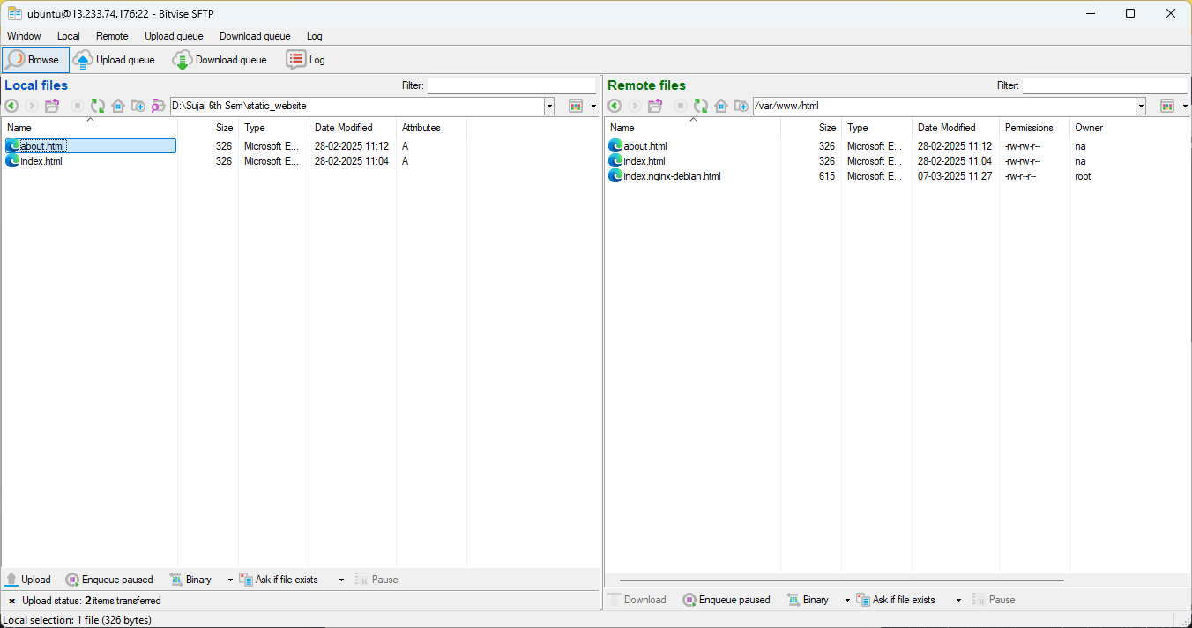

13. Now go back to the AWS window and copy the ***“Public IPV4***

***address”***.



14. Open the copied address in a new browser window. Our website

should be accessible now.

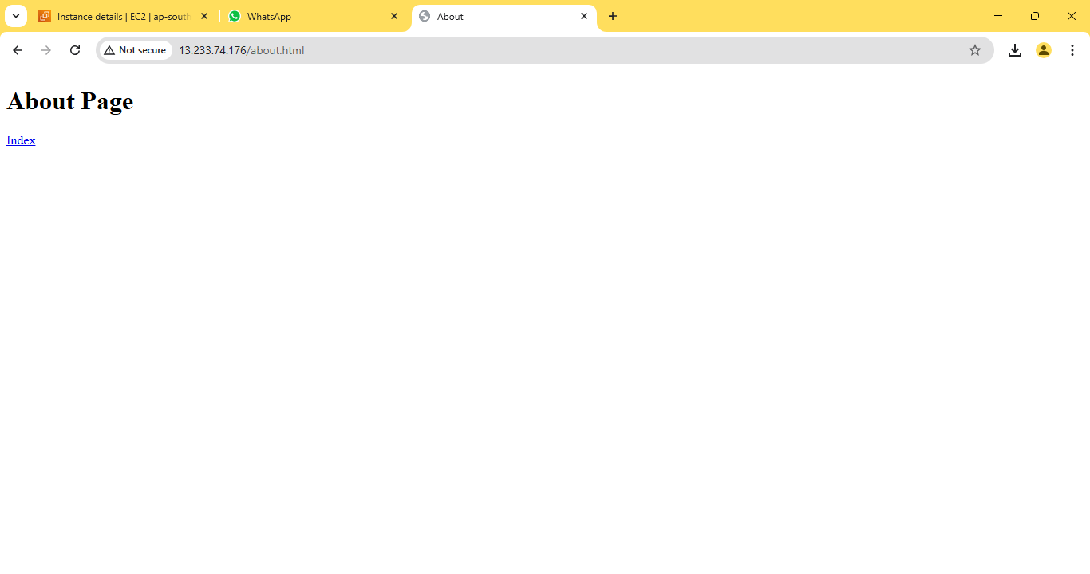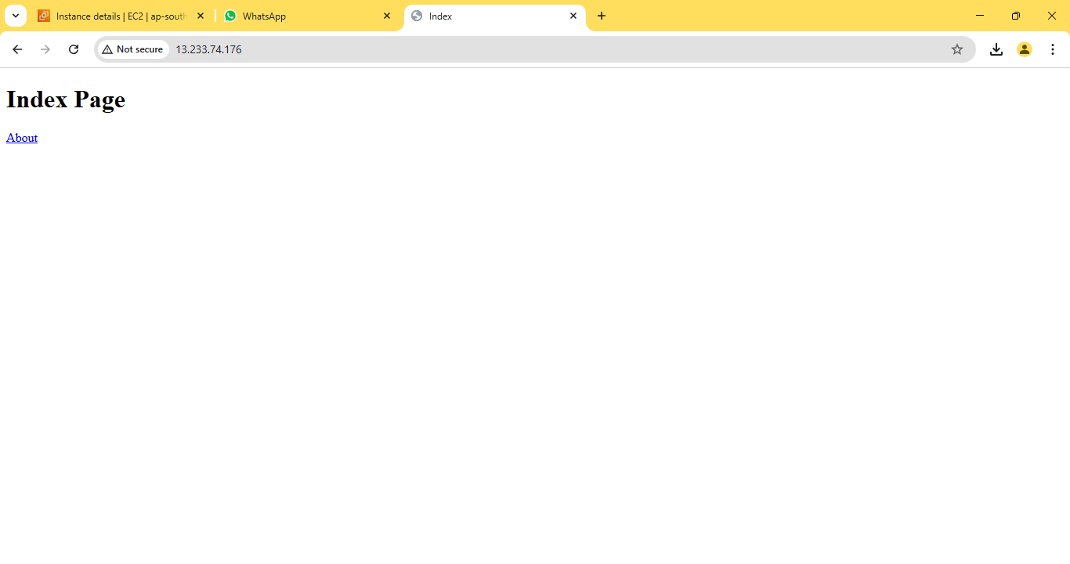

**ASSIGNMENT 8:**

**Problem Definition:** Deploy a project from a local machine to GitHub and vice versa.

**Instructions:**

1. Create a new public Github repository. Click on ***“Create repository”***

to proceed.

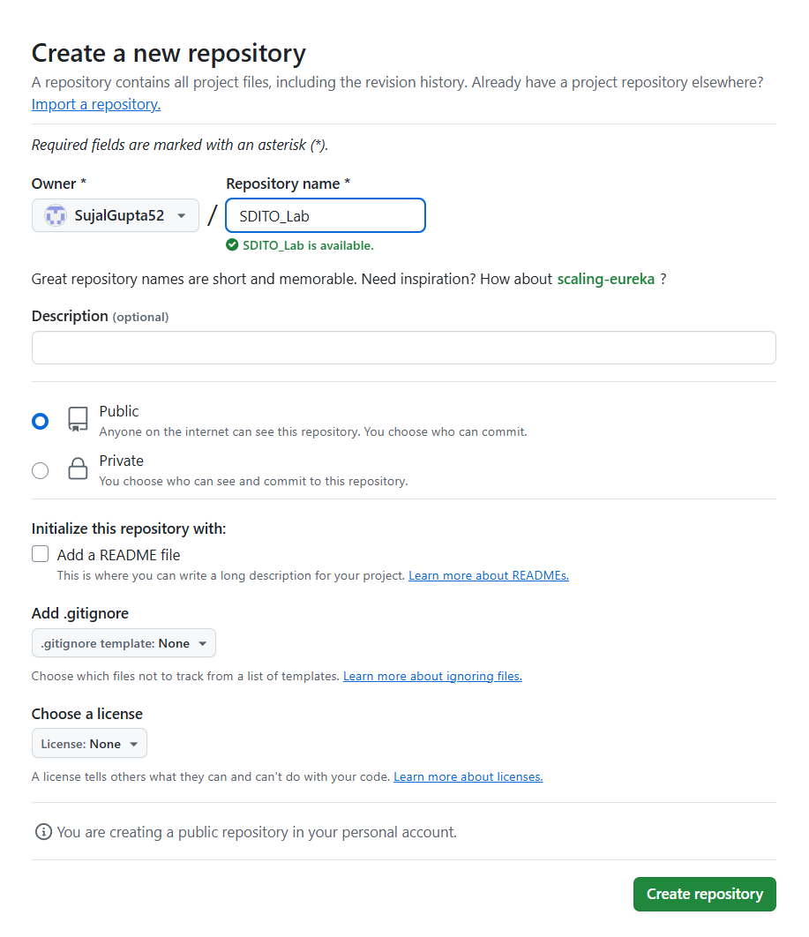

2. Go to ***Settings*** then ***Developer settings***. Now click on ***“Personal***

***access tokens”*** dropdown and then click on ***“Tokens(classic)”***.

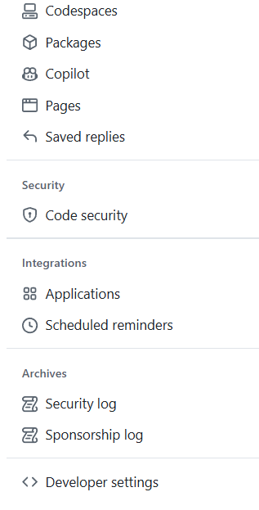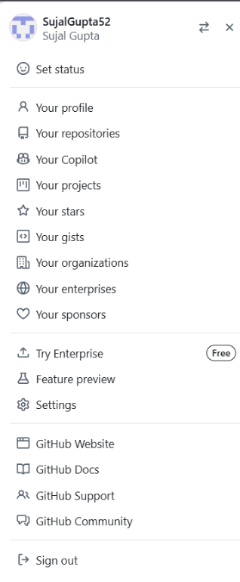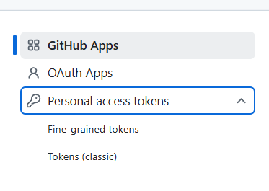

3. Now click on ***“Generate new tokens”*** and then ***“Generate new***

***token(classic)”***.

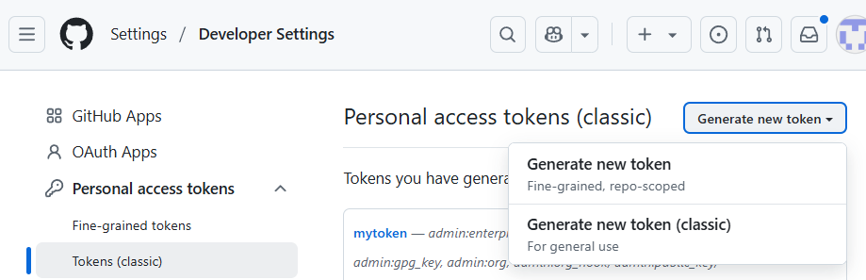

4. Set expiration date for as long as possible and select all scopes.

Then click on ***“Generate token”***.

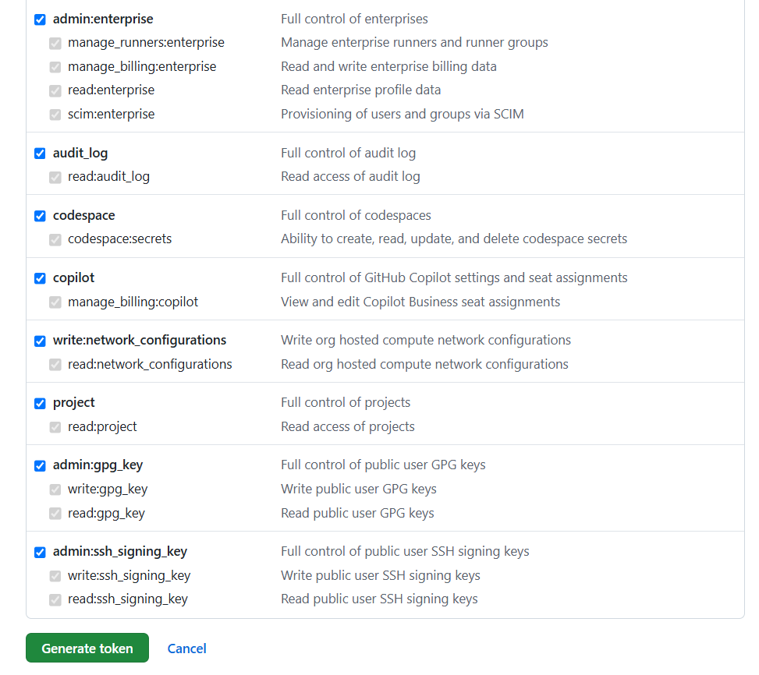 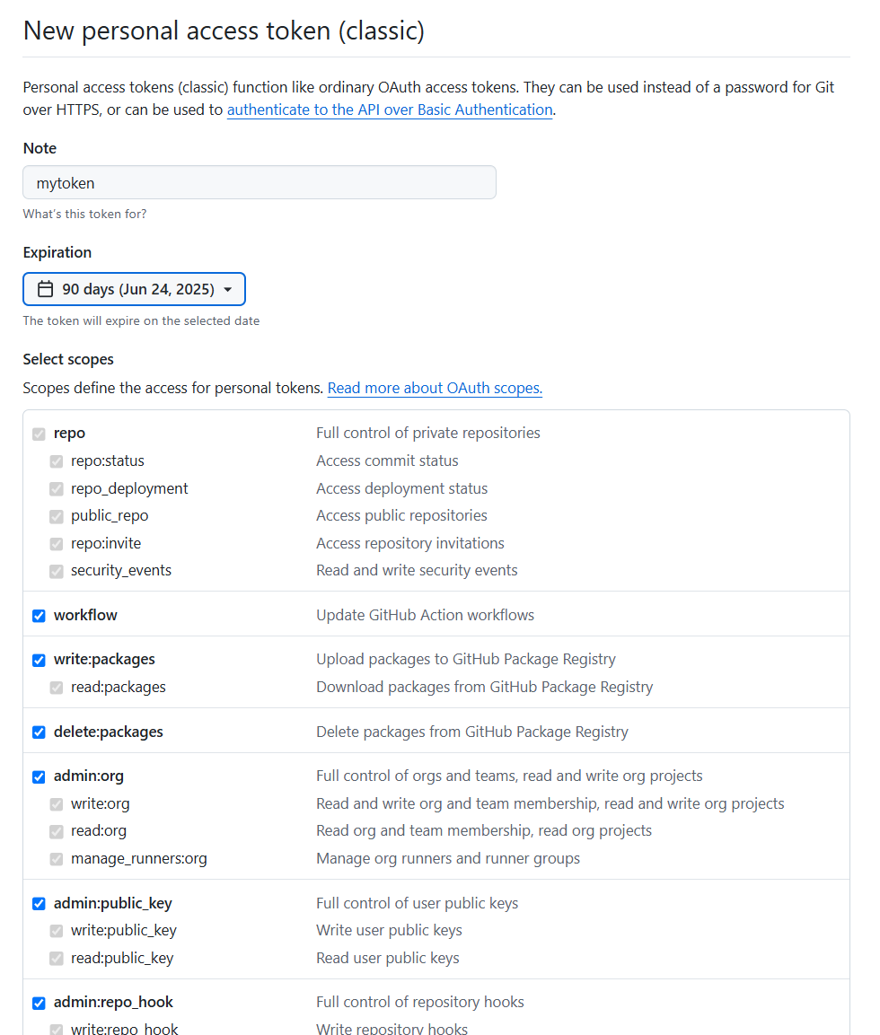

5. After generating the token, click on copy icon and copy the token

somewhere secure.

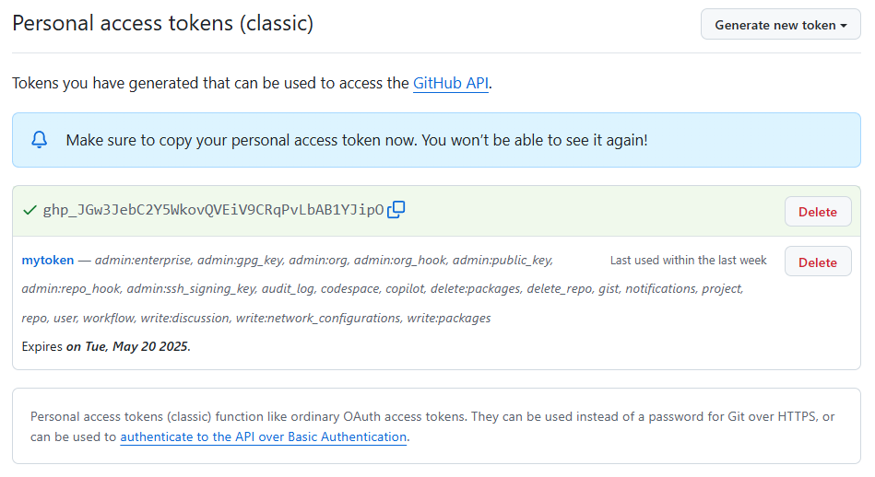

6. Now go to ***Control Panel***, click ***User’s account***, then go to ***Credential***

***Manager*** and click on ***Window Credentials***. From ***Generic***

***Credentials*** remove any existing GitHub account credentials.

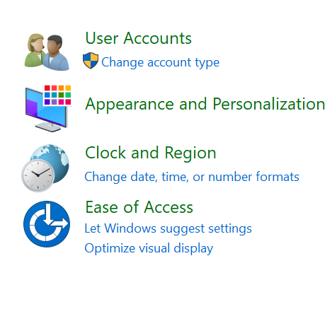 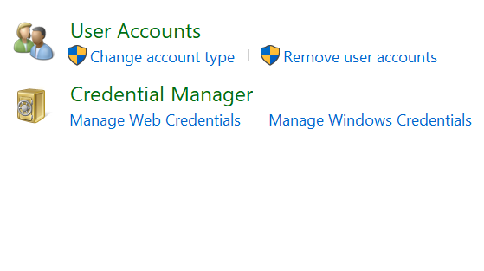

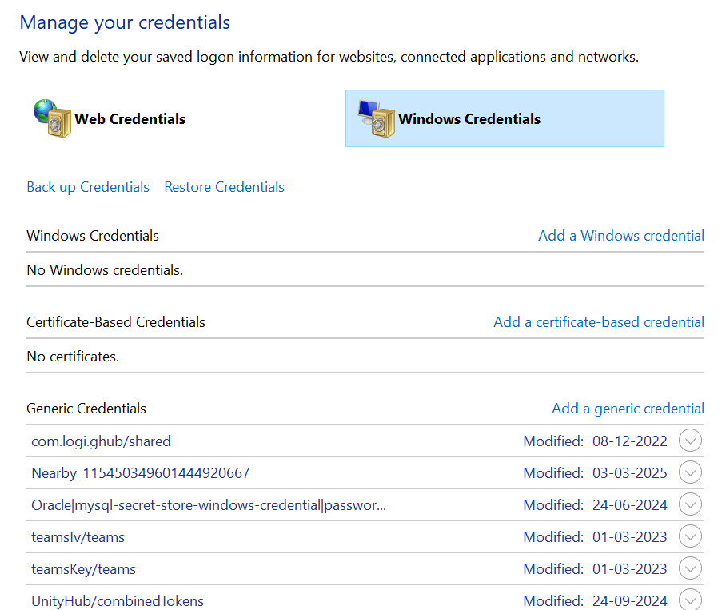

7. Go to the folder containing your project files. Right Click, and select

***“Open Git Bash Here”*** from the pop-up menu.

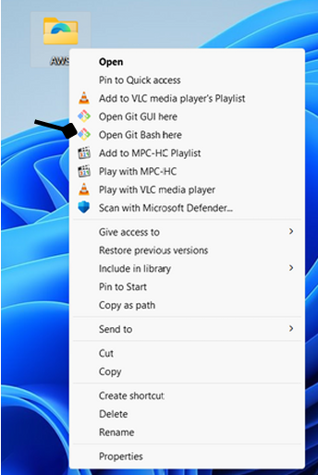

8. Run the following commands:

git init

git add .

git status

git config --global user.email <user email address>

git config --global user.name <username>

git commit -m “<message>”

git push -u origin master

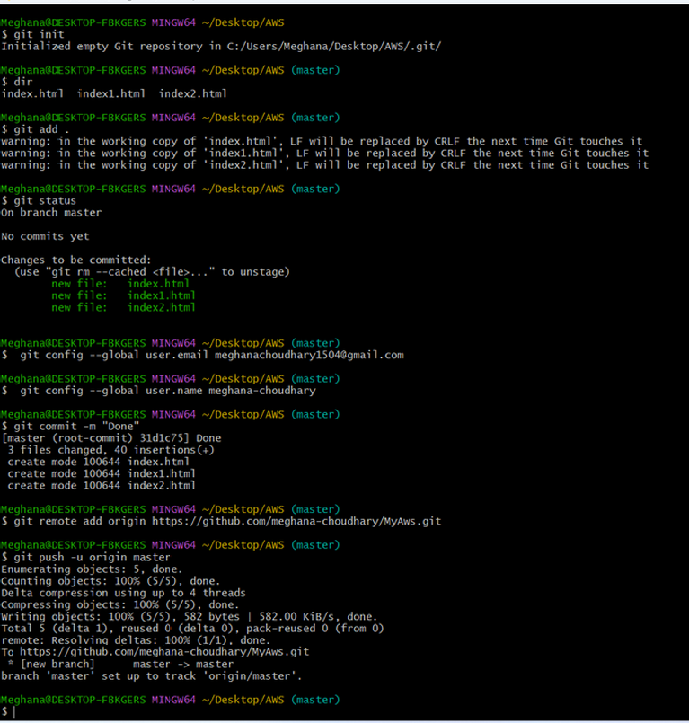

9. After the last command, a new ***“Connect to GitHub”*** window should

open. Go to ***“Token”*** tab and paste the previously generated token

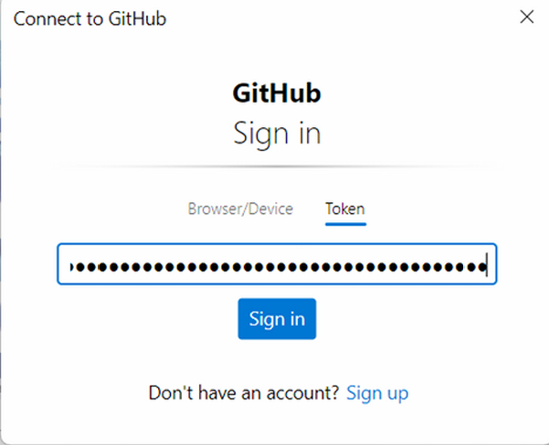 into the text field. Click on ***“Sign in”*** button.

10. Open the repository in **Github**. Our project files should now be

visible. Now click on ***“Code”*** button and copy the HTTPS URL.

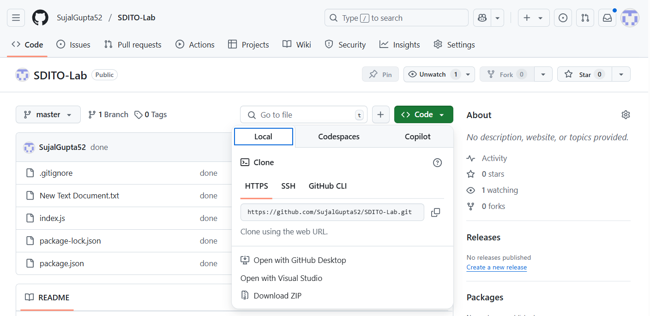

11. Now make a new folder and open the newly created folder in git

bash terminal. Run the following command to clone our repo:

git clone <Repository address>

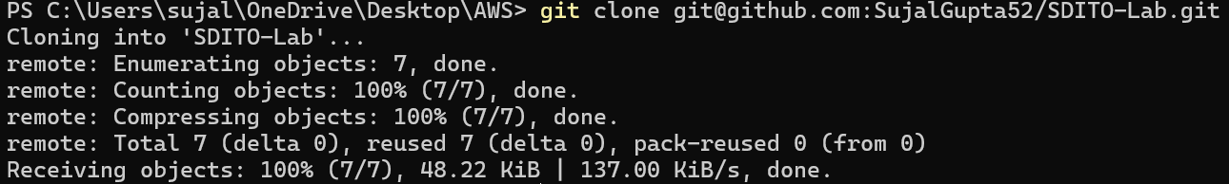

12. Our repo files is successfully cloned locally.

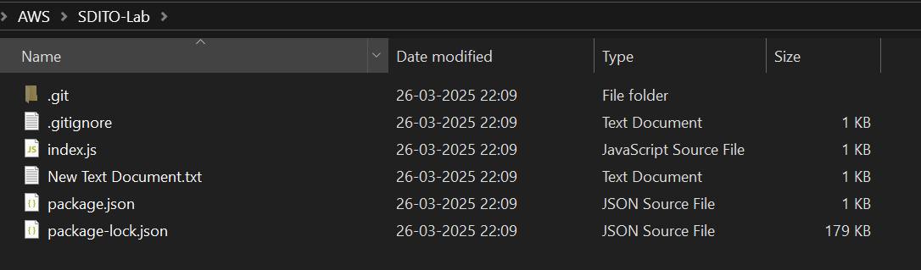

**ASSIGNMENT 9:**

**Problem Definition:** Deploy a project from GitHub to EC2.

**Instructions:**

1. Access the ***AWS console***, search for ***EC2***, and select the top option

from the search results.

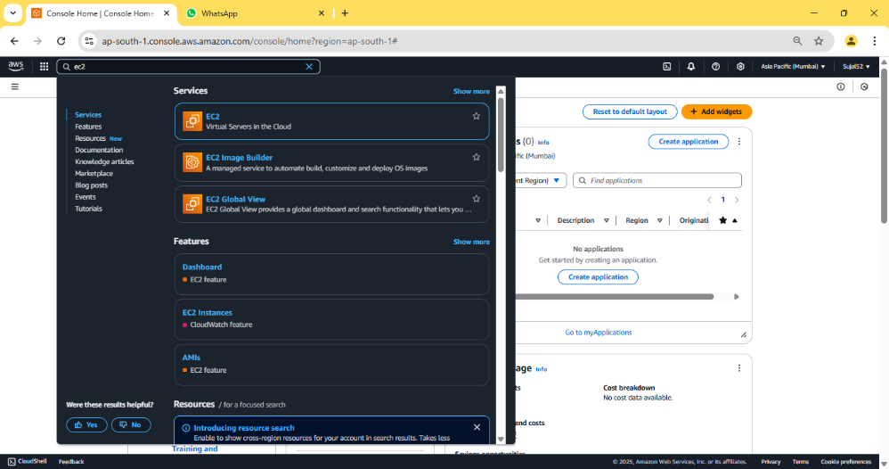

2. Click on ***“Launch instance”***.

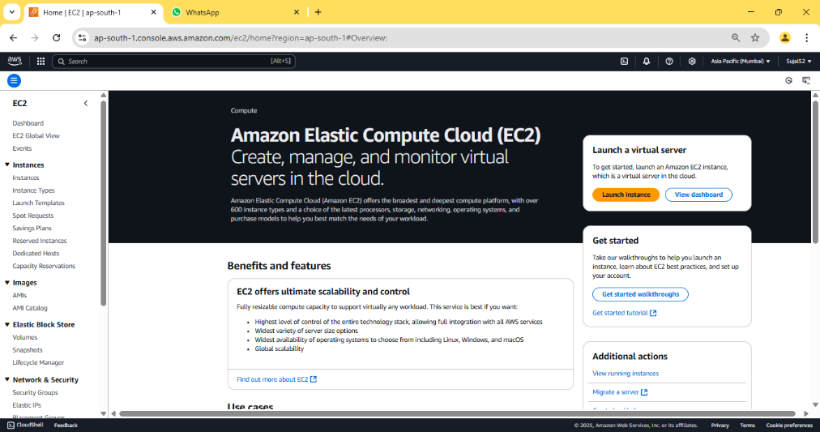

3. Enter instance name and select ***Ubuntu*** under ***“Application and OS***

***Images”.*** Under ***“Key Pair (login)”*** click on ***“Create new key pair”***,

enter key pair name then click on ***“Create key pair”*** button, a *.pem

file will be downloaded. Then click on ***“Launch instance”*** button

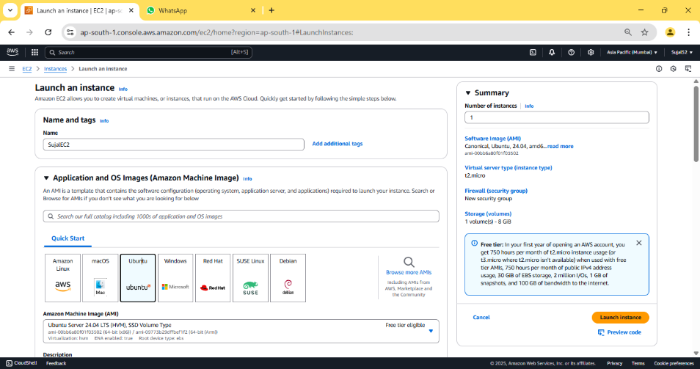

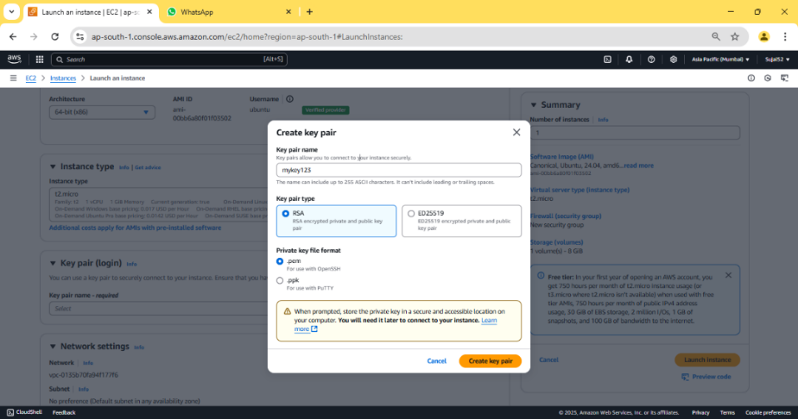

4. Our instance is created successfully.



5. Go to ***“Instance”*** from the sidebar, then click on ***Instance ID*** of our

newly created instance.

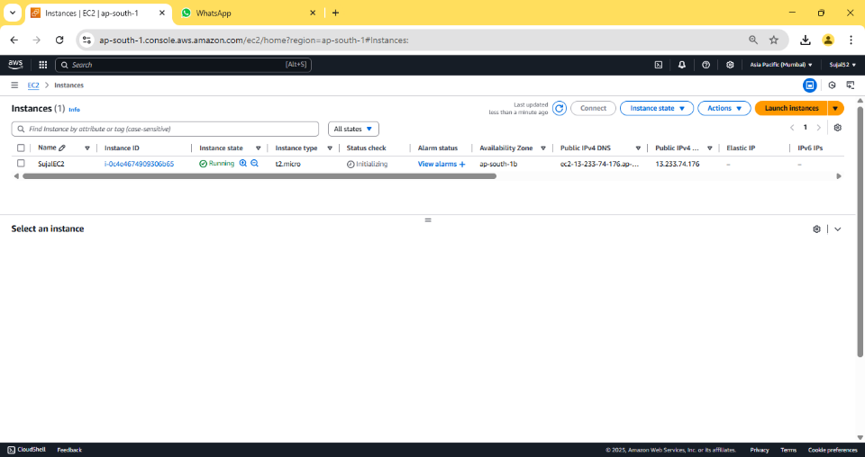

6. Copy ***“Public IPV4 address”***.

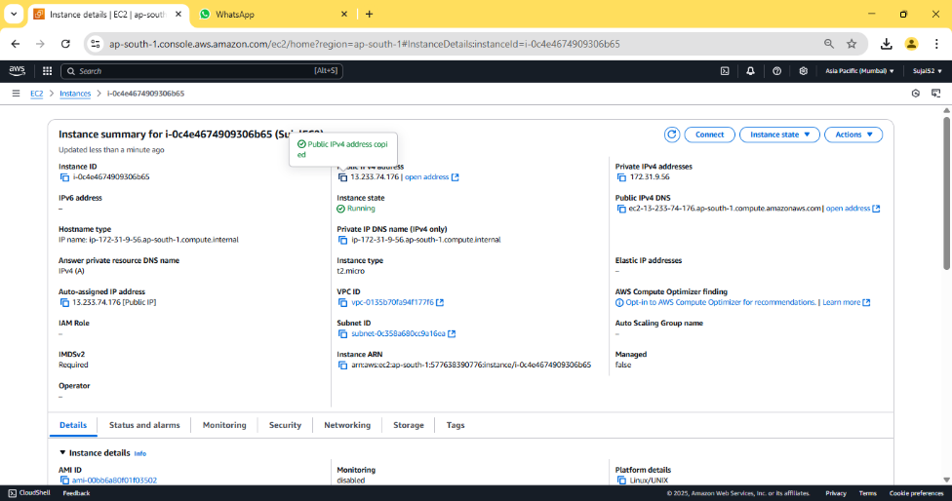

7. Open ***Bitvise SSH Client,*** paste the previously copied address in host

field.



8. Click ***“Client key manager”,*** click on ***“Import”*** and select our

previously downloaded key pair file. Click on ***“Import”*** button. Our

key pair should be imported successfully.



9. In ***“Bitvise SSH Client”***, under ***“Authentication”*** give the username

as ***“ubuntu”***, select ***“Global 1”*** under ***“Client Key”*** then

click on ***“Log in”*** & ***“Accept and save”***.



10. Click on ***“New terminal console”*** from the sidebar. In the terminal

enter the following commands to clone our repo and run our

Node server:

sudo apt-get update

sudo apt-get upgrade

sudo apt-get install nginx

curl -sL https://deb.nodesource.com/setup_18.x | sudo -E bash –

sudo apt install nodejs

git clone <Github repo link>

cd <Github repo name>

npm install

node index.js

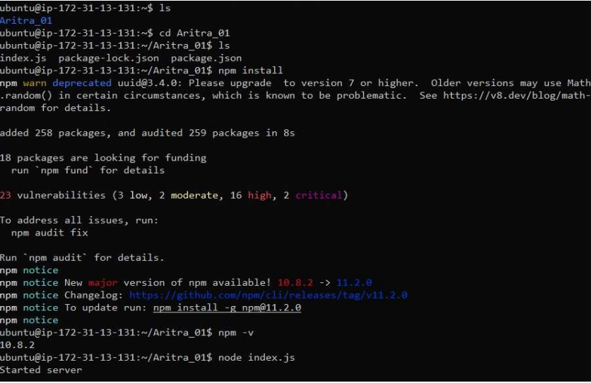

11. Go to ***“Instance Id”,*** and click on our instance. Then go to

‘Security’ and click on link under ‘Security groups’ to get the edit

option.

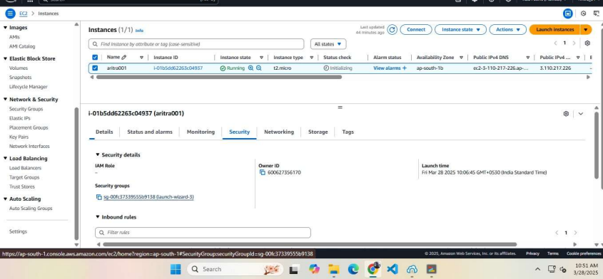

12. Then in ***“Inbound rules”***, click on ***“Edit inbound rules”***. Click on **“Add**

**rule”** and set the ***“Port range”*** to **“4000”**, in ***“Source”*** set ***“0.0.0.0/0”***

& click on ***“Save rules”***. A confirmation is shown stating our rules are

saved.

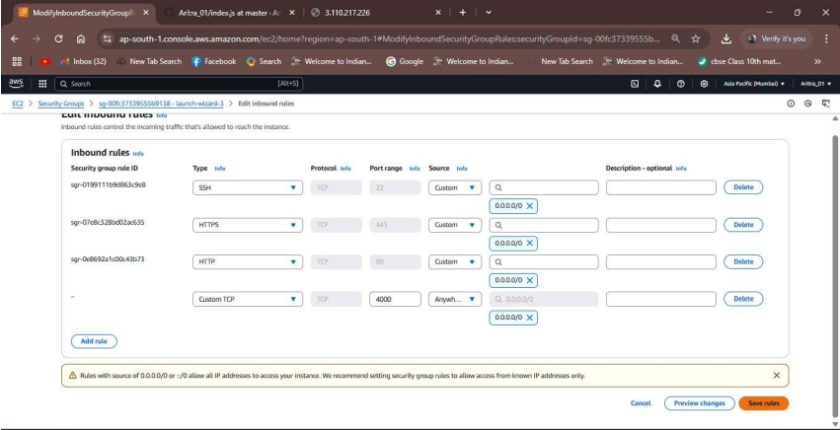

13. Now copy the ***“Public IPv4 address”*** & paste it on a new tab. Add

***“:4000”*** at the end and then press enter. The project has been

successfully deployed from GitHub to EC2.

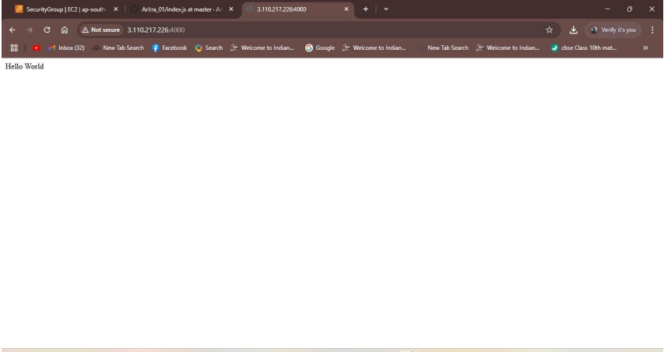

**ASSIGNMENT 10:**

**Problem Definition:** Deploy a project from GitHub to EC2 by creating a new security group and user data.

**Instructions:**

1. Access the ***AWS console***, search for ***EC2***, and select the top option

from the search results.



2. Select ***Security Groups*** from the side bar and click on ***“Create***

***security group”***.

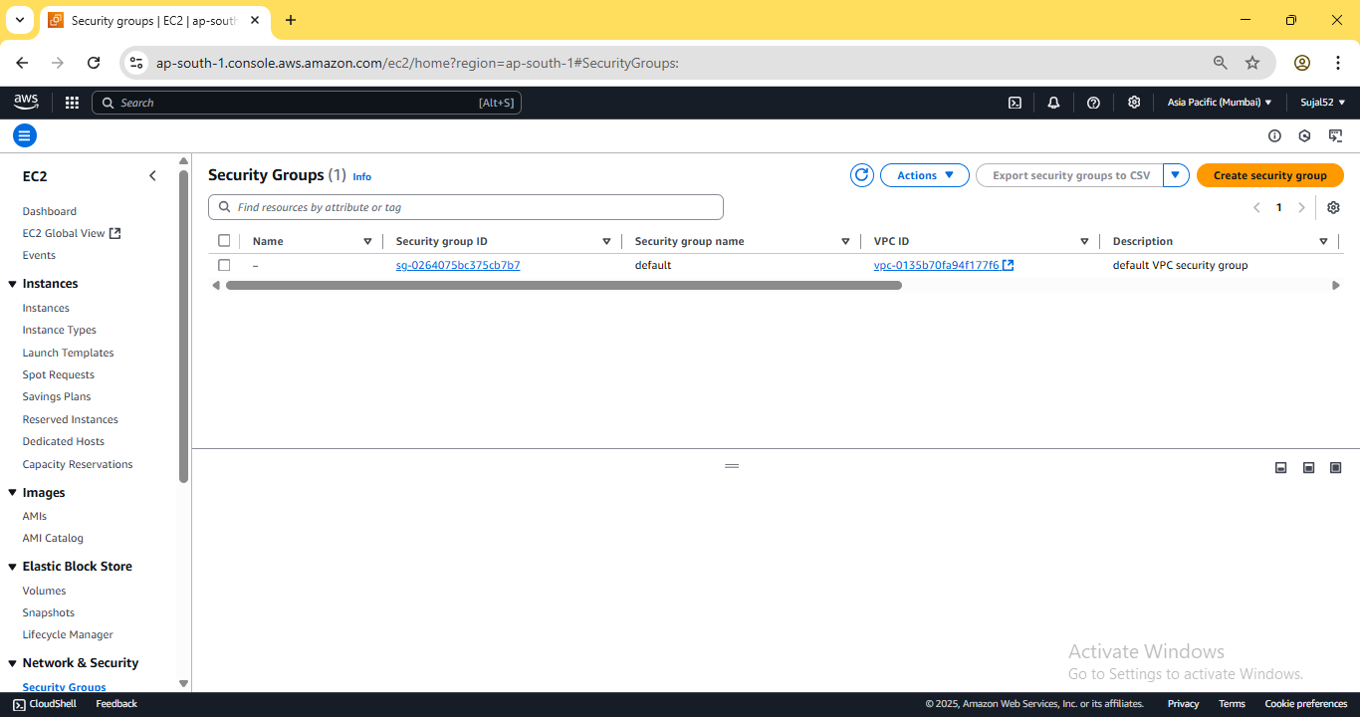

3. Add name and description. Under ***“Inbound Rules”***, add the ***“Add***

***rule”*** to add the following rules: SSH, HTTP, HTTPS and Custom TCP

with port 4000. Select 0.0.0.0/0 under source for all rules. Finally click

on ***“Create security group”.*** Pop up is shown stating our rules are

created successfully.

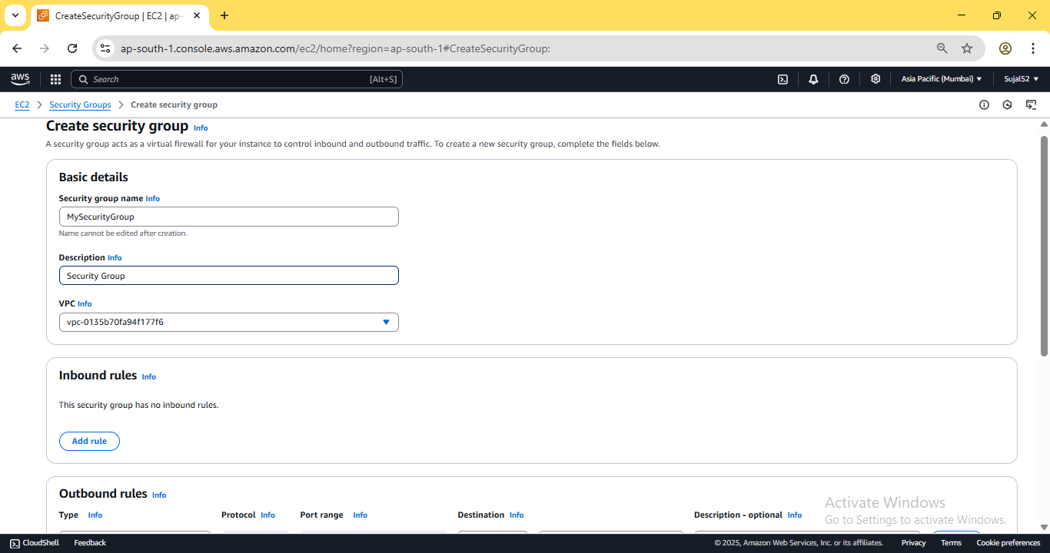

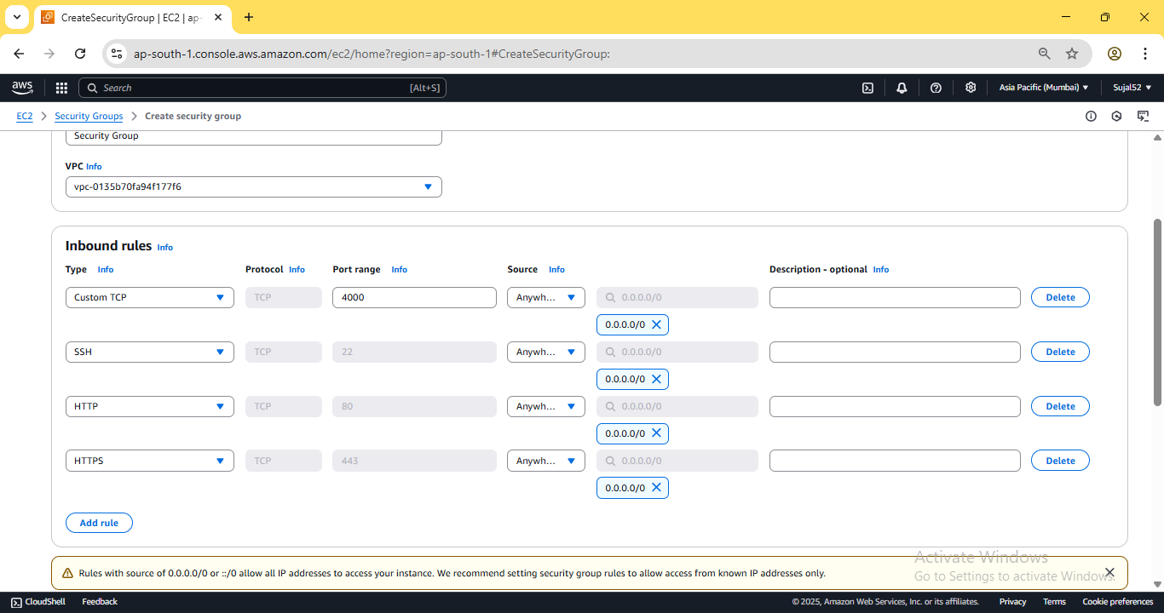

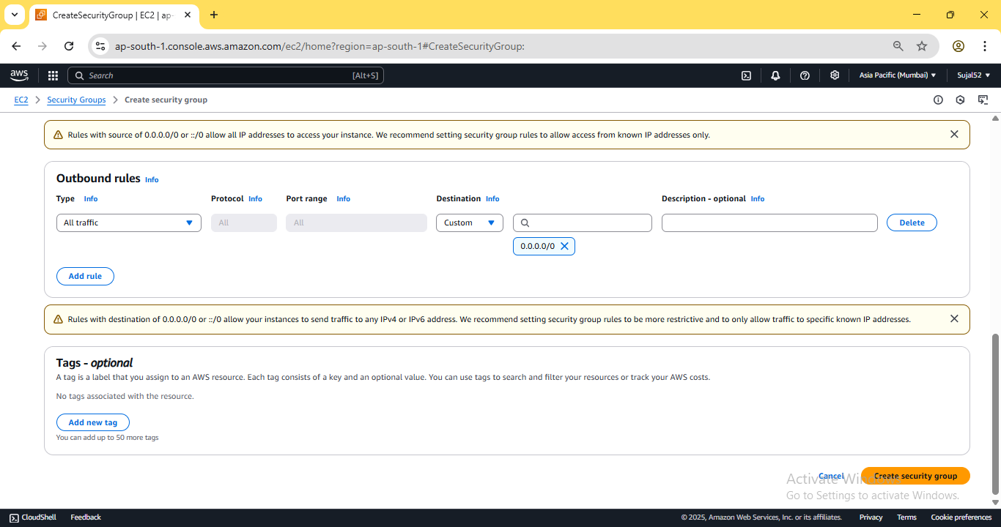

4. Go to ***Instances*** from the sidebar and click on ***“Launch***

***Instance”***. Enter instance name, select Ubuntu as operating system,

select an existing key pair or create a new one. Under ***“Network***

***settings”***, click on ***“Select existing security group”*** and select our

previously created security group.

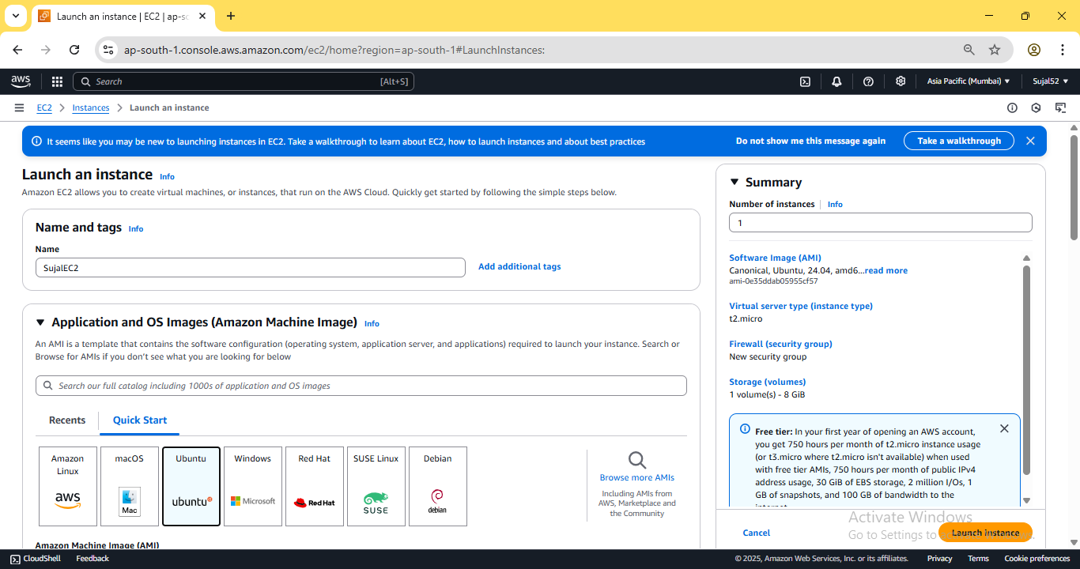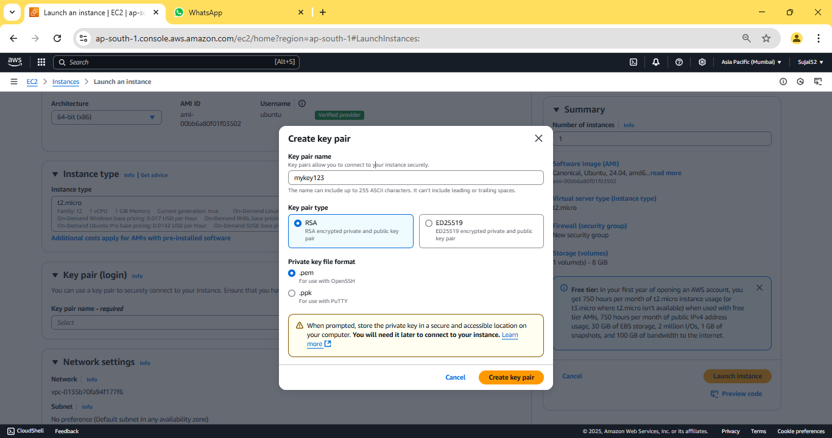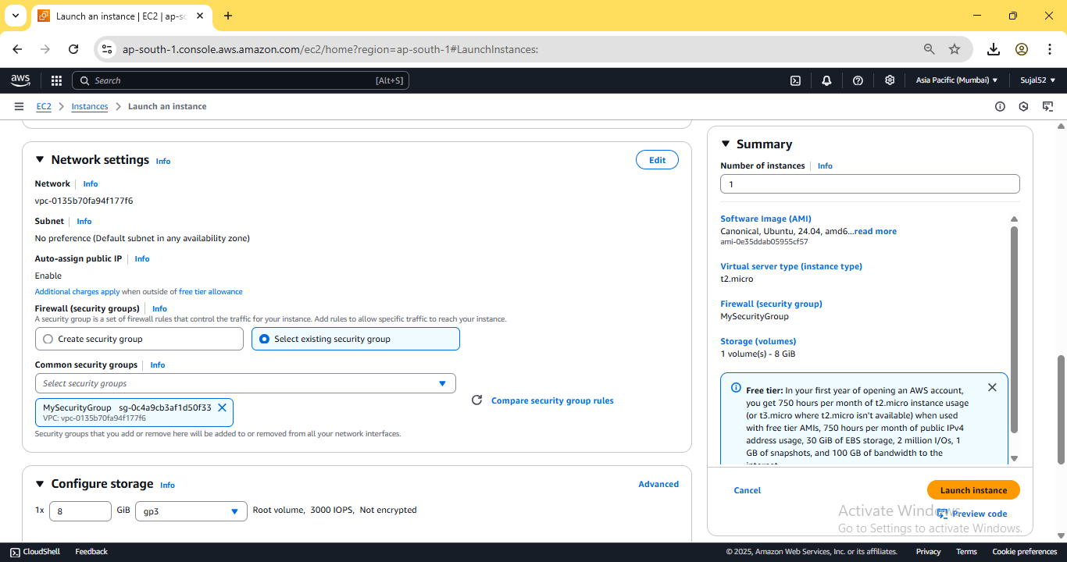

5. Expand ***“Advanced details”***, scroll down to ***“User data”*** and put

the following bash script. Then click on ***“Launch Instance”***.

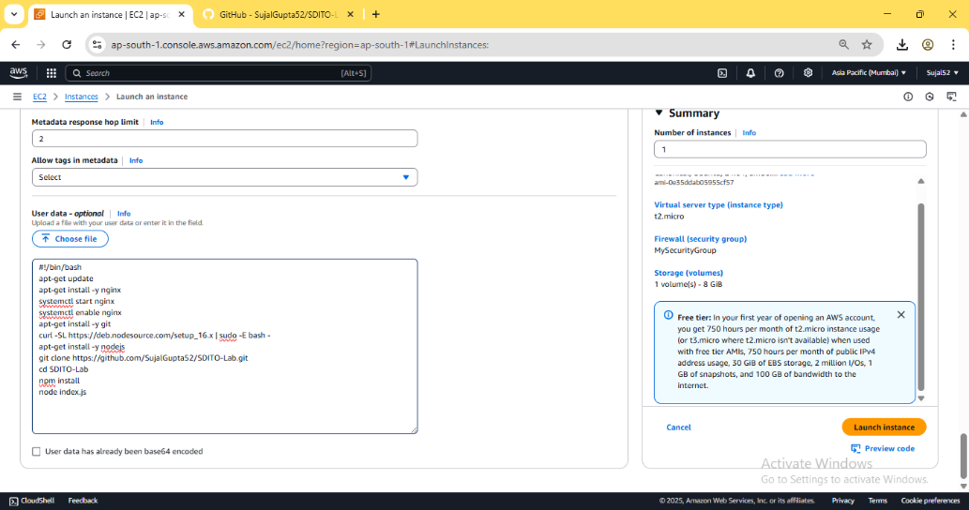

6. Our instance is created successfully

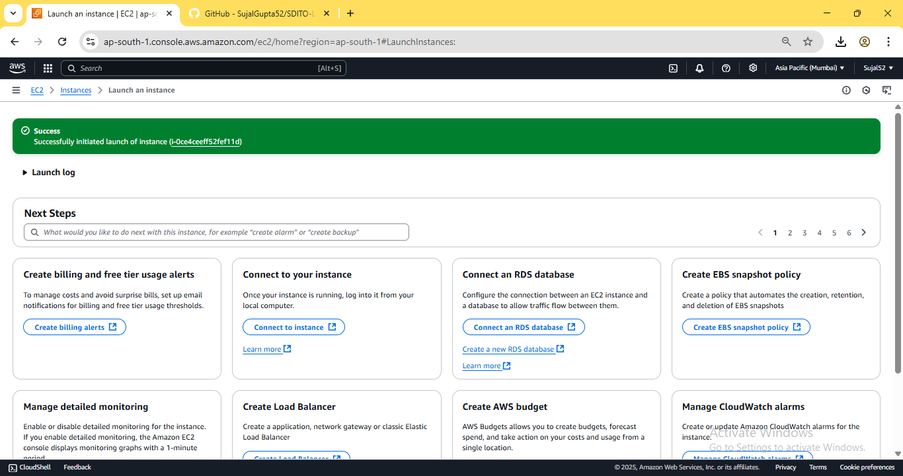

7. Go to ***Instance***, click on ***“Instance ID”*** of our newly created instance.

Copy the ***IPV4 address***.

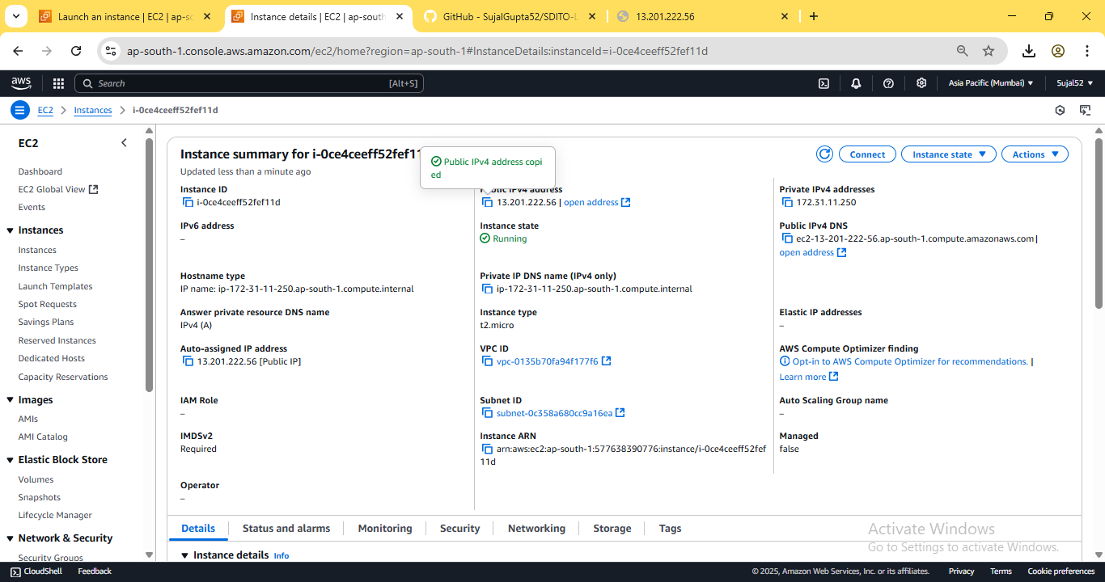

8. Paste the previously copied address into a new browser tab and

suffix “:4000” to indicate our port. Our NodeJS server is successfully

deployed.

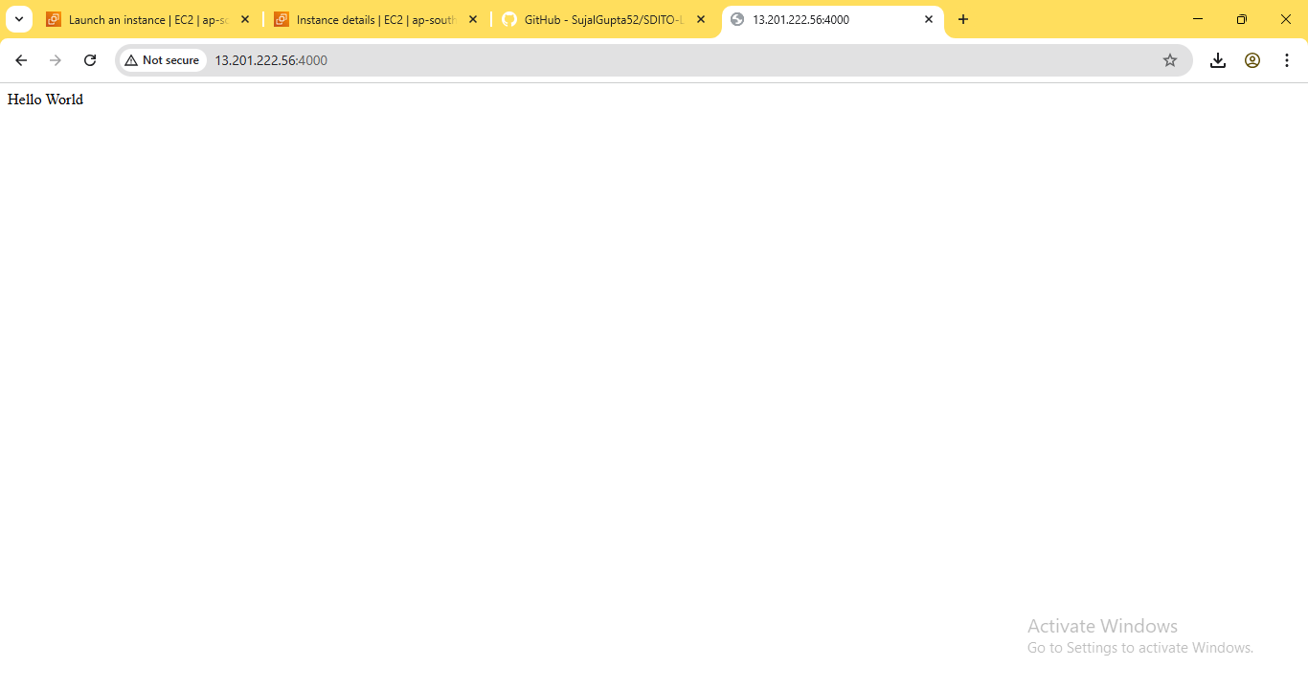

**ASSIGNMENT 11:**

**Problem Definition:** Build scaling plans in AWS that balance load on different EC2 instances.

**Instructions:**

1. Access the ***AWS console***, search for ***EC2***, and select the top option

from the search results.



2. Click on ***“Launch Templates”*** from the sidebar then click on ***“Create***

***launch template”***.

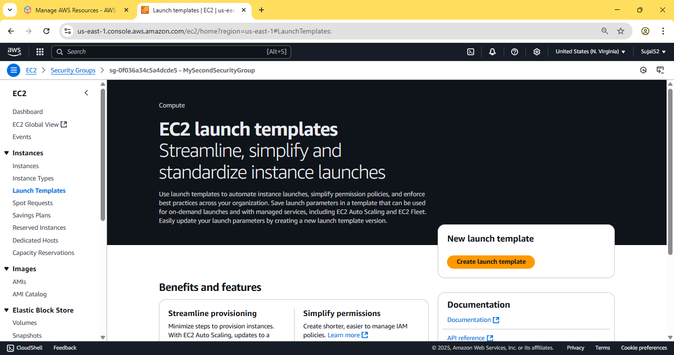

3. Enter name and description. Check the box under ***“Auto Scaling***

***guidance”***. Select ***Ubuntu*** as OS Image, instance type as ***t2.micro***.

Create keypair and select an existing security group where port

4000 is open for incoming traffic.

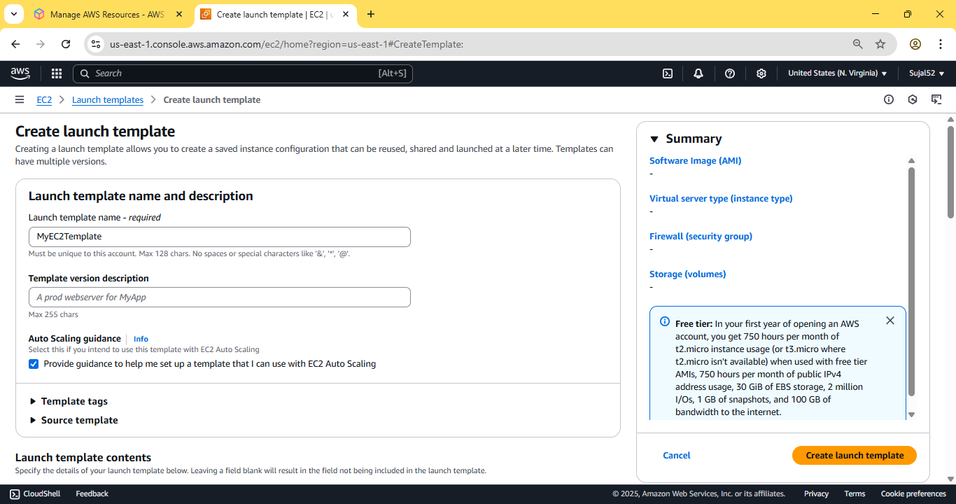

Under ***“Advance details”***, scroll down to ***“User data”*** and add the

following bash script and then click on create instance

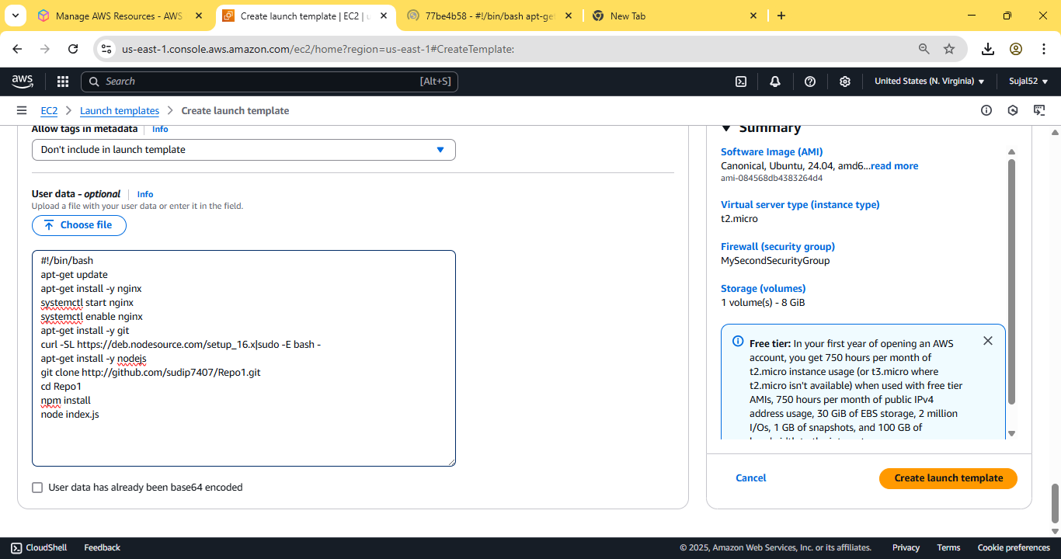

Our launch template is created successfully.

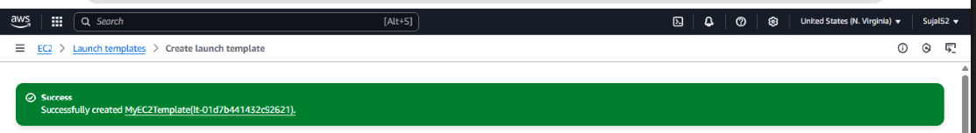

4. From sidebar, scroll down and select ***“Auto Scaling Groups”***. Enter

name and select our previously created launch template from the

dropdown. Then click on next.

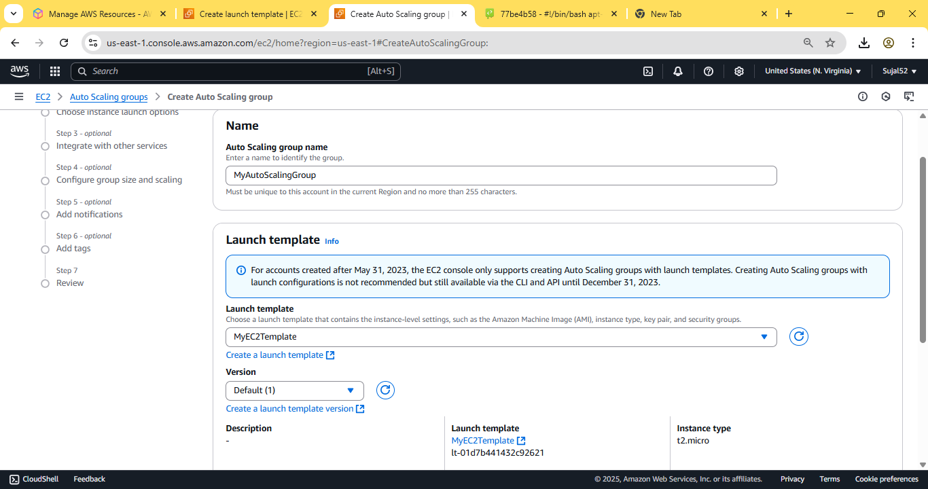

Choose all ***“Availability Zones”*** available then click on next.

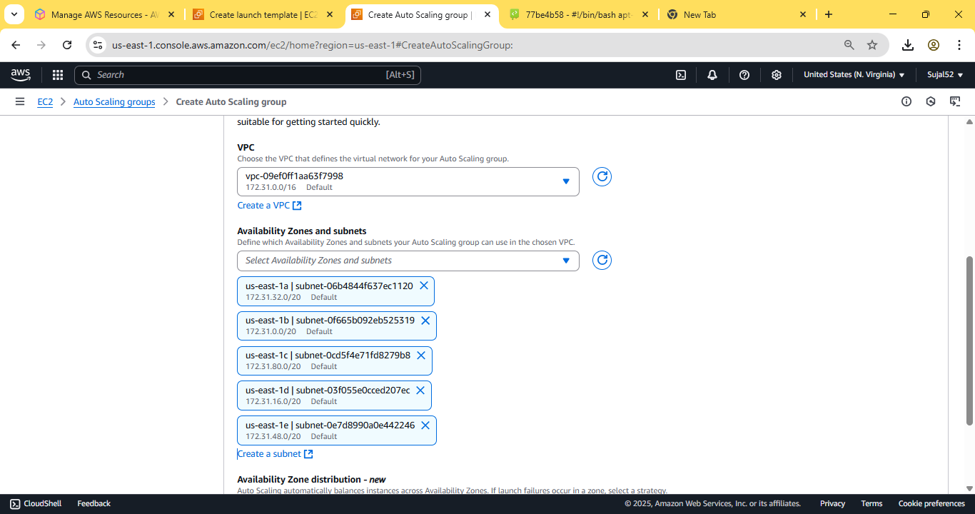

Under ***“Load balancing”***, select ***“Attach a new load balancer”***,

under type select ***“Application load balancer”*** and ***“Internet-facing”***

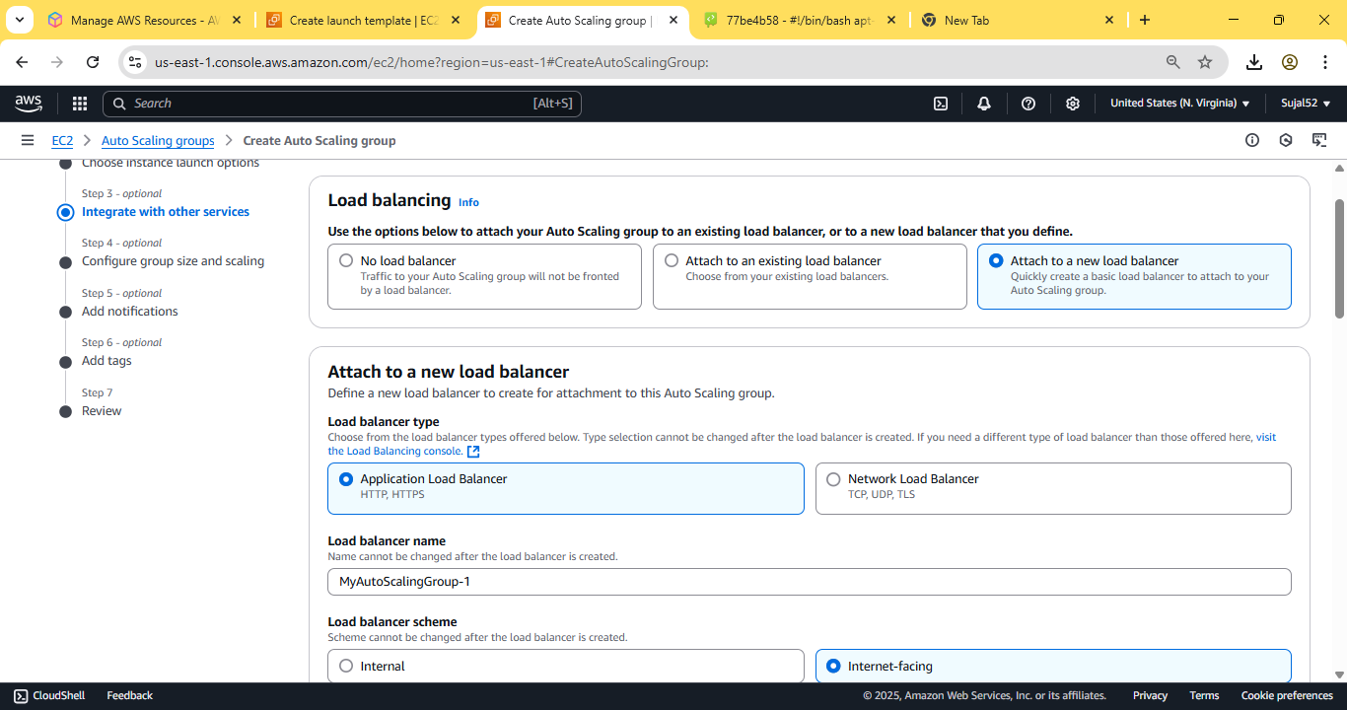

Under ***“Health checks”*** tick the box on ***“Turn on Elastic Load Balancing***

***Health Check”*** and enter the ***“Health check grace period”*** as 240

seconds. Click on next.

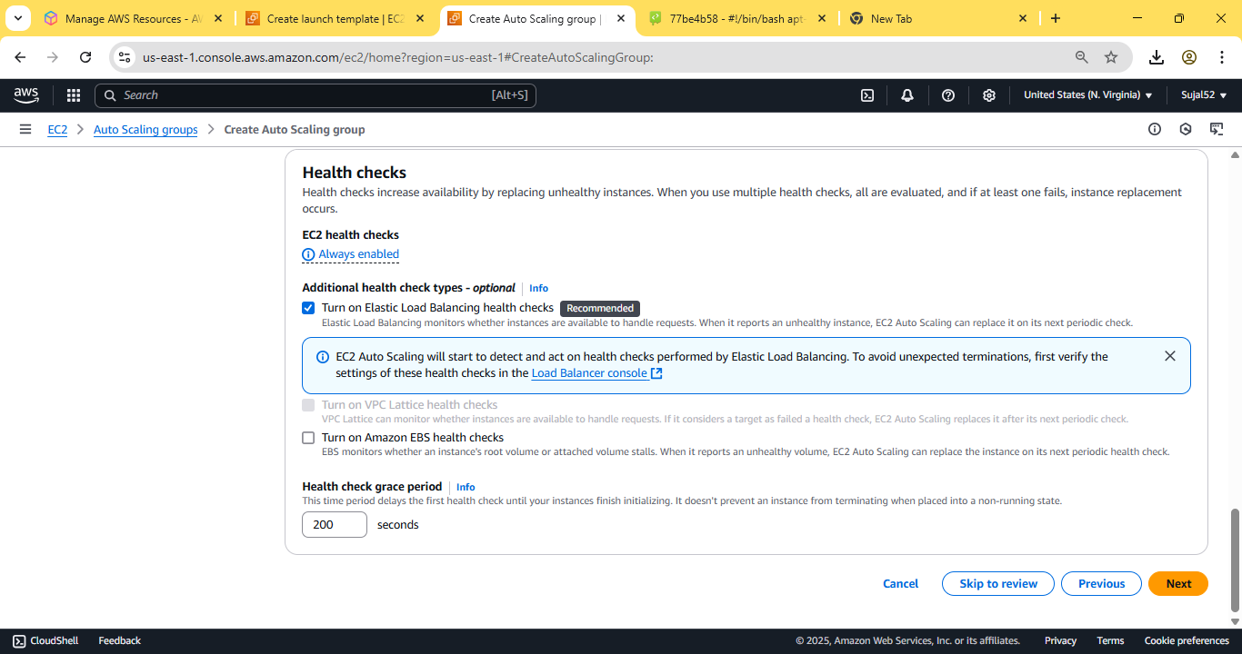

In ***Group size*** set ***Desired capacity*** as 2. In ***Scaling*** set ***Min desired***

***capacity*** as 2 and ***Max desired capacity*** as 3. In ***Automatic scaling***

choose ***target scaling policy*** and set the ***instance warmup*** as 240

second. Keeping everything else as default, click on Next.

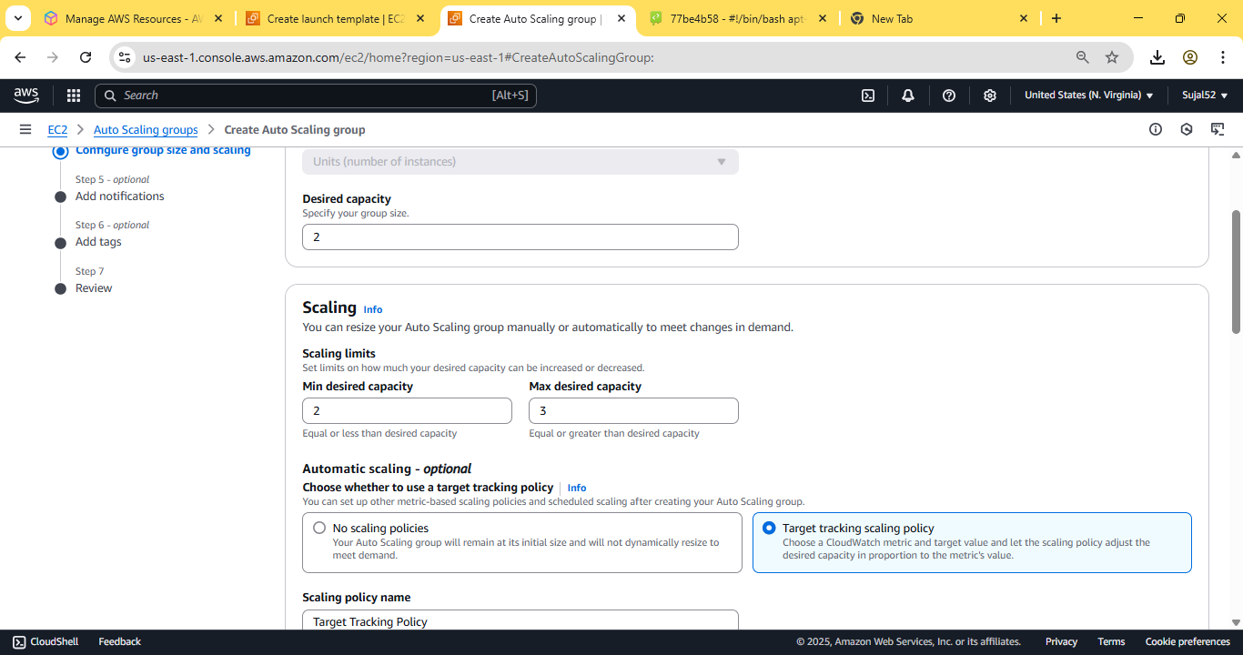

Skip last two steps and click on ***Create Auto Scaling group***. Our auto

scaling group is successfully created.

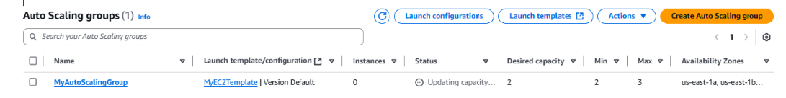

5. Now go to ***Instances*** from the sidebar. We can see two instances

are created. Copy the ***IPv4 address*** of any of the two instance and

log into ***Bitwise SSH Client*** using key pair.

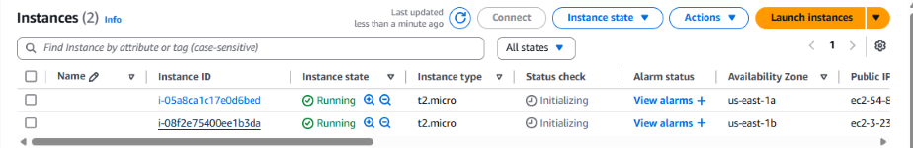

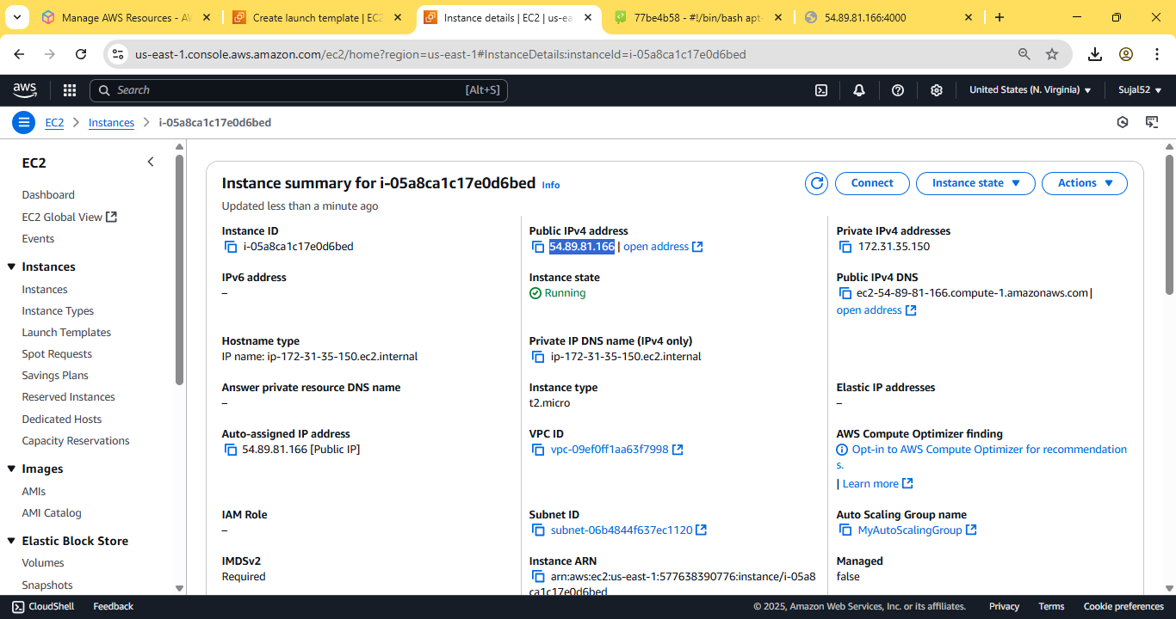



6. Open terminal console and enter the following commands:

vim file.sh

Now paste the following code:

#!/bin/bash

while(true)

do

echo “Inside Loop“

done

Now make the script executable and run it enter the following

commands:

sudo chmod 777 file.sh

sh file.sh

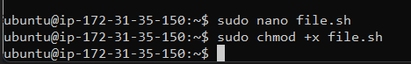

An infinite loop will start to run, stressing the cpu of the instance.

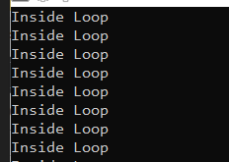

7. Select the two instances to see their utilization graph. After a while,

when it surpasses 50% threshold, we can see that auto scaler spins

up another instance to balance the load.

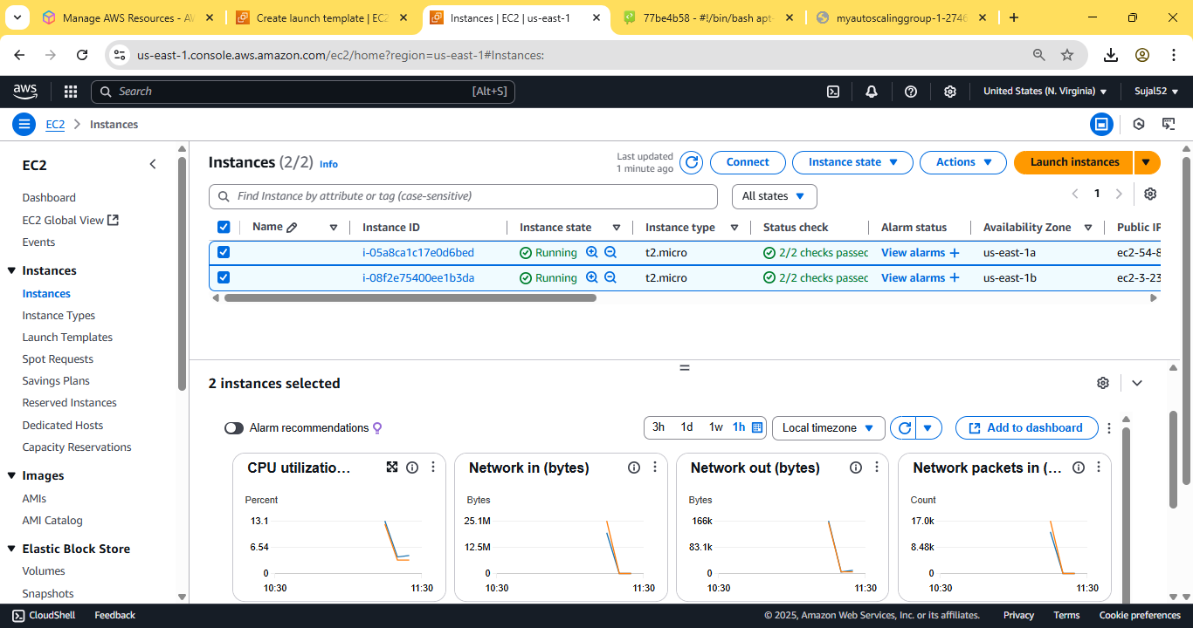

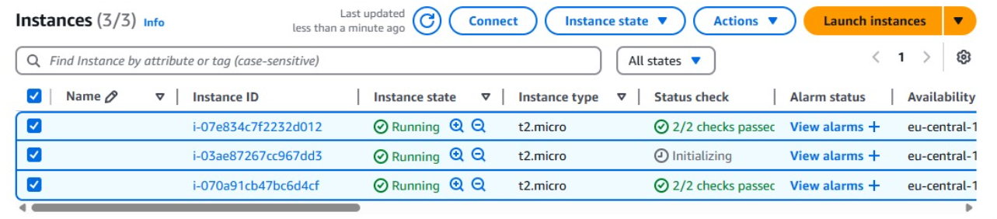

**ASSIGNMENT 13:**

**Problem Definition:** Create a workmail for your organization.

**Instructions:**

1. Access the ***AWS console***, search for ***Workmail***, and select the top

option from the search results. Click on ***Create Organization***.

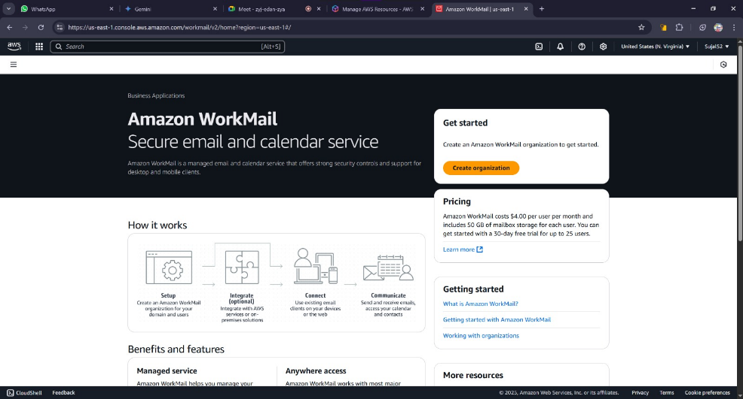

2. Select ***Free Test Domain*** under ***Organization settings***. Enter an alias

then click on ***Create Organization***.

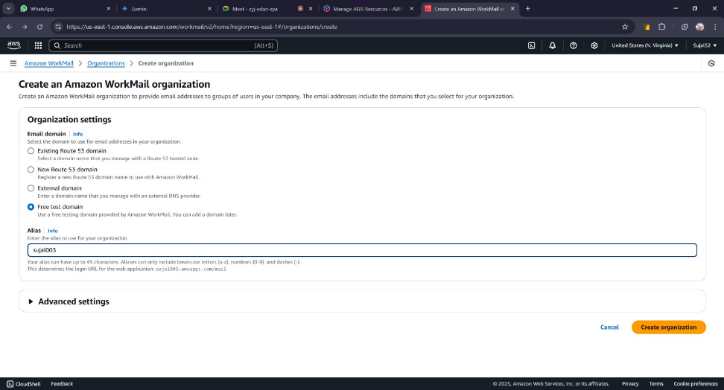

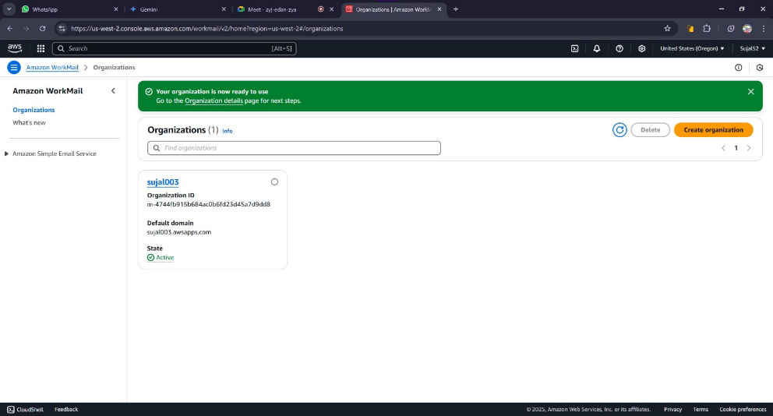Our organization is created successfully.

3. Click on Organisation name. Go to ***Users*** and click on ***Add User***

button.

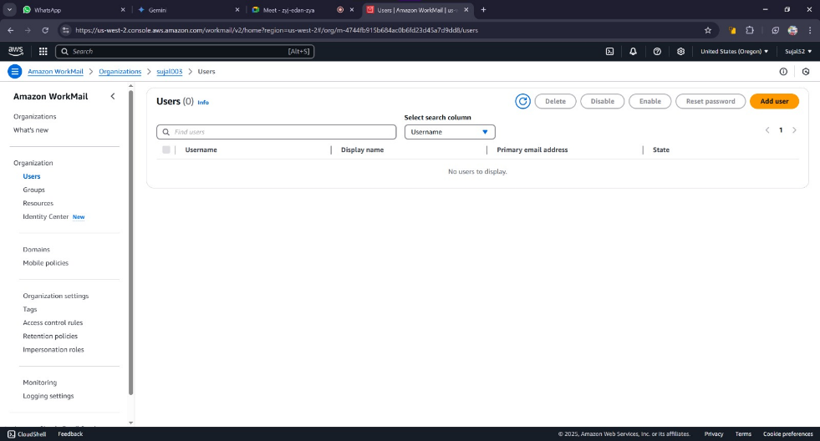

4. Fill username, display name and password. Then click on ***Add User***.

A green banner will be displayed indicating our user is created

successfully.

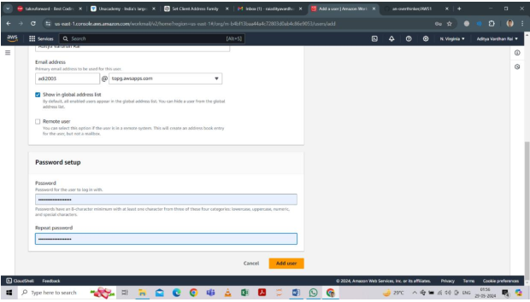

5. Go to Organisation Details page again and click on the ***Amazon***

***WorkMail web application***.

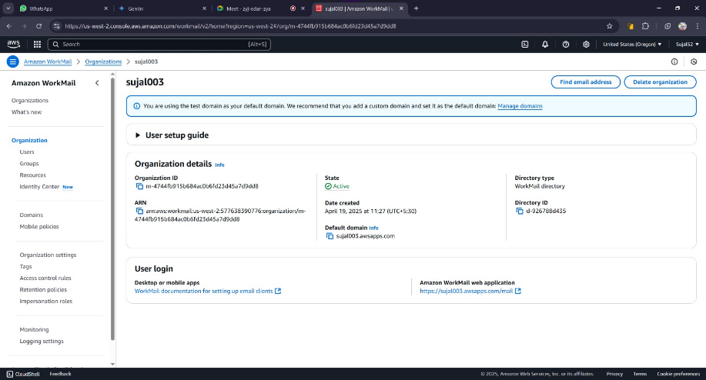

6. Enter our previously created username and password. The inbox

should open indicating our workmail is created successfully.

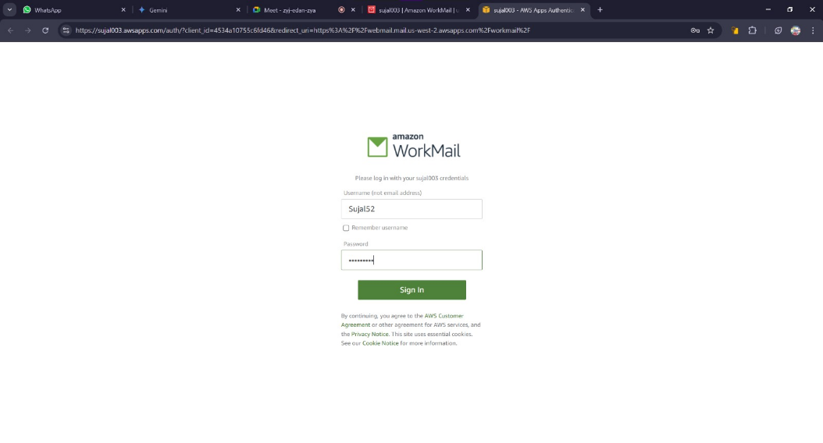

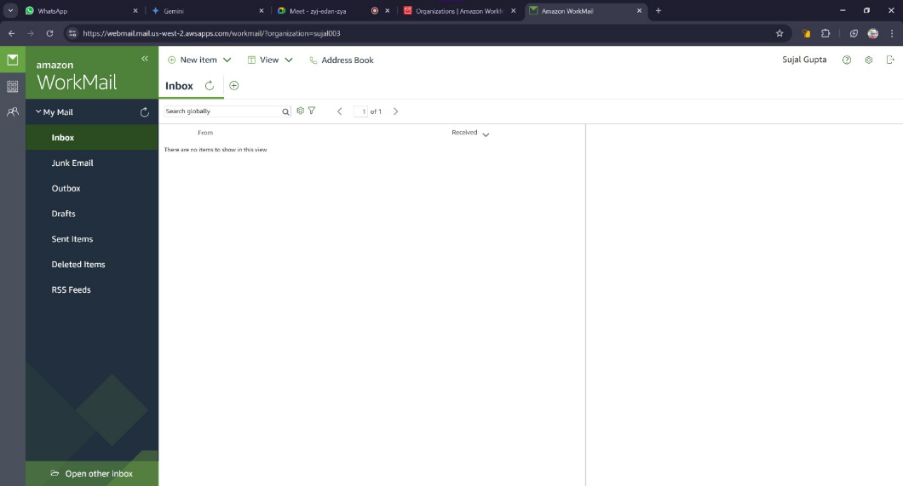

**ASSIGNMENT 14:**

**Problem Definition:** Create an Elastic IP for an Instance.

**Instructions:**

1. Access the ***AWS console***, search for ***EC2***, and select the top option

from the search results. Then go to ***Instances*** from the sidebar.



2. Launch a EC2 instance and copy its Public IPv4 address for future

comparison.



3. Now restart the instance and compare its Public IPv4 address with

the one we previously saved. We can see it changes every time a

instance is launched.

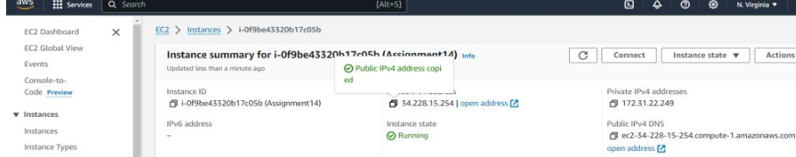

4. From the ***EC2 Dashboard***, go to ***Elastic IPs*** and click on ***Allocate***

***Elastic IP***

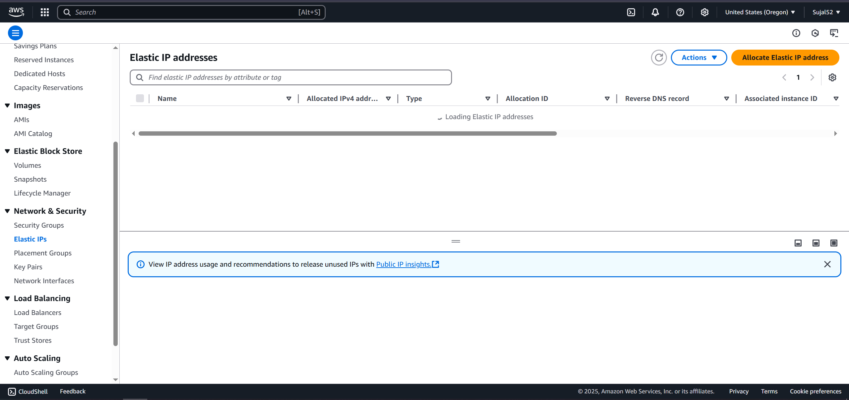

5. Select ***Amazon’s pool of IPv4 Addresses*** and click on ***Allocate.*** A

green banner will be shown indicating our Elastic IP has been

created.

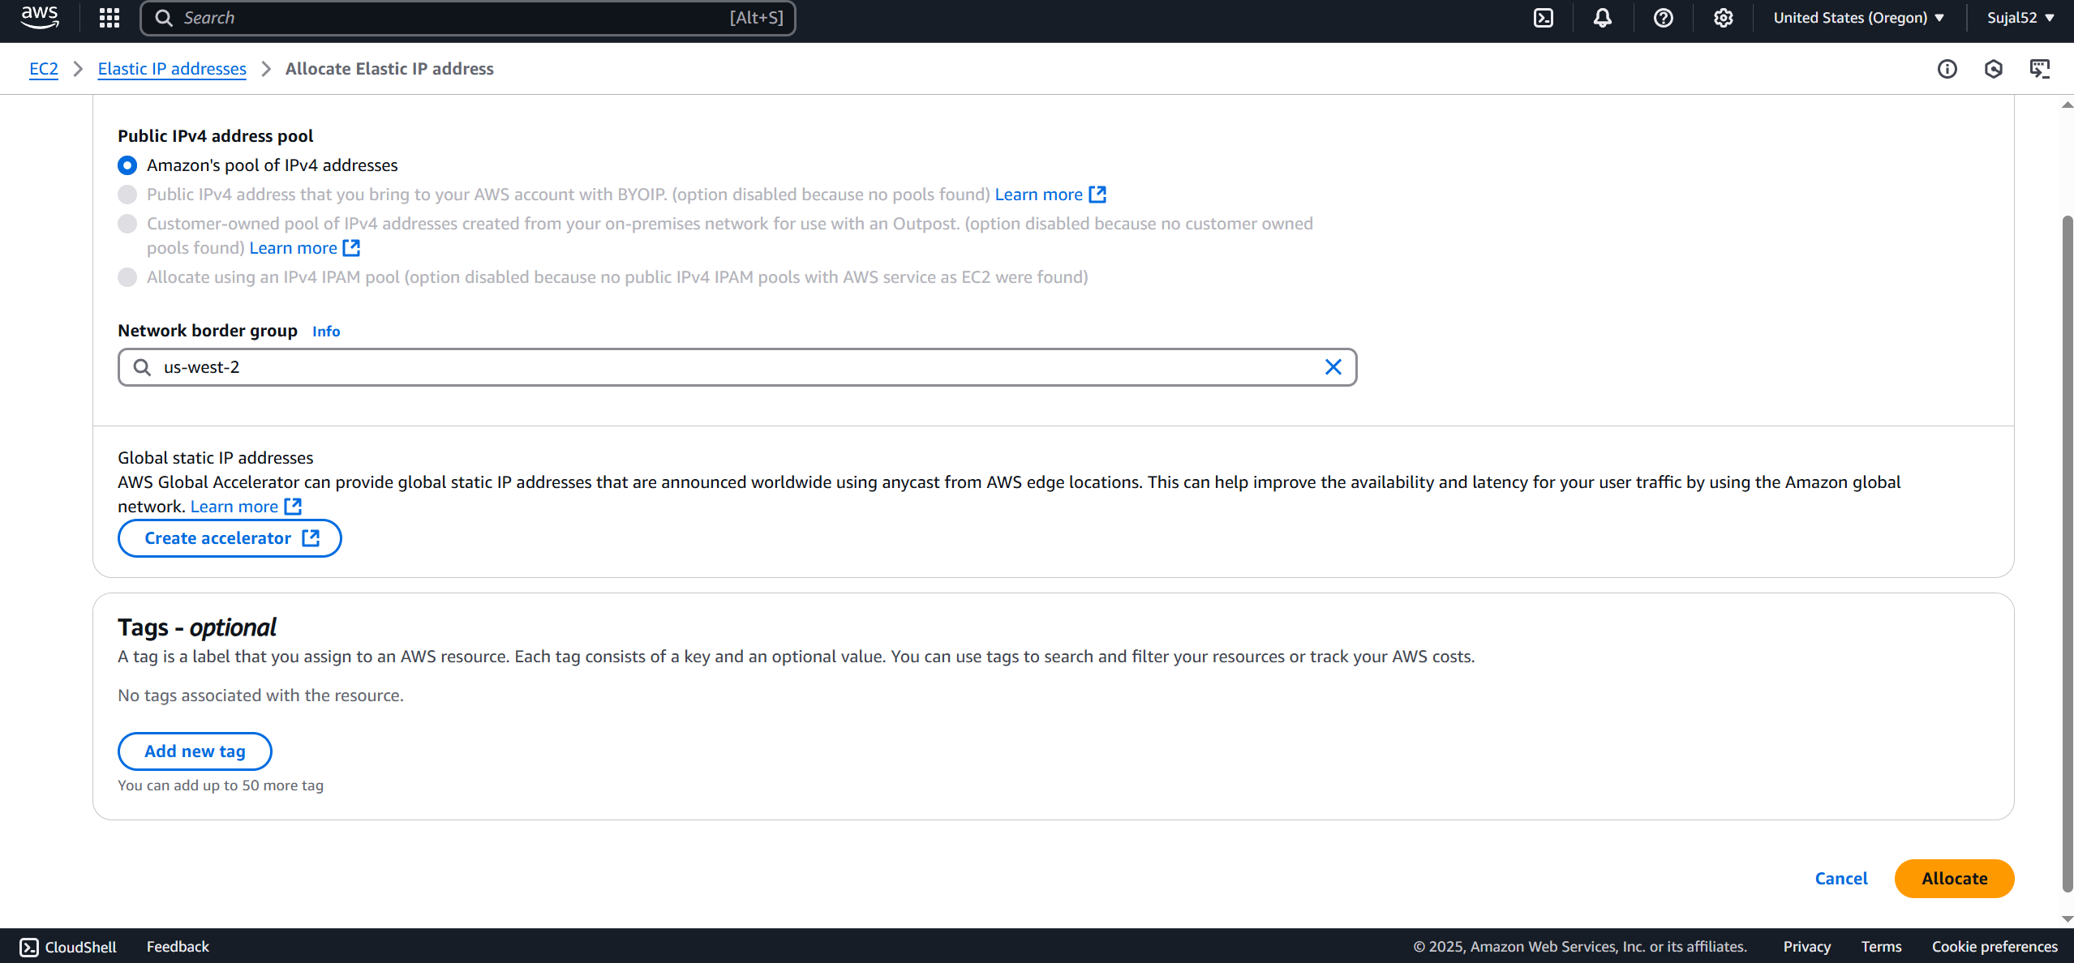

6. Click on ***Associate Elastic IP address***. Select resource type as

***Instance***, select name of our instance, its private IP address and

then click on ***Associate***.

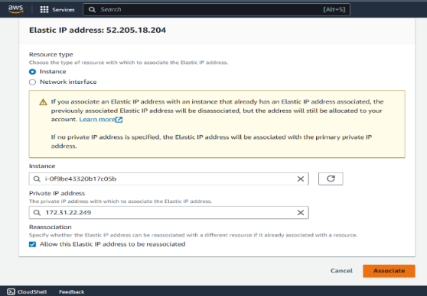

7. Restart our instance again and we can see our Elastic IP is

assigned and does not change on restart.

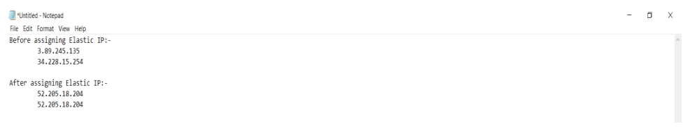

**ASSIGNMENT 15:**

**Problem Definition:** Create a serverless computing service

**Instructions:**

1. Access the ***AWS console***, search for ***Lambda***, and select the top

option from the search results.

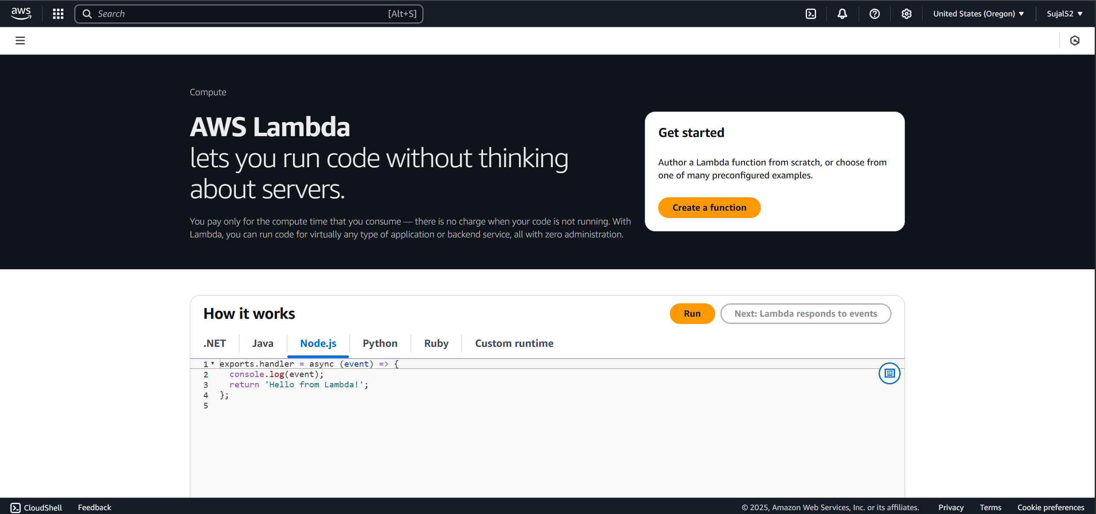

2. Click on ***Create a function***. Enter name and select ***Python*** as

***Runtime***. Under ***Advanced Configuration***, check ***Enable function URL***

and select ***Auth type*** as ***None***. Click on ***Create Function***.

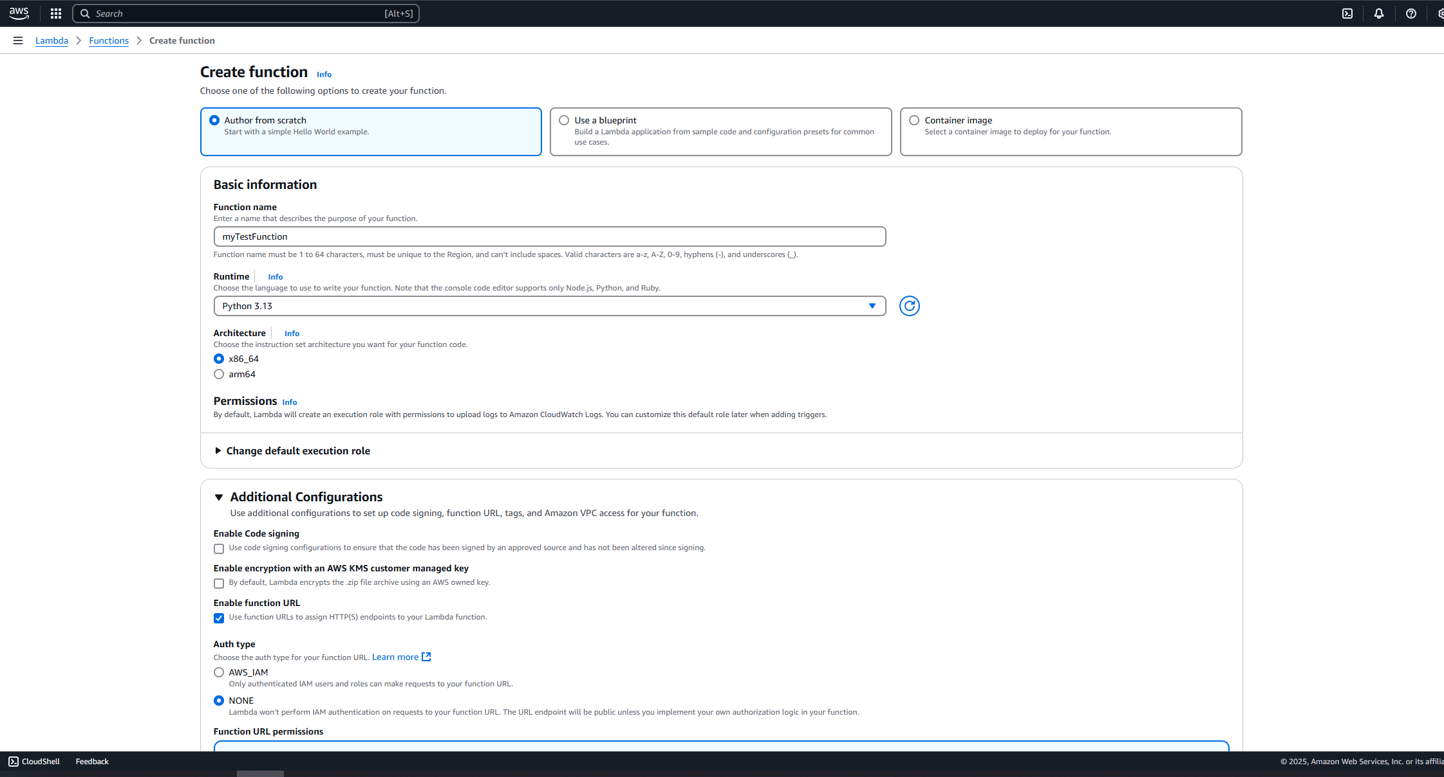

3. Our function is created successfully. Now copy the function URL and

open it in a new tab.

